Habitats
Year 1

A habitat is where living things can live and grow.
A habitat provides food, water, shelter.

There are many different habitats, such as:
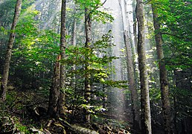  Forest | 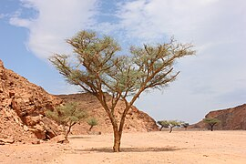  Desert
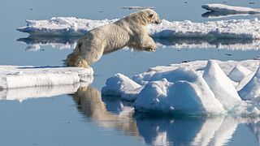  Arctic | 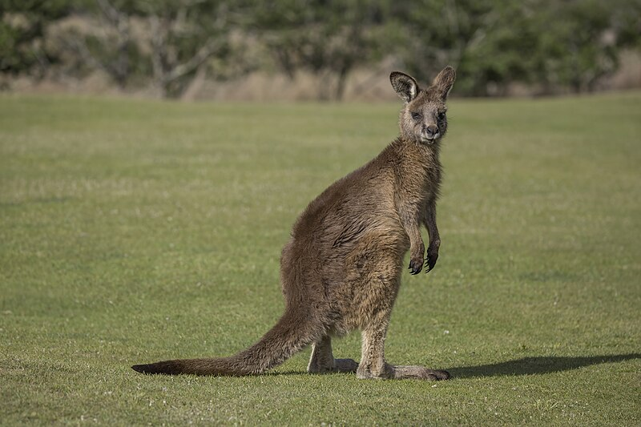  Grassland/ meadow

