Rhinoceros diorama
rhinoceros
Year 1
This is a diorama of a rhinoceros.
This is where a rhinoceros would live because it has everything it need to stay alive and healthy.
In my diorama you can see:
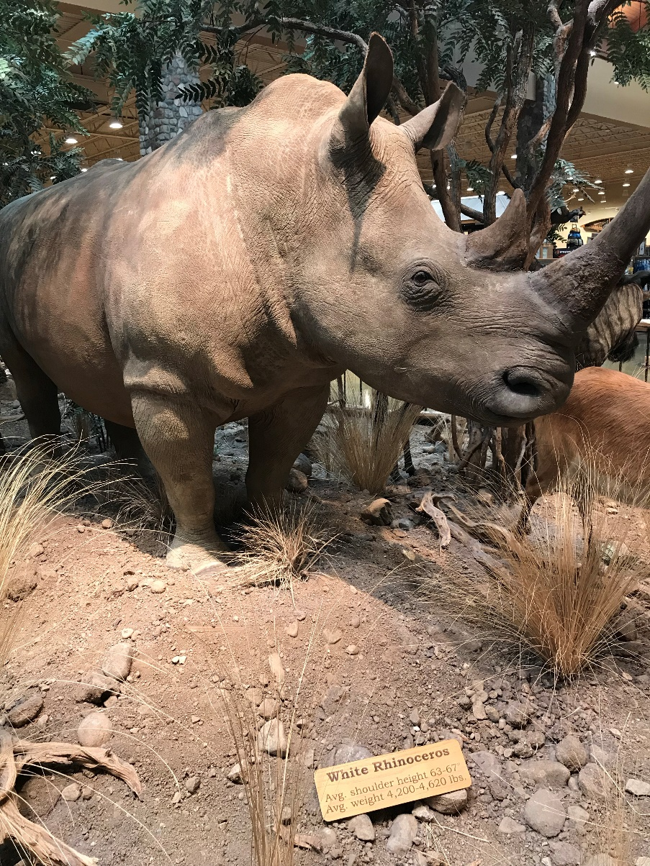
trees for it to eat
and for
shade/ shelter

soil for plants
(rhino food)
to grow
grass for it to eat

(list or draw and label the things needed to stay alive)
We can help the rhinoceros, and other animals by
looking after it / protecting their home.
(circle the best way to help)

