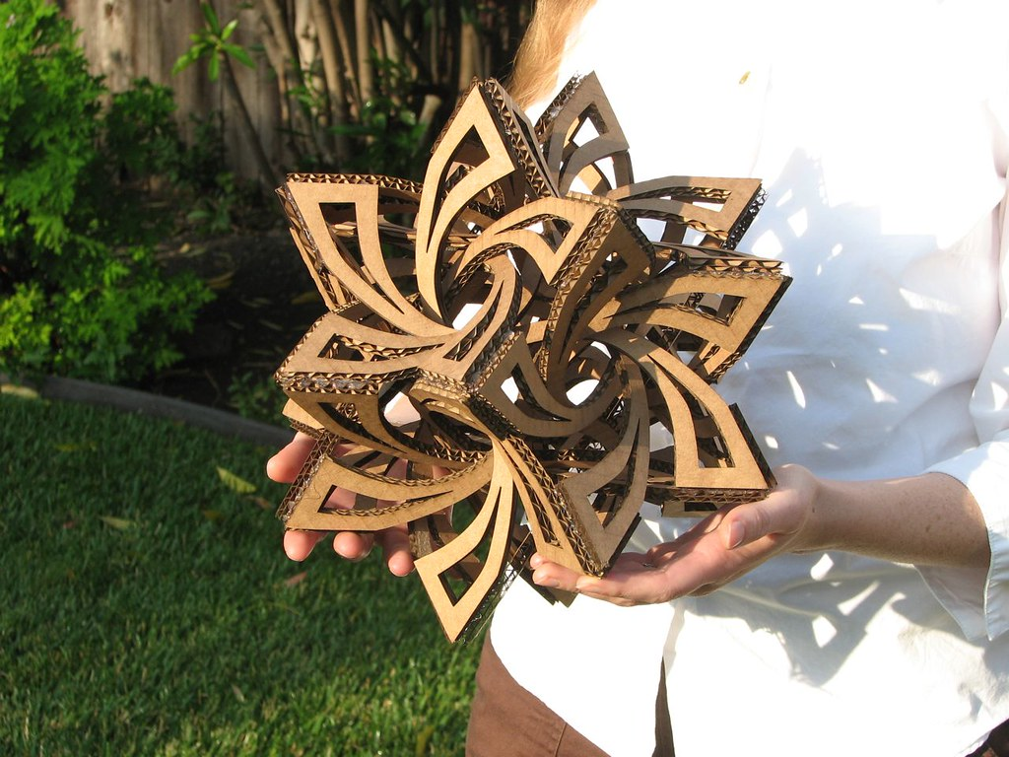
Sculpture gallery
Year 2

"frabjous - 01" by oskay is licensed under CC BY 2.0.
Year 2

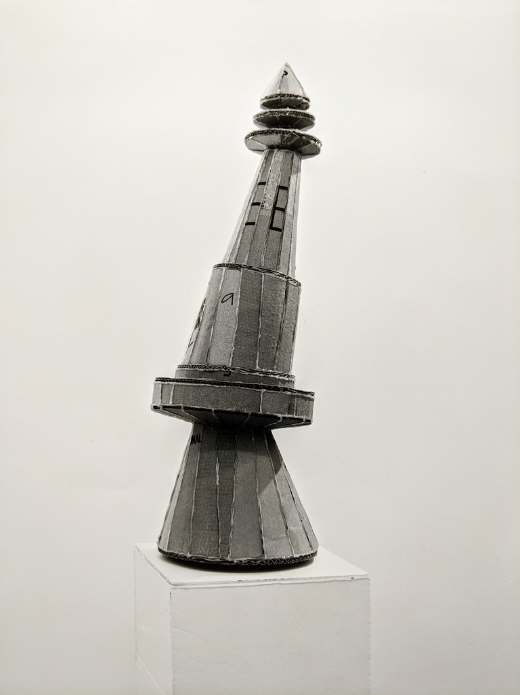
Sculpture gallery

"Sculpture, recycled cardboard" by neil cummings is licensed under CC BY-SA 2.0.

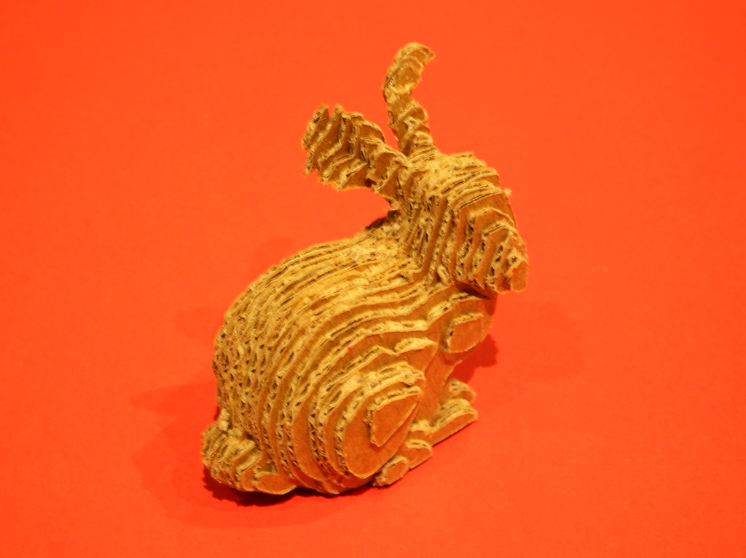
Sculpture gallery

"50 cents 3D printing" by fdecomite is licensed under CC BY 2.0.

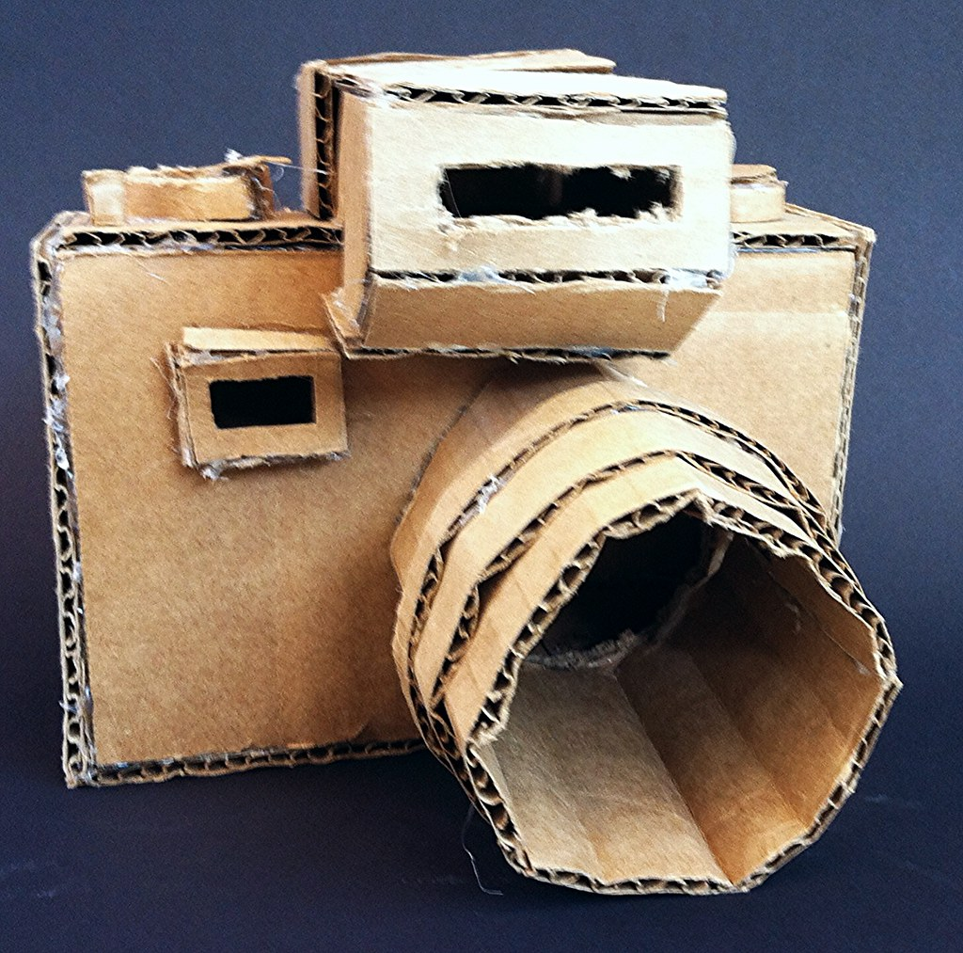
Sculpture gallery

"Cardboard Plane Sculpture" by meredithsteele is licensed under CC BY 2.0.

Sculpture gallery
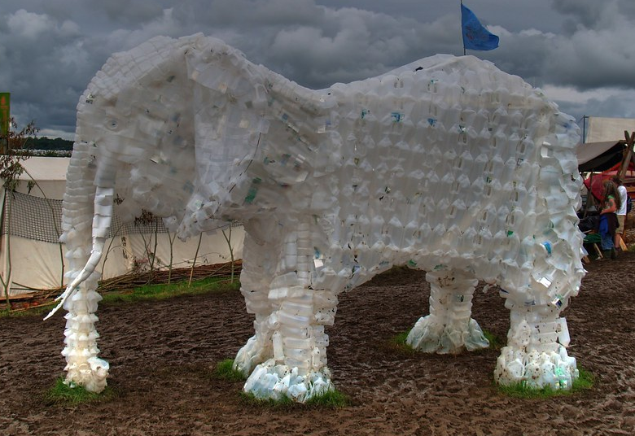

"Glastonbury White Elephant" by andrewcparnell is licensed under CC BY 2.0.

Sculpture gallery

"Sculpture of a Mero ( Grouper ) on the waterfront in Funchal Madeira. Made from recycled plastic. Deep blue sky." by bobbingwide is marked with CC0 1.0.

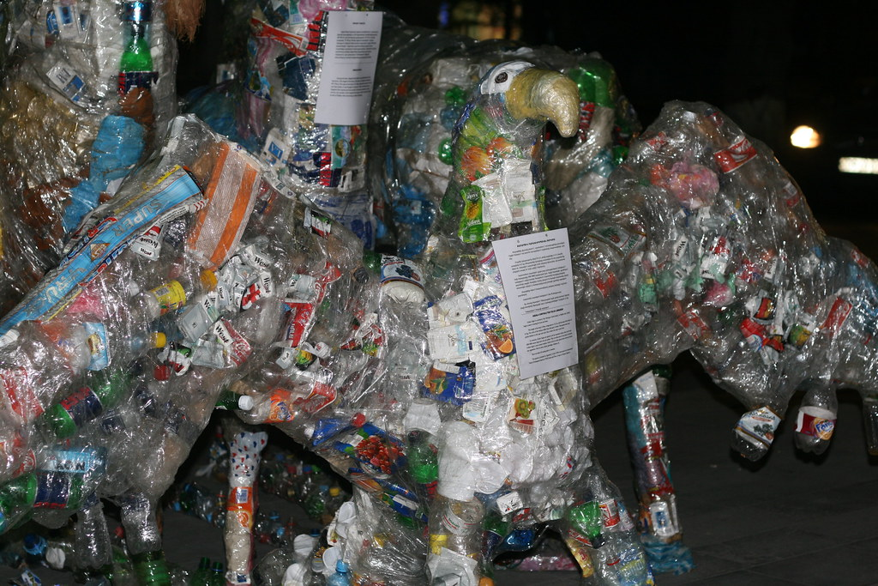
Sculpture gallery

"Sculptures made from plastic junk, Yerevan, Armenia" by Arthur Chapman is licensed under CC BY 2.0.

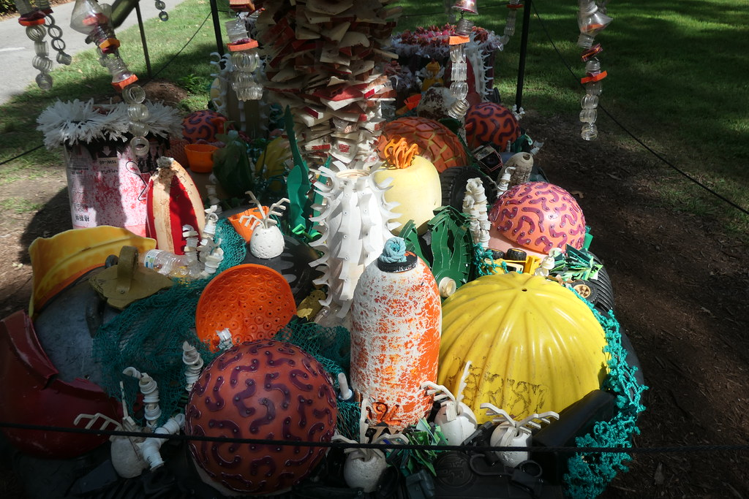
Sculpture gallery

"Washed Ashore - Art to Save the Sea Norfolk Botanical Garden" by MisterQque is marked with Public Domain Mark 1.0.

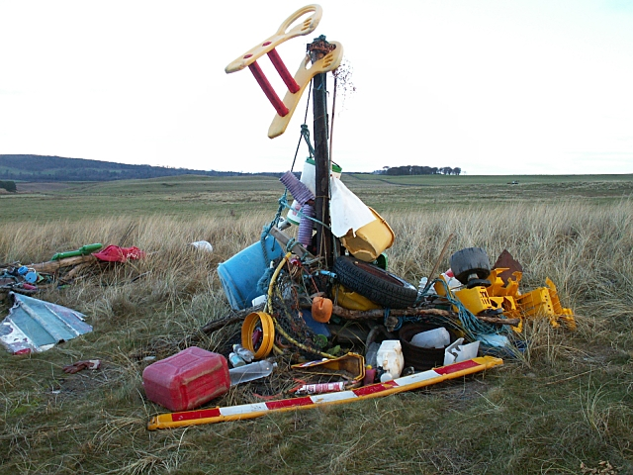
Sculpture gallery

"Rubbish - geograph.org.uk - 168412" by Jim Bain is licensed under CC BY-SA 2.0.

