
Y3

Making sense of changes • Lesson 1 • Melting monsters
Lesson 1
LAUNCH
To read the most recent version of this lesson, download associated resources, and view embedded professional learning including classroom videos and work samples, visit: https://primaryconnections.org.au/teaching-sequences/year-3/making-sense-changes/lesson-1-melting-monsters

Lesson overview
Students make simple monsters from ice cubes, then observe the changes their monsters undergo as the ice changes from solid to liquid. They are introduced to the context of the sequence: creating a sensory experience for other students.

Key learning goals
Students will:
- explore water in its solid/frozen state (ice) and its liquid/melted state (water), and what it looks like in between those states (melting).
- observe sensory experiences that use a variety of solids, liquids, melting and freezing.
Students will represent their understanding as they:
- predict changes that will occur to the ice monster over time.
- draw a labelled diagram of their ice monster.
- contribute to discussions about melting and freezing.

Assessment advice
In the Launch phase, assessment is diagnostic.
Take note of:
- students’ understanding of the terms solid and liquid.
- students’ understanding of the terms melt and freeze.
  - Do they describe the changes that occurred to their ice monsters using descriptions such as ‘hard’ and ‘runny’, or by using terms such as ‘melt’ and ‘freeze’?
- students’ understanding of physical changes.
  - Have they described how adding or removing heat leads to change? Have they been able to predict changes and explain how to reverse the changes?

List of materials
Whole class
- Class science journal (digital or hard-copy)
Each group
- 1-2 ice cubes (prepared at least a day in advance). You may choose to add food colouring to colour the water (if so, take appropriate measures to ensure students’ hands and clothes are not stained as the ice cubes melt) and/or add beads or small solids before freezing. Leave the actual ice cubes in the freezer until they are to be decorated (partway through the first step of the lesson).
- 2 x small solid ‘eyes’ per ice cube (these could be googly eyes, aquarium stones, aluminium foil etc.)
- Other solid materials students might use to decorate their ice-monster, for example: feathers, pipe cleaners, paper and cardboard, fabric.
- Clear container (resealable bags, glass jar or plastic takeaway food container)
- Small resealable bag
- Texta
- Optional: iPad
- A collection of short videos showing sensory experiences, including some related to melting and freezing. See A sensory experience below for included examples.
Each student
- Individual science journal (digital or hard-copy)
- Ice monster Resource sheet (or make their own)

Lesson routine | Estimated time | Task type
Experience & empathise | 25 minutes | Small group/Individual
Elicit and Anchor | 15 minutes | Whole class
Connect | 20 minutes | Whole class

Launch

Experience & empathise • Ice monsters
This activity is best completed over the course of a school day. Working in collaborative teams, students will create ‘ice monsters’ by decorating ice cubes with various solid materials (see List of materials). The ice monsters will then be placed in clear plastic containers and stored around the classroom and students will periodically observe their monsters over the course of the day, until they are completely melted (or as close to as possible).

Before creating the ice monsters
Show students the various materials available for decorating their ice monsters. Teams plan how they will decorate their ice monster/s and each student draws a labelled diagram on their Ice monster Resource sheet. Remind students to include a pair of eyes on their ice-monster so you can ensure that all students have one identical point of reference to compare.
Each team selects a place in the classroom where they will leave their ice monsters for the day, giving a reason for their choice. Each student makes a prediction about the changes they think might happen to the ice monsters over time and why they think that, and records this on their Ice monster Resource sheet.

Creating the ice monsters
Teams collect the required equipment and make/decorate their ice monsters. If their ice cubes contain small solids or food colouring (that were added before freezing), students should add these to their diagrams.
Students make their first observation of their ice monsters by drawing a diagram and writing notes to record what they see, hear, feel and smell, and what, if any, changes they think are happening to it, and why they are happening.
They place their ice monsters in a clear container or resealable bag, label it with their names and place it in their chosen location in the classroom.
Optional: Photograph the ice monsters with iPads, to document their starting state.

Observing the ice monsters
As a class, discuss students’ predictions about how the ice monsters will look in half an hour and at the end of the day, and why they think that. Record their ideas in the class science journal.
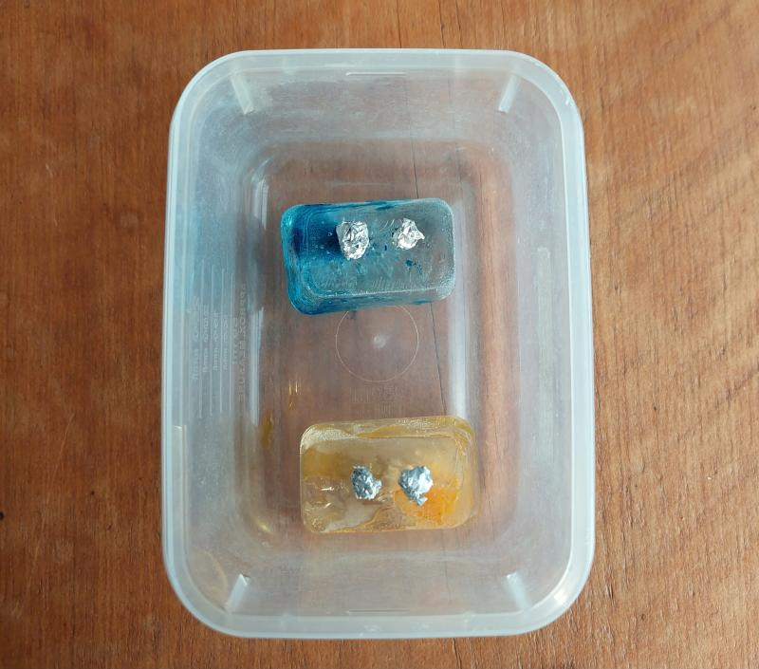
Over the course of the day, students return to make further observations about the changes happening to their ice monsters. Select observation intervals as appropriate for the current context—on a hot day, or in a warm location (e.g. windowsill on a sunny day), the ice monsters will melt more rapidly and intervals between observations will need to be shorter.
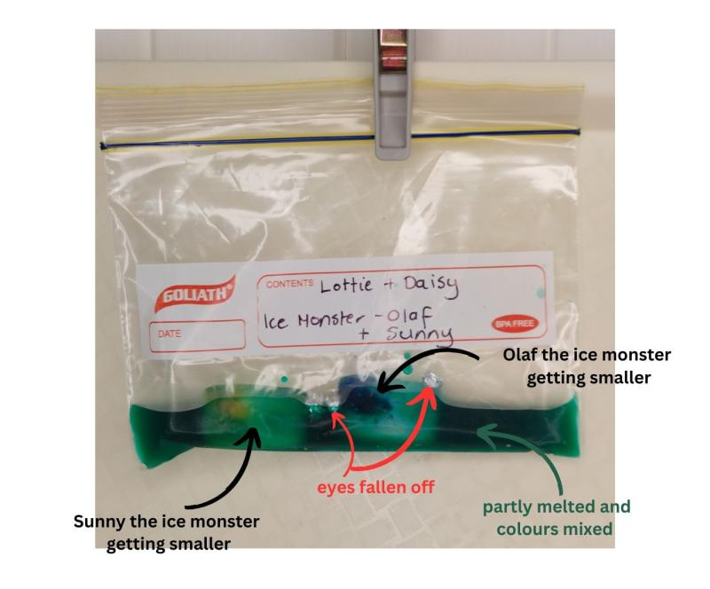
Optional: Undertake an observation walk to allow students to view other teams’ decorated ice monsters and consider their chosen location in the classroom.
Optional: Take photographs of the ice monsters during each observation and create a time-lapse to show the changes that occurred over the course of the day.
Once the ice monsters are fully melted (or have been left for as long as possible), continue by sharing and discussing students’ observations.
Potential discussion prompts
- How would you describe your ice monster when you first created it?
- How did it change across the day?
- How would you describe it at the end of the day?
- Would you describe the different ‘pieces’ of the monster in different ways? For example, how would you describe the body of the monster, compared to its eyes or other decorations?

Elicit and anchor • Everyday melting & freezing
Display the words ‘solid’ and ‘liquid’ and invite students to share their knowledge about them. Record their ideas in the class science journal.
Potential discussion prompts
- Can you give an example of something that is solid? Liquid?
- How would you describe a solid? A liquid?
- When something is solid, how does it feel? Can you describe it in terms of your senses?
- When something is liquid, how does it feel? Can you describe it in terms of your senses?
Display the words ‘melt’ and ‘freeze’ and invite students to share their knowledge about them. Record their ideas in the class science journal.
Potential discussion prompts
- What things have you seen melting/freezing?
- Why do things melt/freeze?
- What is happening when things melt/freeze?
- When do you/don’t you want things to melt/freeze?
- Can everything melt or freeze? Can you give examples and explain why you think that?
- Do you have any questions about melting and freezing?
- When something is melted, or melting, how does it feel? Can you describe it in terms of your senses?
- When something is freezing or frozen, how does it feel? Can you describe it in terms of your senses?

Connect • A sensory experience
Discuss the five primary senses—sight, touch, hearing, sound and taste—and which senses the students used during the ice monster activity. Describe what the senses involve and any vocabulary students know that relate to them, and record these in a table in the class science journal.
Potential discussion prompts
- What are the five main senses that humans have?
- Which senses did you use today? How did you use them?
- How would you describe the senses?
- What parts of the body do each use?
- Can you think of any related vocabulary?
- Why are senses so important to us? To scientists?
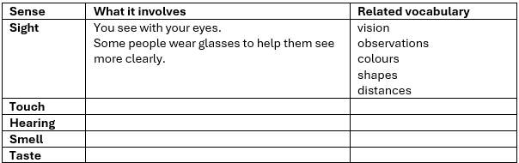
A work sample recording students’ knowledge about the senses.
Ask students to describe what they think or understand a ‘sensory experience’ is, including any they may have taken part in. If necessary, explain what a sensory experience is—an experience where we use multiple different senses to interact with and interpret the environment.
Ask how an ice monster could be part of a sensory experience. What senses would people be using as they observed an ice monster? What would they see, feel, smell etc.?
Using short reels as stimulus, discuss the senses used in each of the following videos and whether the sensory experience would be enjoyable. Some examples include:
- painting yellow curves on canvas (sight, touch)
- ice sensory play (sight, touch, hearing)
- playing at a sand table (sight, touch, hearing)
- bubble wrap (sight, touch, hearing)
- slime (sight, touch, hearing)
- person with flowers (sight, smell, touch)
Explain to students that at the end of the sequence they will design and create a sensory experience that involves a combination of solids, liquids, things that melt etc. Watch some more reels that include these and discuss the senses used in those and if they would be enjoyable.
- Easy hack to melt chocolate without burning it
- Dog eating ice cubes (requires sound)
- Babies first taste of ice cream
- Melting ice cream time lapse
Discuss when it is and isn’t safe to taste items during a science investigation, and determine why it would not be appropriate to include taste as a part of the sensory experience they will be designing.
Optional: Introduce the idea of a sensory table to the students, and invite them to bring along items that provide an interesting sensory experience, such as rice through a funnel, squishy toys, sand.
Note: If there are interesting and relevant questions that lead to a suitable investigation, consider adding it to the sequence.
Place the ice monsters, still inside their resealable bags/containers, into the freezer. The re-frozen ice monsters will be used in the next lesson.
Ask students to share the prediction they made on their Ice monster Resource sheet about what they think will happen when the ice monsters are placed back into the freezer.

Reflect on the lesson
You might:
- begin a class word wall related to solids, liquids, melting, freezing.
- take a walk around the school and collect items to begin a sensory table such as safe solids and liquids including water, leaves, flowers, stones and twigs.

Y3

Making sense of changes • Lesson 2 • Solid or liquid?
Lesson 2
INQUIRE
To read the most recent version of this lesson, download associated resources, and view embedded professional learning including classroom videos and work samples, visit: https://primaryconnections.org.au/teaching-sequences/year-3/making-sense-changes/lesson-2-solid-or-liquid

Lesson overview
Students identify and categorise solids and liquids, observe the similarities and differences between their properties, then sort these properties using a class Venn diagram.

Key learning goals
Students will:
- collect and sort solids and liquids based on observable properties.
Students will represent their understanding as they:
- provide a reason why they think an item is a solid or a liquid.
- contribute to a class Venn diagram of the properties of solids and liquids.

Assessment advice
In this lesson, assessment is formative.
Feedback might focus on:
- the properties that students associate with solids and liquids.
  - Do they recognise the scientific definition of solids, rather than only the use of ‘solid’ as an adjective to denote something as ‘hard’ or ‘large’? Do they recognise all the liquids, including viscous liquids such as honey and oil?
- students’ ability to differentiate between liquids and pourable solids.
  - Do they recognise that pourable solids will mound and require shaking to become level, whereas liquids will level on their own over time?
- students’ recognition that water can be in both solid and liquid states, and it can change from one to the other.

List of materials
Whole class
- Class science journal (digital or hard-copy)
- Solid and liquid search Resource sheet printed and cut into individual pieces. Modify the descriptions to suit your context and the items in your classroom.
- Various solids and liquids placed around the classroom to provide variety during the solid and liquid search, including some items students may find hard to classify as ‘solid’ or ‘liquid’. For example: a jar of honey, a squishy ball, soft toys, cooking oil, sauce, pourable solids such as rice, flour or washing powder.
- Solid and liquid statements Resource sheet printed and cut into individual pieces
- Optional: 2 x hula hoops, ropes or skipping ropes to make the outline of a physical Venn diagram
- Optional: Digital device for taking photos

If undertaking the tests in the Integrate step as a whole class demonstration
- Containers of different shapes and sizes, transparent if possible
- Container of water
- Container/s of a pourable solid, for example small blocks, dried beans, rice, flour, sugar, sand. This solid will be used to demonstrate that pourable solids ‘mound’ when poured, and have to be manipulated to flatten out (unlike liquids). How noticeable this ‘mounding’ is depends on the type of pourable solid used and the size of the tray it is being poured into. Lighter, finer solids (like flour or fine salt/sugar) will mound more quickly in a smaller space and in lesser amounts when poured. Larger, heavier items (like rice) will be needed in larger amounts and will require a larger area before students see a noticeable ‘mound’ when poured. Test the demonstration first so you know how much you will need of the pourable solid you will need.
- 2 x trays to pour the water and pourable solid into
Each group
- Re-frozen ice monsters from the previous lesson
- Optional: coloured water and a variety of additional containers, for students to explore water volume

If undertaking the tests in the Integrate step in collaborative teams
- Containers of different shapes and sizes, transparent if possible
- Container of water
- Container/s of a pourable solid, for example small blocks, dried beans, rice, flour, sugar, sand. This solid will be used to demonstrate that pourable solids ‘mound’ when poured, and have to be manipulated to flatten out (unlike liquids). How noticeable this ‘mounding’ is depends on the type of pourable solid used and the size of the tray it is being poured into. Lighter, finer solids (like flour or fine salt/sugar) will mound more quickly in a smaller space and in lesser amounts when poured. Larger, heavier items (like rice) will be needed in larger amounts and will require a larger area before students see a noticeable ‘mound’ when poured. Test the demonstration first so you know how much you will need of the pourable solid you will need.
- 2 x trays to pour the water and pourable solid into
Each student
- Individual science journals (digital or hard-copy)

Lesson routine | Estimated time | Task type
Re-orient | 10 minutes | Whole class
Question | 10 minutes | Whole class
Investigate | 20 minutes | Whole class/Small group
Integrate | 20 minutes | Whole class

Inquire

Re-orient
Redistribute ice monsters back to students now that they have been re-frozen.
Discuss how the ice monsters have changed, and if the predictions students made at the end of the previous lesson were accurate.
Potential discussion prompts
- Do the ice monsters look the same or different from how they looked when you saw them last? How?
- How has the shape of them changed?
- Why did that happen?
- What could you say about the ‘shape’ of water as a result?
- Is this what we predicted would happen at the end of last lesson?

Question • Solid to liquid
Revise students’ ideas collected last lesson about the terms solid and liquid.
Ask students: How might you describe the difference between solids and liquids to an alien?
Jointly construct a definition of each term, prompting students to include mention of the ‘shape’. These definitions will be built upon as the sequence progresses.
Pose the question: What in this room is solid, and what in this room is liquid?

Investigate • Classifying things around us
Distribute the descriptions on the Solid and liquid search Resource sheet between pairs of students. Students work together to undertake a search around the classroom to find an object or objects that match their description.
After students have located their items, build a class Venn diagram with one circle representing solids, one representing liquids, and with the overlapping section for items students think might be both. You can build the Venn diagram in a few different ways:
- draw two overlapping circles in the class science journal and write the names of items students believe belong in each section.
- take photographs of items and build a digital Venn diagram.
- build a physical representation by placing two hula hoops on the ground, or make large circles using ropes. Place items in the relevant sections.
Each team presents their item/s, explains how/why it fits the descriptive word or phrase and where they would place it in the Venn diagram.
After all items have been added to the Venn diagram, discuss if students would move any of the items around, and why.
Finally, ask students where they would place the ice monster in the Venn diagram and why. Ask if they think it might belong in different parts of the diagram at different times.
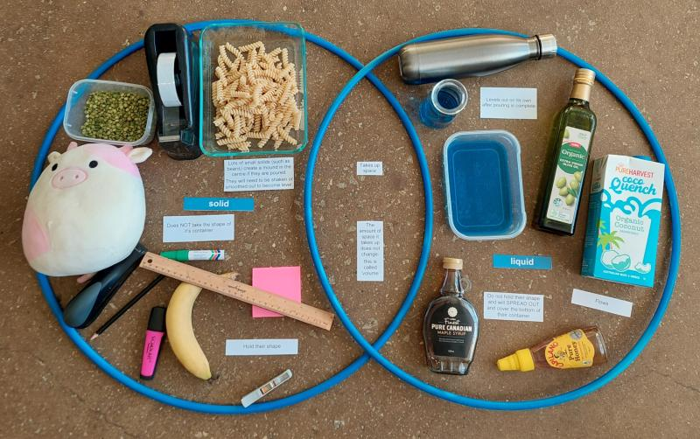
Work sample of a physical Venn diagram constructed inside hula-hoops.

Integrate • Sorting it out
In this Integrate step, guide students to link their experiences in the investigation to the science concept being explored—in this instance, the observable properties of solid and liquids.
Through demonstration, exploration and discussion, students should come to a consensus that:
- solids maintain their shape when placed in different containers.
- liquids take the shape of the container they are in.
- some solids can ‘flow’ like a liquid, but are still solids, just very small.
- you can tell the difference between these because liquids automatically spread out and flatten, whereas solids create a ‘mound’ when poured.
Read and discuss the following statements, found on the Solid or liquid statements? Resource sheet. As a class, decide if each statement best describes things that are solid, things that are liquid, or if it could describe both. Add the statement to the appropriate section of the Venn diagram.
- Do not change their shape easily.
- Do not take the shape of the container they’re in.
- Take up space.
- Flow.
- Change their shape easily and will take the shape of the container they’re in.
Leave the following two statements aside for now:
- Level out on their own after being poured.
- Lots of small solids create a mound when they are poured. They will need to be shaken or smoothed out to become level.
Carry out the following two tests, which explore the difference between liquids and pourable solids, as a class demonstration. Alternatively students working in collaborative teams can be provided with the necessary materials to experience pouring liquids and pourable solids between containers, stopping at opportune intervals to discuss what students have observed.

Test 1: Liquids
Test the statement Liquids change their shape easily and will take the shape of the container they are in by pouring a set amount of water between containers of different sizes and shapes and asking students to describe what they observe. Discuss how the shape of the liquid changes to suit the width and height of the container.
Pour the water back into its original container and discuss how the volume of water has remained the same, even though it looks different in all the containers.
Examine the statement above to see if students agree that liquids change shape and are the shape of the container they're in.

Test 2: Pourable solids
Compare the liquid you were just observing with a pourable solid (without introducing the term ‘pourable solid’ yet).
Discuss what students observe about the new substance, and whether they think it is a liquid or a solid and why. You might refer them to the statements about liquids to support them, asking questions such as Do you think this substance will flow/pour?, Will it change shape easily? and Will it take the shape of the container it’s poured into (like the liquids did)?
Ask students to predict what will happen when the water and the new substance are poured from their containers and into a tray, both in terms of how smoothly they will ‘move’ and how they might settle when they hit the bottom of the tray.
One at a time, pour the water and new substance into the trays and make observations.
Through discussion, determine that the liquid settled flat on its own when poured into the tray, whereas the other substance created a mound when poured. Demonstrate how the new substance will ‘flatten’ out only after the tray is shaken, or hands are used to move it around.
Revisit students’ opinions on whether they thought this substance was a liquid or a solid, and if the demonstration has changed or confirmed their thinking.
Introduce the term ‘pourable solids’ and confirm that the substance is actually made up of tiny solids. Although it might act a bit like a liquid because the solids are so small it can be poured, and may change its shape easily, it is still considered a solid.
Ask students to name other things that would be considered pourable solids and write a list of these in the class science journal. For example: salt, sugar, sand, washing powder, rice, dried beans/lentils, flour. This list can be added to as the sequence progresses if students come across new pourable solids.
Optional: Demonstrate using different-sized pourable solids to compare how size may impact the appearance of ‘flow’, and how bigger pourable solids won’t actually take up all the space in the container they are poured into, so can't really be considered as ‘changing shape’. You might use flour, sugar, salt, lentils, rice, dried beans, MAB cubes etc. If needed demonstrate pouring the small solids multiple times, to show students how they don't ‘flow’ as freely as the liquid.
After demonstrating these two tests, or allowing teams time to observe and discuss the differences between liquids and pourable solids, read the two statements held aside earlier. Determine which statement is describing a solid and which is describing a liquid, and add them to the Venn diagram.
Return to the definitions of solid and liquid constructed at the beginning of the lesson and ask students if they want to amend or add to the definitions based on what they have done and seen in the lesson.
If you have made a physical Venn diagram, photograph it for the word wall or class science journal.
Using a think, pair, share strategy, ask students to consider how they could use solids and liquids to create a sensory experience. Record ideas in the class science journal. Some prompts you might use to stimulate their thinking include:
- Would shaking a container of rice sound different from shaking a container of flour?
- How would flour and rice feel different between your fingers?
- What about dishwashing liquid and honey?
- Would they have a smell?
- What experiences could you design that would be interesting to the senses?
Re-collect ice monsters in bags/jars, as you will need some samples of them again in Lessons 3 and/or 4. Store them at room temperature.

Reflect on the lesson
You might:
- add to the class word wall any vocabulary related to the properties of solids and liquids.
- discuss the ice monsters further. At what points were they solid or liquid? How do we know? What liquid properties of the melted ice monster did we observe? What solid properties did we observe?
- discuss how students were thinking and working like scientists during the lesson, making detailed observations about the items, and classifying them according to those observations.
- revisit the words ‘melt’ and ‘freeze’ in the class science journal from Lesson 1 in the Launch phase, and make additions using a different colour pen/texta.

Y3

Making sense of changes • Lesson 3 • Racing liquids
Lesson 3
INQUIRE
To read the most recent version of this lesson, download associated resources, and view embedded professional learning including classroom videos and work samples, visit: https://primaryconnections.org.au/teaching-sequences/year-3/making-sense-changes/lesson-3-racing-liquids

Lesson overview
Students make predictions and observe how a liquid’s viscosity affects how fast or slow it runs before and after adding heat.

Key learning goals
Students will:
- observe and compare the viscosity of a variety of liquids.
- add or remove heat to/from the liquids and measure the change in viscosity.
Students will represent their understanding as they:
- predict, with reasoning, which liquid will flow the fastest or slowest.
- record their observations and explanations.
- discuss liquids of different viscosity and how adding and removing heat changes the viscosity.

Assessment advice
In this lesson, assessment is formative.
Feedback might focus on:
- students’ reasoning for their liquid race predictions. Did they predict that the less viscous liquids would flow more easily and faster?
- students’ explanation for the race results. Did students recognise that the added/removed heat changed the viscosity of the liquids and affected race times?
- students’ predictions for the liquids prepared for cooling. Do students predict that the liquids will become more viscous or solid by placing them in the fridge/freezer?

List of materials
Whole class
- Class science journal (digital or hard-copy)
- Liquid samples with different viscosities, for both demonstration and racing. For example water, honey, washing up liquid, oil, cordial, shampoo/conditioner, tomato sauce.
- Large flat tray or book to create a slope

- 3 x sheets of greaseproof paper (the race sheets), approximately the length of the book or tray above, each marked identically with:
  - a Start and Finish line.
  - the distance between the Start and Finish line.
- Texta
- Ruler
- A means of attaching the race sheets securely to the slope, for example pegs, clips, blu-tac, sticky tape
- Demonstration copy of The great race Resource sheet
- Devices for recording video and taking photos
- Stop watch or timing device
- A method for warming liquid samples, e.g. a warm water bath, heat bag or hot water bottle. Microwaves are not recommended as they can cook the liquid, or give the perception of cooking the liquid.
- A method for cooling liquid samples, e.g. an ice bath or ice brick
- Optional: Small containers such as patty pans or pie trays to place small amounts of liquids in for warming and cooling (number of containers needed will depend on the number of liquids tested)
- Optional: Video What is viscosity? (1:29)
Each student
- Individual science journal (digital or hard-copy)
- The great race Resource sheet

Lesson routine | Estimated time | Task type
Re-orient | 5 minutes | Whole class
Question | 10 minutes | Whole class
Investigate | 25 minutes | Small group/Individual
Integrate | Variable | Whole class/Small group

Inquire

Re-orient
Use the class science journal to review what was learned and discussed about liquids in the previous lesson.

Question • Fast or slow?
Look at some samples of liquids viewed in the last lesson, and some that will be used in the upcoming investigation.
Discuss how easily the liquids ‘flow’, and demonstrate by shaking them in their container or pouring/squeezing some out. Ask students if they think some liquids flow more easily than others and why or why not.
Pose the question: Which liquid will flow the fastest, and which will flow the slowest?

Investigate • The great race
In this step, students will compare the viscosity of different liquids by racing them down a slope. They will compare the ‘flow’ of the liquids before and after heating and cooling.
Explain that a blob of each liquid will be placed along one end of a tray. Then the tray will be raised to create a slope, to see which liquid will flow down the slope the fastest.
Discuss the meaning of the term ‘room temperature’—the liquid is the same temperature as the room—and how students can be sure that all the liquids are at room temperature.
Using the Race 1: Room temperature race row on their The great race Resource sheet, students Predict which liquid they think will flow the fastest and which will flow the slowest, and give a Reason for that.
Set up the race, following the steps below.
- Nominate a student to video the race so it can be re-watched at a later stage.
- Nominate a student/s to time the race using a stop-watch or timing device.
- Attach a sheet of greaseproof paper (the race sheet) to a large flat surface such as a tray, large book or tub using pegs, blu-tac etc. The race sheet should already be marked with:
  - a Start and Finish line.
  - the distance between the Start and Finish line.
- Place a blob of each type of liquid on the starting line. Try to ensure that each blob is the same size.
  - Optional: Discuss why using the same amount of liquid in each blob is important to keep the test fair.
- Raise one end of the tray/book/tub to a set height to create a slope, for example by propping it on some books.
- As soon as the end is raised, begin timing how long it takes each liquid to cross the finish line.
- Students who are timing should announce the time it took each liquid to cross the finish line.
- Record the results.
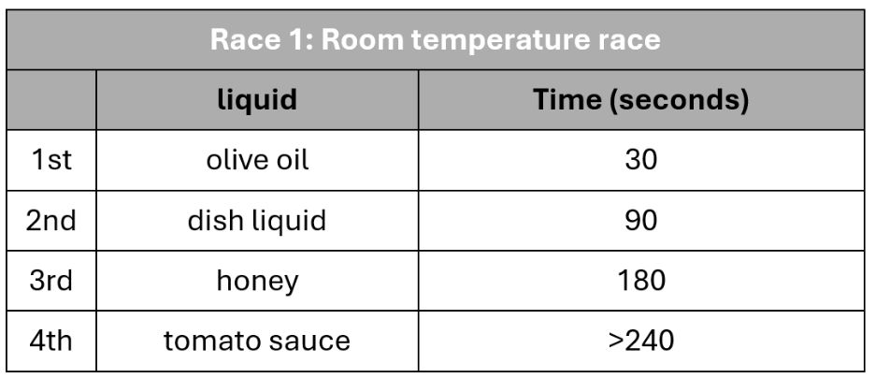
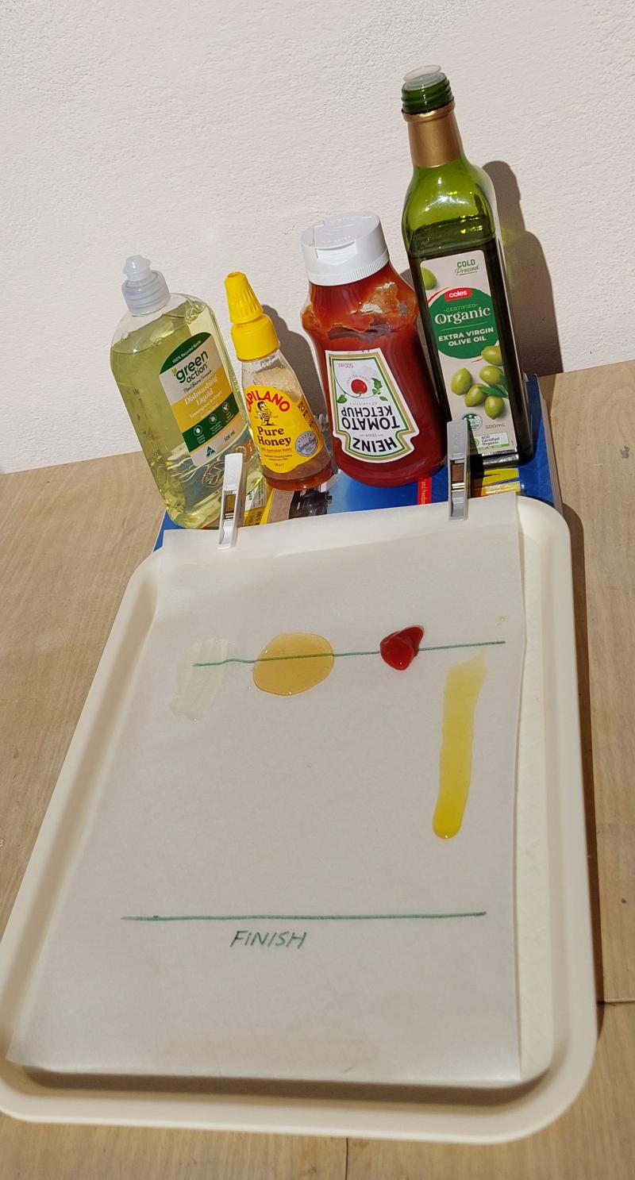
On The great race Resource sheet, students record their observations, determine if their predictions were correct, and Explain what they think happened by comparing the ‘flow’ of each liquid (which finished first, which last, and was it what they expected).
Explain to students that you are going to complete the race two more times, using the same liquids, but in one race the liquids will be heated so they are above room temperature and in the other they will be cooled so they are below room temperature. Discuss what students think about how changing the temperature of the liquids might affect their 'flow'.
Students write their predictions on The great race Resource sheet for Race 2: Warmed up race and Race 3: Cooled down race.
Heat one set of liquid samples to above room temperature using a warm water bath or other method. Cool another set of samples to below room temperature by placing them in a refrigerator, ice-bath, or similar.
Follow the race steps outlined above for the heated and cooled liquids, with students recording their observations and explanations in the appropriate sections on The great race Resource sheet.

Integrate • Race analysis
In this Integrate step, guide students to link their experiences in the investigation to the science concept being explored—in this instance, the observable properties of liquids and how adding or removing heat can change their properties.
Through questioning and discussion, students should come to a consensus that:
- some liquids flow more easily than others.
- adding or removing heat can affect how easily a liquid flows.
- this is called viscosity.
Discuss the race results, how each liquid ‘flows’, and if heating and cooling the liquids changed the race times or the order they crossed the finish line.
Potential discussion prompts
- Why did liquid X cross the finish line first?
- Why did liquid Y cross the finish line last?
- Did the liquids flow faster and finish quicker when we added heat? Removed heat? Why do you think that happened?
- What do you think would happen if we added more heat to the liquids or made them hotter or colder? Would it make them flow faster or slower?
Introduce the term ‘viscosity’, in relation to liquids: how much a liquid resists flowing.
Determine which liquids were viscous/not viscous, and jointly construct sentences using the data collected as evidence. Record these sentences in the class science journal. For example:
- Honey is considered viscous because it doesn’t flow easily. It flowed slowly, taking 180 seconds to cross the finish line.
- Water is not viscous because it flowed easily, crossing the finish line in just a few seconds.
Discuss whether heating or cooling changed the viscosity of the liquids.
Optional: View the video What is viscosity? (1:29).
Using the think-pair-share strategy, students consider how they might use what they have learned about viscosity, heating and cooling liquids in the sensory experience they design. Record ideas in the class science journal. Some examples to prompt thinking might include:
- How might tomato sauce in an ice bath feel different/flow differently from tomato sauce in a warm water bath?
- What could we pour quickly between our hands, and what might pour slowly?
- How would different liquids feel if we pushed our hands into them? Would the feeling change if they were heated or cooled?
- How could we use what we’ve learned to create a sensory experience?

Reflect on the lesson
You might:
- add to the class word wall any vocabulary related to liquids, viscosity, and how adding heat changed the viscosity of the liquids, for example, viscous, thick, sticky, syrupy, runny, thin, pourable, adding heat, removing heat.
- re-examine the intended learning goals for the lesson and consider how they were achieved.
- construct a joint explanation about viscosity, including examples of the liquids explored in the lesson.
- write a list of other liquids whose viscosity students would like to test.

Y3

Making sense of changes • Lesson 4 • Cool liquids
Lesson 4
INQUIRE
To read the most recent version of this lesson, download associated resources, and view embedded professional learning including classroom videos and work samples, visit: https://primaryconnections.org.au/teaching-sequences/year-3/making-sense-changes/lesson-4-cool-liquids

Lesson overview
Students further observe the changes that different liquids undergo when heat is removed, and consider the melting/freezing point of different substances.

Key learning goals
Students will:
- observe and compare the effect of removing heat from different liquids.
- consolidate their understanding of materials as solids and liquids at different temperatures.
Students will represent their understanding as they:
- describe properties of a variety of liquids at room, fridge and freezer temperatures.
- discuss and contribute to a class summary table showing if materials are solid or liquid at freezer/fridge/room/warmer temperatures.
- discuss how different materials are recycled by melting at different temperatures.

Assessment advice
In this lesson, assessment is formative.
Feedback might focus on:
- the freezing/melting point of solids and liquids. Do students recognise that different materials freeze/melt at different temperatures?
- changing states from solid to liquid and back again. Do students identify adding and removing heat as the reason for materials changing from solid to liquid and vice versa?
- identifying solutions that use scientific explanations. Can students transfer their knowledge of melting to predict with fair reasoning, materials that are recyclable?
  - Students are not expected to know that paper/wood products combust and cannot be melted.

List of materials
Whole class
- Small resealable bags
- Scales
- Optional: Multiple sets of scales, included at each station set up for liquids being explored, or at easily accessible locations in the classroom.
- Markers
- A variety of liquids, for example water, oil, tomato sauce, honey, shampoo/conditioner, washing up liquid, prepared at least 24 hours before the lesson as follows:
  - Create 3 samples of each liquid by placing small amounts (preferably the same amount, for example 25mls or as close to as possible) into resealable bags.
  - One at a time, place a resealable bag on a scale, zero the scale, and place a small amount of the liquid into the bag.
  - Label each bag with the liquid’s name, weight, and where it will be stored—one sample in the freezer, one in the fridge, and one at room temperature.
  - Gather samples of students’ ice monsters to be placed with the fridge, freezer and room temperature samples. Label where each will be stored.
  - Optional: Gather 3 x small bottles of alcohol-based hand sanitiser. Label one fridge, one freezer and one room temperature.
  - Place the samples in their labelled location—either the fridge, the freezer, or somewhere where they will remain at room temperature.
  - Note: You could involve students in organising these samples prior to the lesson commencing, and with enough time to ensure they will freeze.
- Class science journal (individual or hard-copy)
- Demonstration copy of the Cool liquid observations Resource sheet (or make your own)
- 1 x copy of the Cool liquid observations Resource sheet (or make your own) for each liquid you have prepared samples for
- Optional: Video The Story of Aluminium Recycling (2:05)
- Optional: Video The Smashing Story of recycling Glass (2:15)
Each student
- Individual science journal (digital or hard copy)

Lesson routine | Estimated time | Task type
Re-orient | 5 minutes | Whole class
Question | Variable | Whole class
Investigate | 20 minutes | Whole class/Small group
Integrate | 15 minutes | Whole class

Inquire

Re-orient
Review if/how adding and removing heat energy to the samples of liquids in the previous lesson affected their viscosity.

Question • Freezing liquid
Discuss the process of removing heat from liquids.
Potential discussion prompts
- How did we remove the heat from the liquids last lesson?
- What are some other ways you might remove heat from a liquid?
- How did removing heat affect the viscosity of the liquids?
- Would you consider any of the liquids frozen? Why or why not?
- How do you freeze a liquid?
Pose the questions: Do all liquids freeze the same way? Do all frozen liquids look and feel the same? Do all liquids at fridge temperature look and feel the same?

Investigate • Observing liquids
Set up stations around the room where teams can make observations about the liquid samples prepared for this lesson at their three different temperatures.
At each station, place:
- three samples of the same liquid at different temperatures, in their clearly labelled bags.
- 1 copy of Cool liquid observations Resource sheet, or butchers’ paper with columns labelled ‘room temperature,’ ‘fridge,’ and ‘freezer’. The observation sheet should be labelled with the name of the liquid at the station.
- textas/pens.
- Optional: a scale to weigh each sample
Note: If you prepared bottles of hand sanitiser as part of the lesson preparation, do not include the hand sanitiser as a station. This sample should be handled by the teacher and used for demonstration only.
As a class list all of the liquids that will be examined in this lesson. Ask students to make predictions about what changes the liquid might have undergone in the fridge or freezer. Record students’ ideas in the class science journal.
Potential discussion prompts
- Do you think all these liquids will be frozen after being in the freezer? Why or why not?
- Will they be more viscous? Why or why not?
- If you think that one won't freeze, what do you think the freezer will do to it?
- What experiences have you had that make you think this?
Using a demonstration copy of the Cool liquid observations Resource sheet (or on a table drawn up in the class science journal), model and discuss how students might make observations of each liquid. If scales are available for student use, the alternative conception of a substance changing when it freezes can be addressed by weighing each liquid in the three forms and recording the weight. Note that the weight of the resealable bag will need to be excluded, so students will need to zero the scale with a ‘control’ bag before weighing each sample.

If you have prepared samples of hand-sanitiser stored in the freezer, fridge, and at room temperature, use this as your demonstration. If not, then use the samples of any other liquid at a station. Look at each different temperature sample individually and record words, phrases and images to describe it.
Allow teams time to move around the room, looking at the samples at each station and adding their observations to the chart. If a team has visited that station before and already added something to the sheet that they agree with, they can place a tick next to the statement to indicate their agreement.
Ensure teams have visited each station to observe each liquid at its three different temperatures.

Integrate • Bringing it together
In this Integrate step, guide students to link their experiences in the investigation to the science concept being explored—in this instance, the observable properties of liquids and how adding or removing heat can change these properties.
Through questioning and discussion, students should come to a consensus that:
- removing heat from a liquid can lead to a change in its properties, and also to a change of state.
- some liquids don’t become solids when you put them in the freezer.
- adding or removing heat can affect how easily a liquid flows.
- if you add a lot of heat to some solids they will become liquids.
- adding or removing heat for a change in state does not change the amount of a substance present.
Review the charts created at each liquid’s station, discussing students’ observations about each liquid at its three different temperatures.
Potential discussion prompts
- Did what you predicted would happen to the sample happen?
  - If you thought something would freeze, did it?
  - If you thought something would stay a liquid, did it?
- Did what happened to any of the samples surprise you? How and why?
- Did you notice any samples where there was almost no change at all compared to the room temperature sample after they’d been in the freezer and fridge?
- What did you notice about the weight of a substance before and after it was in the freezer?
Create a class summary table to show how liquids and solids have different properties at different temperatures. For example:
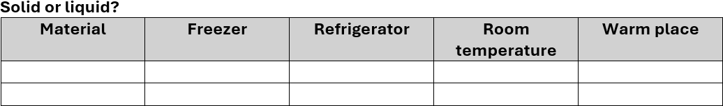 Add data to the Warm place column by recalling what happened to the liquids that were warmed up for race testing in the previous lesson.
If using hand sanitiser, note that it is flammable and may contain substances that are dangerous if inhaled, and that it should never be left in a location where it can become warm, nor should it be intentionally heated. If appropriate, explain that this is because of the alcohol component of the sanitiser, and that this is also the same reason why it won't freeze.
Weigh the samples, comparing them to their original weights, and discuss how the weight did not change regardless of their change of state.
Specifically discuss how much heat was removed from each sample, and how they changed as a result.
Potential discussion prompts
- How did we remove the heat from the liquids?
  - We put them in the fridge and freezer.
- Does one method remove more heat than the other? How do you know?
  - Putting them in the freezer removed more heat than putting them in the fridge.
  - The samples from the freezer (average -18°C) felt colder than the ones from the fridge (average 4°C).
  - The samples from the freezer were frozen and had become solids. This only happens in the freezer.
- Where do you think the heat went? Why do you think that?
- Do you think the hand sanitiser would freeze if it were left in the freezer for longer? What about the (cooking) oil?
Add the names of some things students would typically think of as solids, but that liquefy under high heat, for example, chocolate, plastic, glass, or metal. Ask students how they would classify these items at the different temperatures named on the table, and to predict what might happen to them if they were exposed to very high temperatures.
Use the think-pair-share strategy for students to consider how they could use what they have learned about turning solids into liquids as part of the sensory experience they design. Some prompts to stimulate their thinking might include:
- How would it feel to have something melting in your hand?
- What would be the difference between holding an ice chip in your hand as compared to an ice cube? Why do you think that?
- Would it be safe to hold a big piece of ice for a long time, or put your hands into an ice bath? Why?
- How would the feel of something change as it melted?
- How could you make watching something melt visually interesting?
Optional: View the video The Story of Aluminium Recycling (2:05).
Students could predict other items in their recycling bin that require the addition of heat during the recycling process.
Optional: View the video The Smashing Story of recycling Glass (2:15).

Y3

Making sense of changes • Lesson 5 • Breaking up with chocolate
Lesson 5
INQUIRE
To read the most recent version of this lesson, download associated resources, and view embedded professional learning including classroom videos and work samples, visit: https://primaryconnections.org.au/teaching-sequences/year-3/making-sense-changes/lesson-5-breaking-chocolate

Lesson overview
Students are supported to plan and conduct an investigation on the way specific variables affect the melting rate of chocolate.

Key learning goals
Students will:
- work in teams to investigate the way specific variables affect the melting rate of chocolate.
- identify variables to change and keep the same in an investigation.
Students will represent their understanding as they:
- draw labelled diagrams to record their observations.
- present investigation results in a column graph.
- make claims based on evidence about their results.

Assessment advice
In this lesson, assessment is formative.
Feedback might focus on:
- students’ fair-testing methods. With assistance, do they recognise the importance of changing only one variable and are they measuring and recording data accurately?
- students’ explanation of results. Do they use simple data to explain their findings?

List of materials
Whole class
- Class science journal (digital or hard-copy)
- Demonstration copy of the Variables grid Resource sheet
- Demonstration copy of the Melting investigation planner Resource sheet
- Timing device (e.g. clock, stopwatch or iPad/phone with timer)
- Heat source such as a heat pack, hairdryer, or using the sun
Each group
- Chocolate (or other substance) for melting
- 2 resealable bags or paper plates to hold the chocolate
- Texta/pen
Each student
- Individual science journal (digital or hard-copy)
- Melting investigation planner Resource sheet

Lesson routine | Estimated time | Task type
Re-orient | 5 minutes | Whole class
Question | 5 minutes | Whole class
Investigate | 25 minutes | Whole class/Small group
Integrate | 20 minutes | Whole class/Small group

Inquire

Re-orient
Review students’ predictions made in the previous lesson as to what might happen to materials such as metal, glass, plastic and chocolate when they are exposed to high temperatures.
Relating it to the discussion about testing hand sanitiser, discuss if it is possible and safe to test all of these substances in the classroom, and why or why not.

Question • To melt or not to melt?
Show students a piece of chocolate and ask them if they think it will melt, and how they might go about melting it.
Pose the broad question: What things might affect the time it takes for chocolate to melt?

Investigate • Melting investigation
Using the think-pair-share strategy, students brainstorm possible variables that will affect the melting time of chocolate.
Record these using the demonstration copy of the Variables grid Resource sheet, marking the measurable variable—the time it takes for chocolate to melt—in the centre of the grid with a bold M, and recording the other variables around it. You can add or remove columns/rows as required.
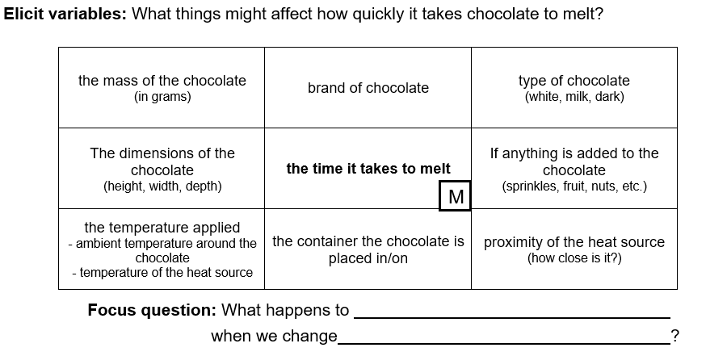 Determine which variable the students will test and write an investigable question using the question stem on the Variable grid Resource sheet.
For example, if you decide to change the dimensions of the chocolate, your investigable question might be What happens to the time it takes chocolate to melt when we change the dimensions of the piece of chocolate? (e.g. a full piece versus a broken-up piece). Alternatively, you might change the heat source itself, making your investigable question What happens to the time it takes chocolate to melt when we change the heat source used to melt it? (e.g. the sun versus a warm water bath).
If your students are not very experienced in carrying out fair tests, you might plan for all teams to change the same variable and carry out the same investigation. You could plan the investigation as a class using a demonstration copy of the Melting investigation planner Resource sheet. If your students are more experienced with fair testing you might allow them to select their own variable and plan the investigation themselves using their own copy of the Melting investigation planner Resource sheet.
During the planning of the investigation, determine how the time will be measured, and the most appropriate device and units to use. For example, the chocolate is unlikely to melt in seconds, so measuring in seconds using a stop watch would not be the best choice. The chocolate may take minutes or hours to melt, so a clock or timer might be more appropriate. Also determine how results will be recorded and displayed. A data table and column graph are included on the Melting investigation planner Resource sheet, however these can be modified for your students' needs.
Optional: Discuss fair-testing principles and why they are important.
In collaborative teams students plan and carry out their investigations, recording their results using the Melting investigation planner Resource sheet.

Investigate • Discussing result
In this Integrate step, guide students to link their experiences in the investigation to the science concept being explored—in this instance, that adding heat to some solids can cause them to become liquids.
Through questioning and discussion, students should come to a consensus that:
- adding heat to some solids can change their properties.
- if we add a lot of heat to some solids they will change state and become a liquid.
- not all solids can become liquids, even when you add a lot of heat.
Teams share their investigation data with the class.
Potential discussion prompts
- Which pieces melted most quickly/least quickly?
- What did you notice about the times that it took the chocolate to melt?
  - The faster it takes to melt, the less time will be recorded.
- What was different about the chocolate that melted fastest/slowest?
- What is happening when material melts?
- Where is the heat coming from?
- How does heat get into the chocolate?
- How do you know when the chocolate has completely melted?
Ask each team to make a claim to answer their original investigable question.
For example, if the original investigable question was What happens to the time it takes chocolate to melt when we change the dimensions of the piece of chocolate?, students should make a claim as to which sized pieces of chocolate melted first. If their original question was What happens to the time it takes chocolate to melt when we change the heat source used to melt it?, they should make a claim about which heat source melted the chocolate in the least amount of time.
Discuss students’ claims and consider the reason why they think they got the results they did. For example, if they tested smaller pieces of chocolate they might determine that their smaller sizes allowed heat to get into them more easily, or if they tested using different heat sources they might determine that one source was warmer than the other.
Discuss if students think that all solids can be changed from a solid to a liquid, and why they think that. You might focus on specific items in the classroom for discussion. Determine that not all solids can become liquids, even if you add a lot of heat. Instead, they might burn and become ash.
Review the investigation as a class and record students’ answers in the class science journal.
Potential discussion prompts
- What went well with our investigation?
- What didn’t go well? How could we have done it better?
- What ideas do you have for another investigation about the melting or freezing of materials?
Students draw a labelled diagram with an arrow to represent the transfer of heat from the heat source to the chocolate. They compare this to their original representation of the ice-monster melting created in Lesson 2, and make any changes or additions to that drawing in a different coloured pen/pencil.
Discuss with students how they might incorporate ideas about melting into their sensory experience and record their ideas in the class science journal.

Reflect on the lesson
You might:
- add to the class word wall any vocabulary related to melting rates and heat transfer.
- re-examine the intended learning goals for the lesson and consider how they were achieved.
- discuss how students were thinking and working like scientists during the lesson. Focus on fair tests, data collection, graphing or discussing results to interpret meaning.

Y3

Making sense of changes • Lesson 6 • Mystery matter
Lesson 6
INQUIRE
To read the most recent version of this lesson, download associated resources, and view embedded professional learning including classroom videos and work samples, visit: https://primaryconnections.org.au/teaching-sequences/year-3/making-sense-changes/lesson-6-mystery-matter

Lesson overview
Students generate questions to investigate whether a mystery substance is a solid or a liquid, and make a claim using evidence from their observations. They observe changing states during the candy making process.

Key learning goals
Students will:
- generate and investigate questions to decide whether the mystery substance is a solid or liquid.
- investigate and observe the mystery substance and use the findings as evidence to make a claim about whether it is a solid or a liquid.
- explore how candy changes states from liquid to solid during production, and at times it can be difficult to categorise.
Students will represent their understanding as they:
- pose questions to differentiate solids from liquids.
- write and draw observations.
- support their claim with evidence from their investigations.
- discuss changes that occur during the candy making process from liquid to solid, and recognise that sometimes candy has properties of both.

Assessment advice
In this lesson, assessment is summative.
Students working at the achievement standard should have:
- identified solids and liquids and named the properties of each.
- identified that solids and liquids can change states by adding/removing heat.
They might also have:
- communicated their science understanding effectively by generating reasonable questions and a claim with evidence to differentiate between solids and liquids.
Refer to the Australian Curriculum content links on the Our design decisions tab for further information.

List of materials
Whole class
- Class science journal (digital or hard-copy)
- A mystery substance, contained within a box, which is able to be divided into smaller pieces. Select a substance that has some of the properties of a solid and some of the properties of a liquid, for example: modelling clay, sponges, oobleck, or a pourable solid such as sugar, flour, washing powder. See the embedded professional learning on Adapting to your context—Mystery substances below for further guidance on selecting your substance.
- Video: How hard candy is made (13:21)
- Optional: Some hard candy to share with the class (be aware of potential food allergies)
- Optional: A second mystery substance to compare to the first
Each group
- What is the mystery stuff? Resource sheet
- A small amount of mystery substance
- 2 clear cups or jars to attempt to pour the substance and to observe whether it levels out on its own
Each student
- Individual science journal (digital or hard-copy)

Lesson routine | Estimated time | Task type
Re-orient | 10 minutes | Whole class
Question | 5 minutes | Whole class
Investigate | 20 minutes | Whole class/Small group
Integrate | 20 minutes | Whole class

Inquire

Re-orient
Use the class science journal to recall the properties, determined over the course of the sequence, that make a material a solid or a liquid. You might review:
- students’ original ideas recorded in Lesson 1.
- the Venn diagram created in Lesson 2.
- how liquids can change viscosity by adding/removing heat, as explored in Lesson 3.
- how many liquids freeze and turn into solids when enough heat is removed, as explored in Lesson 4.
- how some solids melt and turn into liquids when enough heat is added, as explored in Lesson 5.

Question • Solid or liquid?
Show students a box containing a mystery substance and explain that their task is to investigate to find out if it is a substance is a solid or a liquid.
Pose the question: What investigations might we carry out to determine if this substance is a solid or a liquid?

Investigate • Generating questions and testing
In collaborative teams students brainstorm as many questions as they can think of that might help them determine if the mystery substance is a solid or a liquid. If required, prompt their thinking with some examples such as:
- Does it hold its shape?
- Can it change shape?
- Does it pour?
Record the teams’ questions in a table. Discuss and record how each question might be tested, and how useful and reliable the answer might be.
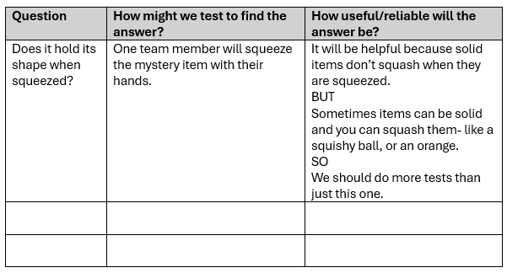
A sample table recording testing ideas and reliability.
Give each team a sample of the mystery substance and ask them to carry out their testing ideas and record the results in a table.
You might design an appropriate data table together as a class, or allow students to design their own.

Integrate • What is it?
In this Integrate step, guide students to link their experiences in the investigation to the science concept being explored—in this instance, that solids and liquids have observable properties.
Through questioning and discussion, students should come to a consensus that:
- objects classified as solids are able to maintain their shape and volume.
- objects classified as liquids can be poured and change their shape to match the base of a container.
- some objects have properties of both solids and liquids and, therefore, are difficult to classify.
Invite teams to make a claim whether the mystery substance is a solid or a liquid and to support their claim with evidence from their investigation.
Reveal to students whether the mystery substance is a solid or a liquid, and explain why. For example, for playdough: Some materials are difficult to classify as either a solid or a liquid. Playdough is actually a solid, but it's a special kind called a ‘viscoelastic solid’. That means:
- it has both viscous and elastic properties.
- it can change shape easily when you push or pull it.
- it doesn’t flow or pour like a liquid. So, even though it feels 'squishy', it still holds its shape and doesn’t spread out on its own.
The science of candy making
Connect these ideas to candy making, as another example of substances that are difficult to classify: Often during food production, when heat is added or removed, the substance changes between liquid and solid, and at times it can be difficult to decide which one it is. This can be seen during the candy making process.
View How hard candy is made (13:21). You may choose to:
- pause along the way for students to apply their knowledge and decide whether the candy is in a solid state or liquid state.
- stop the video at 4:35 (the end of the candy cane making process) or continue the video for students to see more changes of state and how drop candies and blackpool rock/image candies are made.
Discuss what changes occurred to the candy by adding/removing heat.
Potential discussion prompts
- Did the stove add or remove heat? While it was hot, was it solid or liquid?
  - When the candy is hot, it is liquid.
- When the candy poured onto the bench, did the bench add or remove heat from the candy?
  - The bench was cold, so it removed heat—the heat transferred away from the candy and into the bench.
- Why is it important for the candy to go through a state of being not quite a solid and not quite a liquid?
  - It allows the candy to be shaped, twisted, and rolled while it slowly hardens.
Add candy to the chart from Lesson 4, to show whether candy is a solid or liquid at freezer, fridge, room, and warmer temperatures. Students will need to use their knowledge and experiences to make claims about the state of candy for the fridge and freezer columns.
Discuss how students might use what they have learned when designing their sensory experience.
Optional:
- Share some hard candy with the class to eat.
- Compare the first mystery substance to a second mystery substance.
Collect the mystery substance for use again next lesson.

Reflect on the lesson
You might:
- place a piece of candy in the fridge and freezer to confirm whether the students’ claims for cooler temperatures are correct.
- invite students to share their ideas on other substances that might be difficult to classify, such as hair gel, toothpaste and shaving cream.
- add to the class word wall any vocabulary related to solids, liquids and changing states.

Y3

Making sense of changes • Lesson 7 • Delighting the senses
Lesson 7
ACT
To read the most recent version of this lesson, download associated resources, and view embedded professional learning including classroom videos and work samples, visit: https://primaryconnections.org.au/teaching-sequences/year-3/making-sense-changes/lesson-7-delighting-senses

Lesson overview
Students consolidate their learning by designing and creating a sensory experience for others, using a combination of solids, liquids, melting or freezing.

Key learning goals
Students will:
- review and discuss what they have learned about solids, liquids, melting and freezing.
- be guided through the design thinking process to select materials to create a sensory experience for others.
Students will represent their understanding as they:
- discuss what conclusions they have drawn about solids, liquids, melting and freezing.
- create an annotated diagram to explain the solid and liquid materials used in their design and any melting or freezing involved.
- communicate their design choices to a selected audience.

Assessment advice
In this lesson, assessment is summative.
Students working at the achievement standard should have:
- demonstrated an understanding of the observable properties of solids and liquids and how adding or removing heat energy leads to a change of state. Evidence might include:
  - drawing their sensory experience prototype with labels identifying solids, liquids and any changes in state that will occur by adding/removing heat.
  - describing any melting or freezing required for their sensory experience and how it will occur.
  - anticipating logistical challenges and time allowances for materials used for melting or freezing.
Refer to the Australian Curriculum content links on the Our design decisions tab for further information.

List of materials
Whole class
- Class science journal (digital or hard-copy)
- Optional: Demonstration copy of the Sensory experience design Resource sheet

- Various materials that students or teams can use to create their sensory experiences, or part thereof. This might include:
  - access to fridges and freezers.
  - access to warm water or other equipment that can be used to warm materials such as microwaves, heaters, heating pads/bags or hairdryers.
  - moulds to shape liquids for freezing.
  - various types of liquids.
  - items that can be placed in liquids for freezing such as plants, twigs, glitter, small plastic items.
  - food colouring.
  - solids that can be melted, such as chocolate, cheese, butter, crayons.
Each student
- Individual science journal (digital or hard-copy)
- Sensory experience design Resource sheet

Lesson routine | Estimated time | Task type
Anchor | 10 minutes | Whole class
Connect | 15 minutes | Whole class/Small group
Design | Variable | Whole class/Small group
Communicate | Variable | Whole class/Small group

Act

Anchor • What have we learned?
Discuss what conclusions students have drawn about solids and liquids, adding and removing heat, and the resulting processes of melting and freezing.
Potential discussion prompts
- What materials are solid/liquid/melted/frozen?
- What kinds of materials can be easily changed by adding/removing heat?
- What kinds of materials are harder to change by adding/removing heat?
- Can all materials be changed from a solid to a liquid?
- What materials might be readily available for our sensory experience?

Connect • Sensing our world
Refer to some of the sensory reels viewed in the Launch phase.
Reels used in Lesson 1 to focus on the senses included:
- painting yellow curves on canvas (sight, touch)
- ice sensory play (sight, touch)
- playing at a sand table (sight, touch, hearing)
- bubble wrap (touch, hearing)
- slime (touch, hearing)
- person with flowers (sight, smell, touch)
Reels that included melting or freezing included:
- Easy hack to melt chocolate without burning it
- Dog eating ice cubes (requires sound)
- Babies first taste of ice cream
- Melting ice cream time lapse
Discuss which of the experiences shown in the reels would be suitable for a sensory experience related to solids, liquids, melting, and freezing, which would not be, why and if the ideas could be modified to be included. For example, the reel of the person smelling flowers is a good example of the senses of sight, smell and touch, but it doesn't explore anything to do with solids and liquids, or melting or freezing. However, you could explore the ideas by getting ‘solid’ flowers and the scent in liquid form (essential oils, a candle) and explore the differences between the two. You might even freeze a flower to see if the scent is affected, or see if the essential oil or wax freezes and how it affects the scent.
Discuss when it is and isn’t safe to taste items during a science investigation, and determine why it would not be appropriate to include taste as a part of the sensory experience they will be designing.
Optional: Distribute the mystery substance from last lesson and discuss the senses that students used while investigating to determine whether it was solid or liquid.

Design• Designing and building a sensory experience
Using the steps of the design thinking process, students use their understanding of solids, liquids, and adding or removing heat from materials, to design a sensory experience for a specific person or audience. You might present students with a design brief to outline what you would like them to do. Consider if you will add some parameters around the design (for example, requiring students to incorporate a material that can melt and/or freeze, or using a melted/frozen or solid/liquid sample of the ‘same’ thing—like honey, and a honey-scented/flavoured item). Consider if the sensory experience should adhere to a specific theme related to your school or community context.
Define
Outline the problem in a simple manner such as:
How can we … (add or remove heat from solid and liquid materials) ... to ... (design a sensory experience)…for…(students)?
Ideate
Brainstorm ideas related to the design of the sensory experience. At this stage, to support creative thinking, every idea offered by students should be recorded in the class science journal. No idea is discounted, as the practicality/possibility of each idea will be considered later.
As students offer ideas, ask probing questions (Why do you think… or How do you know that…) to draw out the reasoning and evidence behind the idea.
Potential discussion prompts
- What materials could we use?
  - Examples include sand, shaving cream, playdough.
- What materials could involve melting or freezing?
  - Examples include water, coconut oil, chocolate.
- What materials could represent other things?
  - For example, shaving cream can represent snow or sea foam, leaves and flowers can represent hair/trees and playdough shapes can represent natural or man-made objects.
- How might the materials be changed by adding or removing heat?
- Which materials would be a pleasant sensory experience and which would be uncomfortable?
  - For example, playdough is a comfortable temperature, ice blocks are fun if they can put them down when their hands feel too cold.
- Which senses could be safely used during the sensory experience?
Once all ideas are listed, discuss which ideas might be easy to include in a design and which ones might not be. Introduce the criteria by which the designs will be assessed. Invite students to add to these criteria if appropriate.
Potential criteria might include:
- the person experiencing the sensory experience uses two or more of the main senses.
- the materials are safe for people to use.
- it is not too hot or too cold for people to use.
- it has some of the properties of either/both a solid or a liquid.
- the students can explain the properties of the materials used and relate them to solid, liquid, melting and freezing.
- it is fun to do the experience.
- the experience can be easily and safely cleaned up.
Potential discussion prompts
- Does it matter how small or large the sensory experience is?
- Does the experience need to be colourful?
- Will the sensory experience need to be moved from one place to another? How will this affect your design?
- Are any materials too expensive or difficult to get?

Prototype
Students draw a design of their sensory experience using the Sensory experience design Resource sheet. Their design should include clear labels stating the materials used and if/how they will change from solid to liquid, or liquid to solid.
Optional: Model for the students how to draw and label their design using the demonstration copy of the Sensory experience design Resource sheet.
Conduct a gallery walk for students to share and explore design ideas.
After the gallery walk, decide whether students will proceed with their own designs or select a range of experiences to proceed with as a class.

Communicate • A sensory experience

Test and share
Students share their sensory experience with a selected audience.
You may choose to have students share their designs including explaining how the science concepts they have explored in this sequence are demonstrated in the experience. Alternatively you might allow students the opportunity to create part or all of the components of their sensory experience, and invite students to take part before school, during lunchtime, or in any other way that suits the context of your school.
Optional:
- Record video of students discussing their design.
- Take photographs of each sensory experience for students to annotate what is shown/happening in the experience they designed.
- Create a book with photos of the sensory experience and the designers.

Reflect on the sequence
You might:
- refer back to the list of student questions asked in the Launch phase. Determine which questions have been answered over the course of the learning sequence, what the ‘answers’ to the questions are, and the evidence that supports these claims. Address questions that have not been answered during the learning sequence, discuss why they might not have been addressed and potential investigations that might support students to answer them.
- consider what students have learnt about solids and liquids and how adding and removing heat can change the state of solids and liquids. Ask students to represent this learning in words, symbols and pictures.
- discuss why it’s important to have a good understanding of solids, liquids, melting and freezing. What kinds of jobs would require you to understand this? What about in your everyday life?

