Lustre and tenacity
Year 3
Year 3

Lustre
Glassy
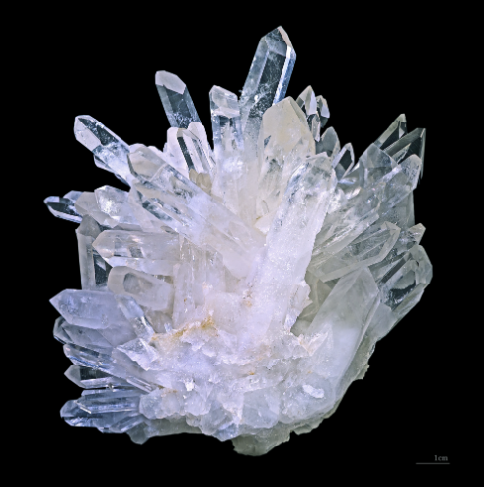
Quartz
Didier Descouens, CC BY-SA, via Wikimedia Commons
Metallic
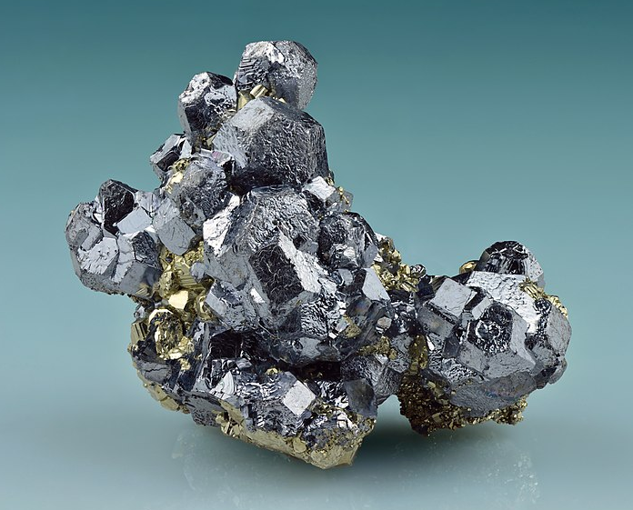
Galena
Ivar Leidus, CC BY-SA, via Wikimedia Commons
Dull
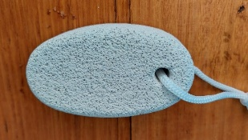
Pumice
Tenacity
Shatter
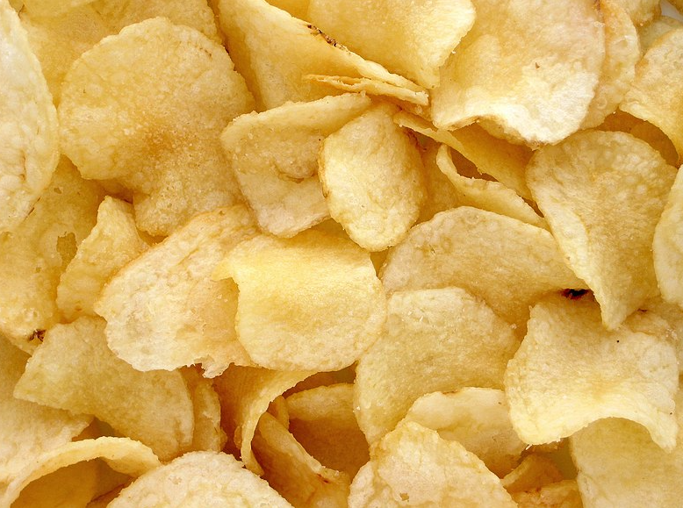
Potato chips
Evan-Amos, Public Domain, via Wikimedia Commons
Bend
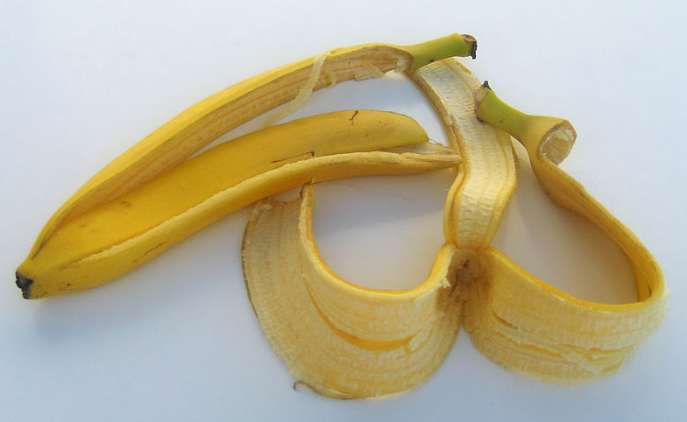
Banana peel
Priwo, Public Domain, via Wikimedia Commons
Spring back
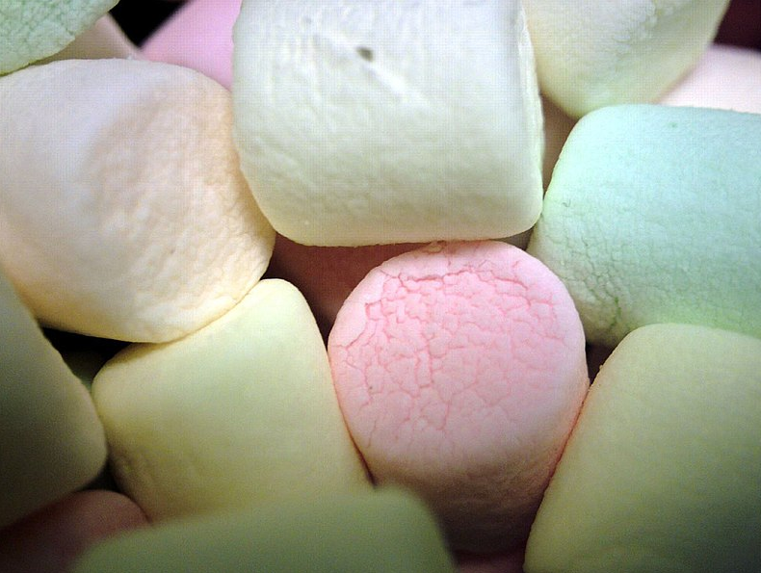
Marshmallows
Father.Jack, CC BY 2.0, via Wikimedia Commons

