Soil layers & labels

**Year 3**

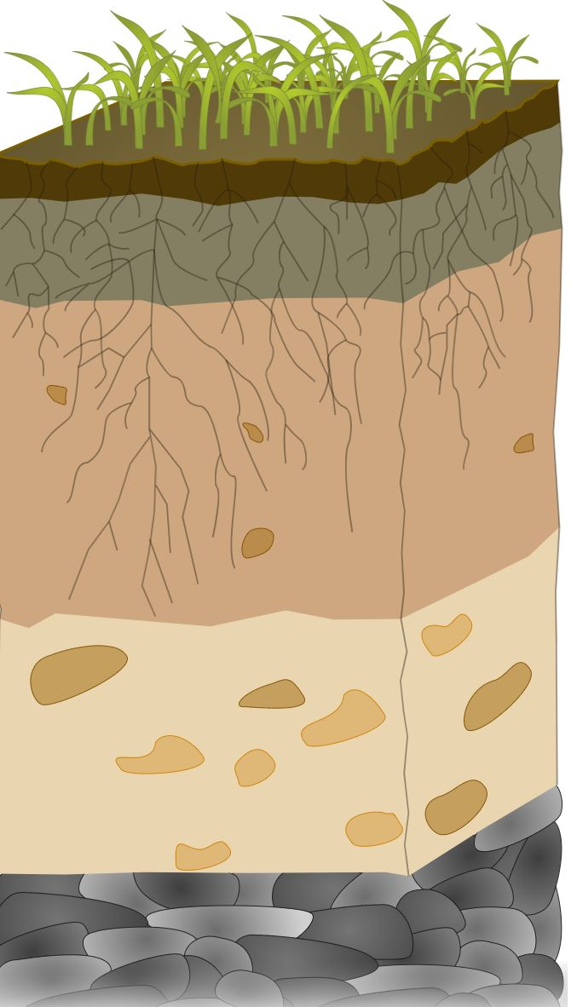

|  |  |
| --- | --- |
| **Soil layer** | **Description of layer** |
| **Organic material** | Organic matter (living or dead plants and animals and their waste) and humus (dark crumbly material of decomposed organic matter). |
| **Topsoil** | The top layer of soil underneath the organic material. Often dark in colour due to humus and organic matter. Most plant roots, earthworms, insects and micro-organisms can be found here. |
| **Subsoil** | *Sub* means under/below,so the subsoil is under/below the topsoil. Often rich in clay and a lighter colour as it has less organic material. |
| **Weathered** **Rock** | Broken pieces of bedrock and some soil mixed together. This layer is sometimes called ‘the parent material’. |
| **Bedrock** | Just like a bed, all the soil layers rest on top. Bedrock is a solid layer of rock (granite, quartzite, basalt or sandstone). Occasionally bedrock is exposed (outcrops) at the surface, for example Uluru. |

**…………………………………………………………………………………………………………………………..**

|  |  |  |
| --- | --- | --- |
| **Soil layer names** | | |
| **Organic material** | **Topsoil** | **Subsoil** |
| **Weathered rock** | **Bedrock** |  |