
Y3

Dig deep • Lesson 1 • School exploration
Lesson 1
LAUNCH
To read the most recent version of this lesson, download associated resources, and view embedded professional learning including classroom videos and work samples, visit: https://primaryconnections.org.au/teaching-sequences/year-3/dig-deep/lesson-1-schoolyard-exploration

Lesson overview
Students participate in a geology quest through the school grounds or local area to find and record the locations of rocks and soil. They collect a sample for further exploration.

Key learning goals
Students will:
- identify examples of rocks and soil in the school grounds and record how they are being used.
- consider what they already know about soils and rocks and their importance.
- pose questions for investigation about soils and rocks.
Students will represent their understanding as they:
- complete a table to record their findings.
- contribute to a class TWLH chart.

Assessment advice
In the Launch phase, assessment is diagnostic.
Take note of:
- students’ ideas about soil, rocks and minerals.
  - See the embedded professional learning Science Content—alternative conceptions in the Elicit step of this lesson.

List of materials
Whole class
- Class science journal (digital or hard-copy)
- A sample of soil and a sample of dirt, in separate trays or containers so that students are able to see them clearly. See Soil versus dirt—collecting samples for Lesson 1 in the Preparing for this sequence tab of the sequence overview for more information.
- Birds-eye view map of the geology quest location, for example the school, hand-drawn or printed from Google/Apple Maps or similar
- Demonstration copy of the Geology quest Resource sheet (or make your own)
Each group
- iPad/digital camera
- Small container or masking tape and paper
- Pen/pencil and a texta
Each student
- Individual science journal (digital or hard-copy)
- Geology quest Resource sheet (or make their own)

Lesson routine | Estimated time | Task type
Experience & empathise | Variable | Whole class/Small group
Elicit | 15 minutes | Whole class
Anchor and connect | 10 minutes | Whole class

Launch

Experience & empathise • Geology quest
Explain that students will undertake a geology quest in collaborative teams. They will explore the school yard (or other suitable place in the local area) to:
- find rocks and soil.
- note their location.
- observe and describe them.
- take photographs.
- collect and label one sample for future observations.

Before the quest
Discuss the meaning of the term ‘geology’: the study of the Earth, including the rocks and soils that make up its structure.
Discuss what kind of samples students are likely to find, where they will find them, and what they might be being used for (to grow flowers, oval to play on, garden edging etc.).
Ask students if they think ‘soil’ and ‘dirt’ are the same thing, and why they think that. Show them the samples of dirt and soil and give them the opportunity to examine it. List students’ observations about each sample in the class science journal and come to an agreement about which sample students think is dirt and which is soil.
Note to students that during this sequence we will be examining soil, and after the next few lessons we will be able to confidently identify the difference between dirt and soil and give a definition for both (Lesson 3).
Ask students why geologists/geoscientists (people who study geology) think it’s important to know the location, date and time rock or soil samples were collected. Determine and agree upon a method for suitably labelling and identifying where sample were collected from.
Model how to record observations and locations of samples using a demonstration copy of the Geology quest Resource sheet as appropriate.
Begin the T column of a TWLH chart.

During the quest
Students explore the school/local area and complete their Geology quest Resource sheet.
They use a digital device to photograph or record the location of rocks and soil, as well as the process of collecting their sample, and the labelled sample itself. They collect and label a soil or rock sample.Remind students to be mindful of insects and spiders that may be under rocks, and to take suitable safety and hygiene precautions whilst collecting samples.

Elicit • What did we find?

After the quest
Optional: If required, discuss what a ‘bird’s-eye view’ means. You might display some images to illustrate, or hide an object in the classroom, and use a bird's-eye view map to help students locate it.
Display a bird’s eye view map of the geology quest location.
Teams share their findings from the geology quest, including any images taken. They share where they located samples and describe what they found. Record locations on the map, marking rocks (r) and soil (s).
Retain map for the following lesson.
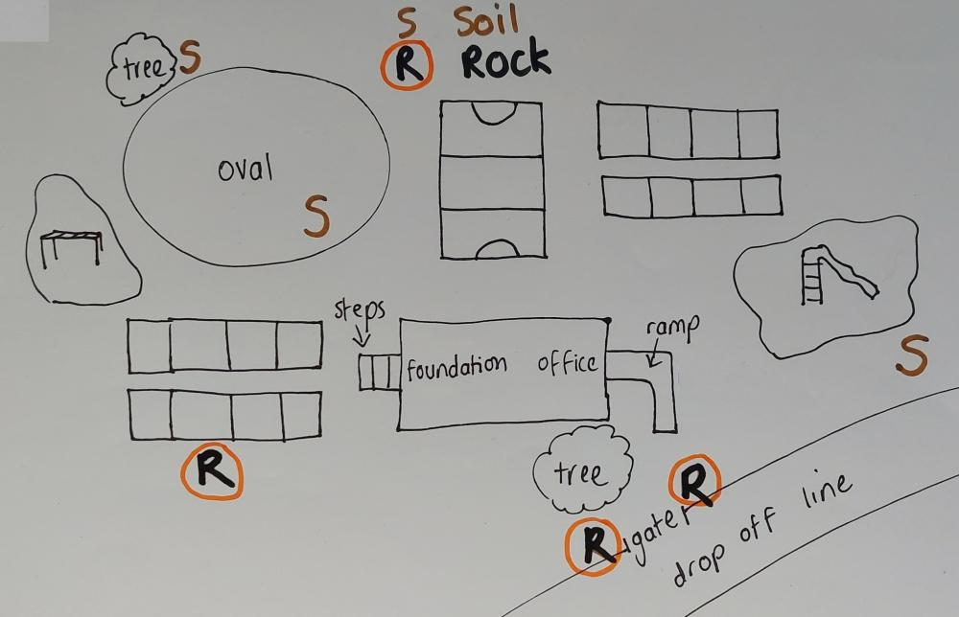
Sample hand-drawn map with marked locations of soil and rock finds.
Discuss students’ ideas about what they found and record important points in the class science journal, or in the T column of the TWLH chart.
Potential discussion prompts
- How were the soil samples found around the school similar? Different?
- If we dug down 50 cm do you think the soil would look the same? Why? Why not?
- What if we dug down 3 meters?
- If we walked 1 km away from the school, do you think the soil would look the same? Why? Why not?
- What if we went 50 km away from the school?
- What do we use soils for?
- Do other creatures use soils? How?
- What is soil made of?
- Why is soil important?
- How were the rock samples found similar and different?
  - Repeat a similar line of questioning as demonstrated above for soils.
- Are concrete/asphalt/bricks a type of rock? How are they similar and different to the rocks we found under the tree in the garden?
- How were rocks we found in the garden made?
- How were the concrete/asphalt/bricks made?
  - The above four questions are used to determine if students can distinguish between ‘natural’ and ‘man-made’ rocks, and the processes that form them. The questions are included for diagnostic purposes, and students may not have the required prior knowledge to answer them, beyond knowing that some rocks are ‘natural’ and others are ‘man-made’.

Anchor and connect • How will we use our learning?
Introduce and link the context and content of the teaching sequence—that students will be:
- learning about the observable properties (features) of soil, rocks and minerals and why they are important Earth resources.
- contributing to the sustainability of Earth’s resources by using/reusing a material that exists because of rocks, soils and minerals.
If you have already selected a specific task for students to complete in the Act phase, introduce this now and connect it to what students will be learning about. For example, if students are going to support the regrowth of vegetation in a local ecosystem by making seed bombs, then ask students or their ideas on the importance of rocks and soils in a healthy ecosystem where plants and animals thrive. If they are going to make a native bee hotel using repurposed materials made of glass and tin, then ask students for their ideas about how glass and tin are made.
If you are going to negotiate a task with students during the course of the sequence, start their thinking by brainstorming ideas about what resources are dependent on rocks and soils. Make a list of student ideas in the class science journal that can be referred to throughout the sequence as students consider how they might demonstrate their learning.
For more information on selecting a task for the Act phase see the Preparing for this sequence tab on the sequence overview page.
Continue building the TWLH chart in the class science journal by recording students’ thoughts about the importance of soil, rock and mineral resources in the ‘What we think we know’ column.
Encourage all students to share their ideas. Take note of any alternative conceptions to address during the Inquire phase.
Ask students what they would like to know about rocks, soil and minerals and their importance. Record their questions in the ‘What we WANT to know’ column of the TWLH chart.

Reflect on the lesson
You might:
- group together similar questions and ask students which ones they think would be important to answer first.
- begin an Earth table with collections of rocks, soils and minerals.
- place the rocks collected this lesson on the Earth table, to be used later in the teaching sequence.
- begin a class word wall related to rocks and soil.

Y3

Dig deep • Lesson 2 • Features of soil
Lesson 2
INQUIRE
To read the most recent version of this lesson, download associated resources, and view embedded professional learning including classroom videos and work samples, visit: https://primaryconnections.org.au/teaching-sequences/year-3/dig-deep/lesson-2-features-soil

Lesson overview
Students investigate soil samples to observe what they can see, feel and hear in soil.

Key learning goals
Students will:
- explore and describe what is in soil.
- discuss different components of soils.
Students will represent their understanding as they:
- complete the Exploring soil samples Resource sheet.
- present their findings verbally in teams.

Assessment advice
Feedback might focus on:
- students’ identification of soil features. Are they able to recognise and describe multiple features such as sand, rock, decomposing and fresh leaves?
- students’ descriptions of soils they have observed in other places. For example, can they describe the difference between the soil in a vegetable garden to the soil next to basketball court or next to the classroom steps?

List of materials
Whole class
- Class science journal (digital or hard-copy)
- 3 buckets of soil, each sourced from a different location on the schoolgrounds or elsewhere. See Collecting soil samples for Lessons 2 and 3 on the Preparing for this sequence tab for advice on collecting soil samples for this and the subsequent lesson. Alternatively, soil can be studied in situ on the school grounds.
- Demonstration copy of the Exploring soil samples Resource sheet
- Dirt and soil samples used in Lesson 1
- 3 x transparent screw top jars (size approx. 500ml)
Each group
- 1 x cup for holding and transporting soil samples
- Magnifying glass
- A piece of white paper upon which to spread out the soil sample
- 1 x transparent screw top jar (size approx. 500ml)
- Small plastic resealable bag to hold 2 tablespoons of soil
- Access to water
- Optional: Sieve
- Optional: Pop-stick or spoon to separate soil features
- Optional: Digital device for taking photos
Each student
- Individual science journal (digital or hard-copy)
- Exploring soil samples Resource sheet
- Optional if conducting investigation in the field (i.e. while outside): a clipboard/book to rest the Resource sheet on

Lesson routine | Estimated time | Task type
Re-orient | 5 minutes | Whole class
Question | 5 minutes | Whole class
Investigate | 20 minutes | Whole class/Small group
Integrate | 25 minutes | Whole class/Small group

Inquire

Re-orient
Refer to any questions asked by students in Lesson 1 about soil and what is in soil (see the ‘W’ column of TWLH chart), for example: Why is some soil slippery when it’s wet?
Recall the previous lesson, focusing on the school map and soil locations recorded during the geology quest.
Potential discussion prompts
- Looking at the map from last lesson, where did we find soil?
- Why do you think soil is found/used in that part of the school grounds?

Question • What’s in the soil?
Further discuss soil, including any samples students collected during the geology quest and other soils students have encountered.
Potential discussion prompts
- Do you think the soil in our schoolgrounds is the same as soil you would find in a desert/rainforest/cave? Why do you think that?
- Have you ever had soil stick to the bottom of your shoes? Does all soil stick to the bottom of your shoes?
- What is in soil?
- Is sand a type of soil? Why/Why not?
Ask students if they can think of a way to observe soil more closely so that we can answer these questions. Pose the question: What is in soil?

Investigate • Examining soil
Students undertake an investigation to answer the question What is in soil? This investigation can be conducted in the field (i.e. outside the classroom), with samples collected from the school grounds and taken back to the classroom, or with samples supplied by the teacher in buckets.
If students are collecting or examining soil samples in situ in the school ground, first discuss why it is important not to dig too deeply when looking for samples: it can disturb plants and animals, it can expose the soil and cause it to get washed/blown away. Also discuss the importance of returning the area to its prior state as closely as possible, for example, replacing leaf litter covering soil.
SAFETY NOTE: Remind students not to taste or smell the soil and to wash their hands after handling soil for safety reasons.
Model how to investigate a soil sample, and take notes on a demonstration copy of the Exploring soil samples Resource sheet as appropriate:
- Take a cup of soil.
- Look at the soil and describe its characteristics/features (colours, clumps etc.) in as much detail as possible. For example: the soil is dark brown with some white and black speckles in it, with some small clumps and bits of what looks like bark.
- Spread out the soil on a piece of white paper and look for details, such as types of particles and leaves.
- Use the magnifying glass to look at particles closely.
- Rub the soil between your fingers to feel its consistency.
- Rub the soil onto the paper and listen to the sound it makes. Notice if it leaves a colour on the paper.
- Optional: Sieve the soil to separate particles according to size.
Ask students if they can think of other ways to investigate the soil.
Allow time for each team to:
- investigate the three soil samples.
- record results on Exploring soil samples Resource Sheet.
- return soils to the school grounds or bucket.
If the investigation was conducted in the field, collect a bucket of each soil type to use in later lessons.
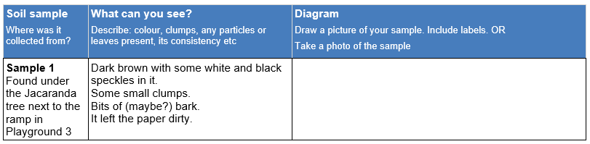

Integrate • Sharing about soil
Discuss and record teams’ findings in the class science journal as they share them.
Potential discussion prompts
- What did you notice?
- In what ways were the soils similar?
- In what ways were the soils different?
- Can you name any of the features in your soil?
  - Sand, insects, leaves, clay etc.
- Can you think of other soils that you have seen that are different from the soils we’ve examined today?
- Why might it be useful to compare the soils?
- Why do you think scientists want to know about different types of soil?
- How could your findings help people in the community?
  - They will know what to plant in certain places, or if things will grow in an area.
- Do you have any new questions about soil since doing this investigation?
- Think back to when we looked at the samples of dirt and soil last lesson. Would you add any observations to our list? What other ideas do you have now we've examined soil more closely?
  - Show the samples if possible.
Mark the location where the samples were taken on the school map if required, and label each sample with its date and location of collection. Discuss whether the varying locations would affect the features in each sample and how.
Potential discussion prompts
- How is this area of the school used?
- Does the way we use the area change the soil?
  - For example: food scraps/compost is added to the kitchen garden; students run up and down the hill area a lot so the soil is really hard and dry; lots of stone gets kicked off the path into the area we took the soil sample.
- Do we think this soil has been here longer than the school, or has the soil been brought into the school grounds?
- How does soil improve our school grounds?
  - Grow grass for playing on, grow trees for birds and possums to live in and provide shade, grow vegetables, plants look nice, and help keep the school grounds cool.
Preparing a soil profile
Explain that students will prepare a soil profile to be observed in the next lesson. The soil profiles will allow us to compare soils by measuring the different materials that settle into layers (mud, sand, leaves etc.).
Model creating a soil profile:
- Place 1 cup of one of the soils the class studied into a transparent screw-top jar.
- Place a few tablespoons of the same soil into a small plastic resealable bag. Label the bag and attach it to the jar using adhesive tape.
- Fill the jar with water (approximately 400 mL), leaving a small space at the top. Screw the jar closed.
- Add a label to the jar, including your name, a description of the soil used, and the date and location of collection.
Discuss with students:
- why labelling things accurately is important in scientific investigations.
- why the small sample in the plastic bag might be useful (to compare the wet soil with how it looked originally).
- what to change (soil), what to keep the same (water amount, time, temperature) and what to measure (layers) to make a test fair.
Discuss how to work safely with glass in the classroom. Explain that students will be asked to make sure the lid is screwed on tightly and then gently shake their jars. Remind students to use two hands when shaking the jar and to stay away from tables and other hard furniture.
Each team creates their own soil profile jar using one soil type and jar provided.
Also, create one class set of all three different soil profiles examined during this lesson.
Students watch their jar as the soil settles for a couple of minutes and then describe in their science journal what they see. Ask students to leave their jars in a place where they will not be disturbed. The soil profiles will be examined in the next lesson, after they have settled. This could take up to two weeks depending on the soil type. It is ideal to wait at least 1 week before conducting Lesson 3—if the profile is not completely settled the water may still appear 'muddy'.

Reflect on the lesson
You might:
- review the TWLH chart. Record what students have learned and answer any questions.
- add to the class word wall vocabulary related to soil.
- re-examine the intended learning goals for the lesson and consider how they were achieved.
- discuss how students were thinking and working like scientists during the lesson. Focus on using senses (of sight, touch and hearing) for the soil investigation, along with accurately labelling samples and doing a fair test by only changing one thing (the soil type) in the soil solutions investigation.
- consider how what was explored about soil in this lesson relates to the task selected for the Act phase, or ask students to review and add to their list of ideas if negotiating a task with students during the course of the sequence.

Y3

Dig deep • Lesson 3 • Soil profiles
Lesson 3
INQUIRE
To read the most recent version of this lesson, download associated resources, and view embedded professional learning including classroom videos and work samples, visit: https://primaryconnections.org.au/teaching-sequences/year-3/dig-deep/lesson-3-soil-profiles

Lesson overview
Students measure their settled soil profiles and create a labelled diagram, then determine soil texture using the ribboning technique.

Key learning goals
Students will:
- observe and measure the soil components in their profile.
- use the ribboning technique and a flow chart to determine soil texture.
Students will represent their understanding as they:
- draw an annotated diagram of their soil profiles.
- discuss soil texture observations.
- discuss what soil components could change over time and the benefits of compost.

Assessment advice
In this lesson, assessment is formative.
Feedback might focus on:
- students’ soil solution diagrams. Are they able to represent the layers that have settled in the jar? Do their diagrams include labels and measurements?
- students’ soil ribboning. Are they able to use the flow chart to determine the soil type? Do they describe the texture of the soil using scientific words such as gritty, sandy, silty?
- students’ discussion about soil types and composting. Do they recognise that soils change over time due to natural processes and human intervention?

List of materials
Whole class
- Class science journal (digital or hard-copy)
- The video Types of soil (2:02 min)
- The video How to test your soil - texture (sand, silt, clay composition) (3:39 min)
- The video Composting for kids | Gardening Australia Junior (3:24 min)
- Demonstration copy of the Soil ribboning technique flowchart Resource Sheet (digital or hard-copy)
- Class soil samples (the three buckets of different soil types used in the previous lesson)
- Dirt and soil samples used in Lesson 1
Each group
- Soil profile prepared in the previous lesson that have been allowed to settle (may take 1-2 weeks)
- Dry soil sample stored in snap-lock bag in previous lesson
- Cup
- Small amount of water (approx. ¼ cup)
- Soil ribboning technique flowchart Resource Sheet (digital or, if in hard-copy in plastic pocket or laminated)
- Ruler
Each student
- Individual science journal (digital or hard-copy)

Lesson routine | Estimated time | Task type
Re-orient | 5 minutes | Whole class
Question | 5 minutes | Whole class
Investigate | 20 minutes | Whole class/Small group
Integrate | 15 minutes | Whole class
Question | 10 minutes | Whole class
Investigate | 20 minutes | Whole class/Small group

Inquire

Re-orient
Review the previous session using the class science journal, the TWLH chart and the word wall.
Focus students’ attention on the three soil samples explored in Lesson 2 and remind them of the soil profiles they prepared.

Question • What’s changed?
Students examine the class set of three soil profiles. Ensure the profiles remain undisturbed.
Pose the question: How do our soil profiles look different now, compared to when we first made them?
Discuss obvious similarities and differences between the three profiles (e.g. floating layer, clearer water, objects settled to the bottom, different layers) and record students’ initial responses in the class science journal.

Investigate • Drawing profiles
Teams collect the soil profiles they made in the previous lesson. Highlight the importance of being careful to ensure the jars aren’t bumped, potentially disturbing the layers and re-mixing the components in the water.
Teams carefully observe their soil profiles, discussing the layers they can see and what each layer contains.
Discuss, and model if required, how to create a labelled diagram of the soil profile, including:
- measuring the height of the jar and each layer within it.
- recording the measurements of each layer on the diagram.
- using an accurate scale.
  - A 1:1 scale is easiest and should be possible if the jars are not too large.
Students create a labelled diagram of their soil profile in their science journals.
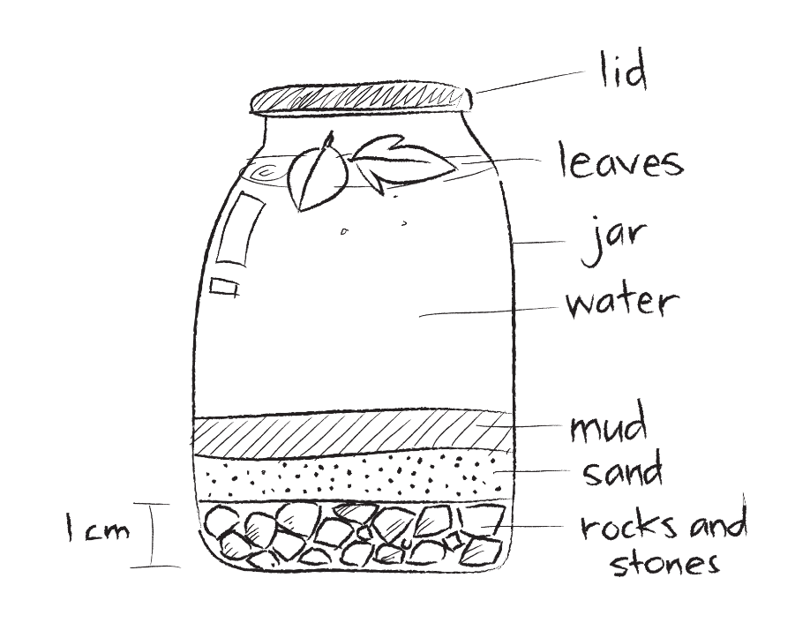
Sample of a labelled diagram of a soil profile.
Teams compare their soil profiles to the sample of dry soil that was stored in the resealable bag during the previous lesson. They record their observations in their science journals.

Integrate • What did we see in the soil?
After students have completed their diagrams, share and discuss each group’s observations about their soil profiles as a class.
Potential discussion prompts
- What settled at the bottom of the jar?
- What was floating at the top of the jar?
- Why do you think that happened?
- What made up most of the soil profile—rocks, leaves, soil? How do you know?
  - The thickness of the layers might indicate what was most prevalent in the soil profile.
- What size and shapes are the different things in the solution? How does this impact how they settle, and the ‘space’ created between them?
- What do you think would happen if we did make a ‘dirt profile’ in the same way? Would it look the same? Why/why not?
Undertake a gallery walk to allow an opportunity for students to examine other students’ soil profiles, original samples, and diagrams.
As a class, group different soil profiles according to their characteristics, then discuss the groupings and record students’ ideas in the class science journal.
Potential discussion prompts
- Do any soil profiles look similar? In what way?
- Do any soil profiles look different to each other? In what way?
- Why do you think some profiles look different to others?
- Do the profiles that are grouped together come from the same place in our school grounds or local area?
- Are any of these soils similar to your soil at home?
- What kinds of things are soils made from?
- Where do the living things come from?
- How are the non-living things formed?
- Where do the non-living things come from?
- Why are there different size pieces in the soil?
- What things might cause soil to change?
  - Vegetation change, human activity.
- What do you think you did well in the soil profile activity to make it a fair test?
- If you were to repeat the activity, would you do it differently? How?
Allow students an opportunity to add to their labelled diagrams of the soil profiles if required.

Question • Types of soil
Show the video Types of soil (2:02 min). Discuss and highlight some of the key points of the video, including:
- Soil is made up of tiny rocks, air, water and humus.
- Humus is made up of dead and decomposed plants and animals.
- How does this relate to what students just observed about their soil profiles?

- The tiny rock particles are classified as either sand, silt or clay. Discuss students’ prior knowledge/experiences with these (students will most likely easily identify sand and clay, but not silt).
  - It might be important to note for students that beach sand and the sand found in soil are not the same. They are similar in size and are both made of grains of broken-down rocks, but beach sand has a very high salt content due to its proximity to the ocean and only specially adapted plants and animals can live in it. The sand found in soil is not high in salt.
- Sand, silt and clay are different sizes, so they either let more water pass through or hold more water in the soil.
- Different plants grow best in different soils. Ask students’ ideas on why this might be.
Pose the question: Can we tell whether the soil has sand, silt or clay particles in it by just looking at it?
Discuss how it can be difficult to differentiate the different particles with visual observations alone, because the particles are very small and close together. Sand may separate as part of the soil profiles but is likely unobservable by the naked eye in a 'dry' sample of soil.
Pose the question: How can we find out if our soil has sand, silt or clay in it?

Investigate • Soil texture
View the video How to test your soil - texture (sand, silt, clay composition) (3:39 min) to examine the methods for observing soil texture: feeling, listening and the ribboning technique.
Note: It is recommended that you watch this video from 0:46 onwards. The first section of this video discusses concepts and uses vocabulary not suitable for students at this age group or this stage of conceptual development. From 0:46 the video is more practical and clearly shows techniques students can use to determine what’s in a soil sample.
Optional: Either as an alternative, or in addition to watching the video, conduct a live demonstration of the feeling, listening and ribboning technique shown.
Using the demonstration copy of the Ribboning technique flow chart Resource sheet, discuss how the chart can be used to help observe the soil texture and determine the soil type.
Teams use the ribboning technique to determine soil texture:
- Collect one cup of one soil type, taking note of which sample they are investigating.
- Add a small amount of water.
- Use the feeling, listening and ribboning technique and flow chart to investigate the soil texture and soil type.
Discuss teams' findings and record results in the class science journal.
Potential discussion prompts
- Were you able to form a long ribbon by pushing your thumb into the ball of soil? What does this tell us about the soil type?
- Did your soil feel slippery, silky or gritty when you rubbed it between your fingers?
- What are the hard gritty pieces likely to be?
  - Sand.
- Did it stain your hands easily and feel silky? Why would it do that?
  - Soil that does this is likely to contain silt.
- Did it feel sticky?
  - Soil that feels sticky is likely to contain clay.
- Based on your results using the ribboning technique, what type of soil is it?
  - Clay, silty clay, sandy clay, silty loam, loamy sand or sand.

Integrate • Making sense of soil types
Ask students to identify some uses of soil they know, for example: growing plants, food, habitat for animals, an anchor trees, to purify water, making bricks, lining dams.
Ask students to consider if some soils would be better for some uses than others, and why and how.
Potential discussion prompts
- Would you be able to grow most food plants in a really sandy soil? Or clay soil? Why do you think that?
  - Some plants grow better, or can only grow, in sandy soil because too much water can give them what gardeners call 'wet feet'. 'Wet feet' means that a plant's roots get a lot of water, and are always too wet. This can cause the roots to rot and ultimately kill the plant. Root vegetables like carrots can grow crooked and stunted in clay soil, because the soil particles are very close together, or compacted, making it harder for them to grow.
- What is a good way to use sand?
- Is sand a soil type?
  - Yes—it drains well.
- What would be a good way to use clay?
- Are some soils a mixture of clay and sand?
- Does this investigation make you think of any other questions about soil (water holding capacity, how well quickly water drain through a soil, can you see humus)?
Introduce the concept of composting by watching the video Composting for Kids (3:24). Discuss with students what composting is, and why you might add sticks or newspaper etc. to a compost heap. Discuss how compost can be similar to soil.
Potential discussion prompts
- What did the person in the video say about adding sticks to the compost heap? What about the newspaper?
- Why would you add water to a compost heap?
- How would this be similar to soil?
- If you had a clay soil, but you wanted to grow plants that needed ‘good drainage’ what could you do to? What might you add to the soil to help?
Return to the samples of soil and dirt looked at in Lesson 1, and the list of observations students made. Ask them again which sample they would say is dirt and which is soil and why. Explain that dirt is just the sand, clay and silt part of soil, sometimes with rocks in it. It doesn't have the other ‘organic matter’ in it, the bits of decaying leaves and animals etc. Jointly construct definitions of soil and dirt, and consider how you might turn dirt into soil.

Reflect on the lesson
You might:
- add to the class word wall vocabulary related to features of soil, soil solutions and texture.
- review the TWLH chart. Record what students have learned and answer any questions.
- discuss how students were thinking and working like scientists during the lesson. Focus on why taking accurate measurements is important and using scientific language for observations (small/large grain size, layers, silky, gritty, rocks, smooth).
- determine whether soil profile jars will remain in the classroom for continued observation or be taken home by students.
Y3

Dig deep • Lesson 4 • Rock sort
Lesson 4
INQUIRE
To read the most recent version of this lesson, download associated resources, and view embedded professional learning including classroom videos and work samples, visit: https://primaryconnections.org.au/teaching-sequences/year-3/dig-deep/lesson-4-rock-sort

Lesson overview
Students observe a rock in detail so it can be recognised amongst a collection of other rocks. They sort and classify a collection of rocks then attempt to work out other groups’ classification systems.

Key learning goals
Students will:
- identify and sort rocks according to observable features.
- recognise that rocks are made of one or more minerals.
Students will represent their understanding as they:
- draw a labelled diagram of a rock.
- describe features of rocks.
- describe how rocks have been sorted and classified.

Assessment advice
In this lesson, assessment is formative.
Feedback might focus on:
- students’ descriptions of rocks. Do they use adjectives to describe factual observations (‘it is grey and smooth with one jagged edge’) rather than notions (‘it is lovely’)?
- students’ classification of rocks. Do they classify the rocks according to factual observations? Can they think of multiple ways to classify the same rocks (colour, shape, texture, grain size…)?

List of materials
Whole class
- Class science journal (digital or hard-copy)
- A tub/basket of rocks, containing at least enough rocks for one between two students. See Curating a collection of rocks for Lessons 4 and 5 on the Preparing for this sequence tab for advice on preparing a selection of rocks for the purpose of this lesson.
- One rock selected from the tub to be your ‘pet rock’, that you can distinguish from the others.
- The video ROCKS and MINERALS for Kids - What are their differences? (4:09)
Each group
- A rock
- Magnifying glass(es)
- A collection of 6-10 rocks for students to sort and classify. See Curating a collection of rocks for Lessons 4 and 5 on the Preparing for this sequence tab for advice on preparing a selection of rocks for the purpose of this lesson.
Each student
- Individual science journal (digital or hard-copy)

Lesson routine | Estimated time | Task type
Re-orient | 5 minutes | Whole class
Question | 10 minutes | Whole class
Investigate | 20 minutes | Whole class/Individuals
Integrate | 20 minutes | Whole class/Small groups

Inquire

Re-orient
Recall the previous lesson, focusing on the small rocks/stones found in the soil samples and what students noticed about them.

Question • Pet rocks
Show students the rock you have selected as a ‘pet rock’. Explain that you know it so well that it could be placed among other rocks and you would be able to pick it out.
Invite a student to hide the pet rock amongst the tub/basket of rocks.
Students vote on whether or not they think you will be able to find your pet rock in the tub/basket. Discuss their reasoning, drawing out the alternative conception that all rocks are the same.
Search the tub or basket for your pet rock, thinking aloud during the process and pointing out features of some of the rocks. For example: Mine is a different colour...this one has a similar shape to mine...this one is too big/small.
Select your rock from the basket and describe in detail how you know it is your pet rock e.g. I know this is my pet rock because...it has speckles of shiny black, pink and white, it’s small so I can close my hand around it, and it has this really pointy end.
Pose the question: If I gave you a rock, do you think you be able to find it when it gets put back into the basket with all the others? How might you do that?

Investigate • Rock observation
Ask students to share their ideas on how they might get to know their rock well enough to be able to pick it out of the basket. Describe to them how you got to know your pet rock.
Discuss the difference between factual observations such as "my rock has white swirls on it" or "my rock is smooth, except for this edge" and notions such as "my rock is pretty".
Distribute a small rock from the basket and a magnifying glass to each pair of students.
Students observe their rock very carefully, so they will be able to find it again when it is placed back in the tub/basket. They:
- use the magnifying glass to examine the rock in detail, looking for any distinct patterns/grains, colour/markings and scratches.
- describe the rock in detail to their partner.
- individually draw a labelled sketch of their rock.
Allow teams to complete their observations before returning their rock to the tub/basket.
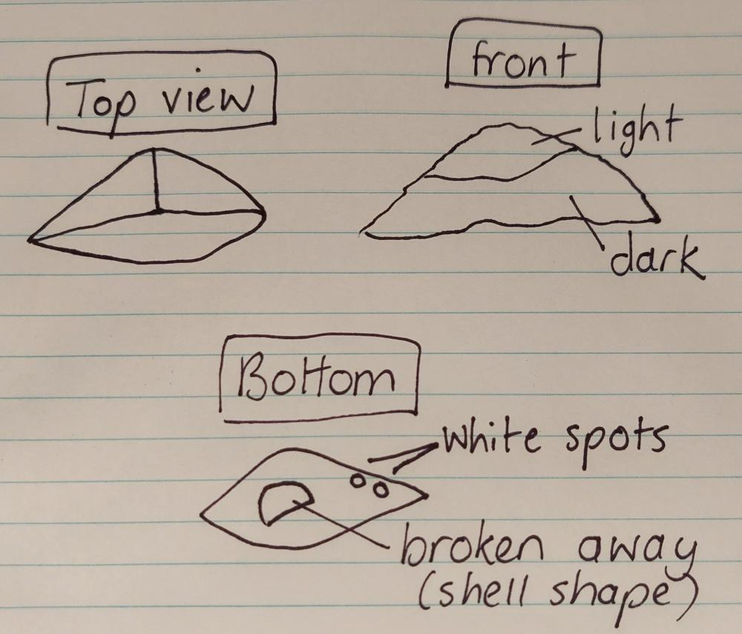
Rock sketch work sample
Give the rocks a gentle shake/stir and invite one team at a time to find their rock and explain the features of their rock that enabled them to find it. Be prepared with prompts, or to offer assistance to teams who are having difficulty picking out their rock.
As a class, discuss and compare the different features of the students’ rocks.
Potential discussion prompts
- Who had a rock that was…black? White? Grey? Brown? Rough? Smooth? Shiny?
- Were there any other features you noticed about your rock? Did it have layers/lines? Was it a particular shape? Did it have particular marks or crystals/sparkles that made it different?

Integrate • What’s in a rock?
Hold up a rock and ask students: What are rocks made of? Prompt further thinking by asking What are the bits made of?
View the video ROCKS and MINERALS for Kids - What are their differences? (4:09), stopping at 2:51. Discuss the main points of the video, focusing on:
- how rocks are the solid parts of Earth.
- rocks are made of one or more minerals.
- how geologists use the features/characteristics of rocks and minerals to tell them apart from each other (e.g. diamonds are very hard, talc is soft and used to make powder).
Secret mission: classifying rocks
Explain that students will examine and classify rocks based on a secret classification system of their own design. They will then attempt to figure out how other groups have classified their rocks.
Distribute a collection of rocks and magnifying glasses to each team and ask them to:
- examine and discuss the rocks as a team.
- select one rock feature/characteristic (e.g. crystal size, texture, shape, colour).
- group the rocks accordingly, but without labelling the groupings.
Once the teams have grouped their rocks undertake a gallery walk, visiting each group and attempting to decipher the classification system they have used. Discuss students’ ideas as you undertake the walk, stopping at each, or specifically-chosen, collections.
Potential discussion prompts
- How do you think these rocks have been grouped?
- Do we think these rocks are made of the same or different minerals? Why?
- Are there any rocks that were difficult to group, because they could have been put into more than one group?
  - It might be helpful to have some sample rocks you could demonstrate with, for example a rock that is mostly one colour, with flecks of another colour in it, or a rock that is smooth, but has a rough, broken edge.
- Can we see a different way to group these same rocks?

Reflect on the lesson
You might:
- review the TWLH chart. Record what students have learned about rocks and answer any questions.
- add to the class word wall vocabulary related to rocks (solid parts of Earth made of minerals) and characteristics of rocks (shape, colour, feel, weight etc.)
- discuss how students were thinking and working like scientists during the lesson. Focus on classifying objects (rocks) by observable features.

Y3

Dig deep • Lesson 5 • Scratch test
Lesson 5
INQUIRE
To read the most recent version of this lesson, download associated resources, and view embedded professional learning including classroom videos and work samples, visit: https://primaryconnections.org.au/teaching-sequences/year-3/dig-deep/lesson-5-scratch-test

Lesson overview
Students investigate the hardness of rocks with a simple scratch test, then examine how a rock’s hardness determines its use.

Key learning goals
Students will:
- scratch test rocks to compare their hardness.
- explore how rocks are used based on the property of hardness.
Students will represent their understanding as they:
- record their observations on the Hard rock Resource sheet.
- order rocks from softest to hardest.
- discuss the different uses for softer rocks and harder rocks.

Assessment advice
In this lesson, assessment is formative.
Feedback might focus on:
- students’ rock scratch test. Can they identify that some rocks are harder and dent softer rocks?
- applying understanding. Can students apply their knowledge of rock hardness to explain possible ways to use different rocks?
In this lesson, assessment might also be summative in relation to Science inquiry.
Students working at the achievement standard (science inquiry) should have:
- made predictions and carried out investigations to test their predictions.
- used informal measurement techniques to make observations.
- considered if their investigation was fair.
- compared findings with others.
- drawn conclusions based on observations.
Refer to the Australian Curriculum content links on the Our design decisions tab for further information.

List of materials
Whole class
- Class science journal (digital or hard-copy)
- Two different rocks. See Preparing for this sequence for advice on preparing a selection of rocks for the purpose of this lesson.
- A variety of rocks on the Earth table or in the school grounds
- Optional: Demonstration copy of the Hard rock Resource sheet
- Videos about the use and importance of rocks to First Nations people, for example:
- The ancient Aboriginal art and culture of NSW's Sandstone Caves (4:16), about engravings and water wells in sandstone
- Grindstones (1:22)
- Aboriginal blade making with Traditional Resin handle (6:59), about the making of a quartzite blade
- Making ochre at luyni mungalina (3:01)
Each group
- At least two different rocks. See Preparing for this sequence for advice on preparing a selection of rocks for the purpose of this lesson.
- Optional: Iron nail
Each student
- Individual science journal (digital or hard-copy)
- Hard rock Resource sheet

Lesson routine | Estimated time | Task type
Re-orient | 5 minutes | Whole class
Question | 5 minutes | Whole class
Investigate | 20 minutes | Small group/Individuals
Integrate | 20 minutes | Whole class

Inquire

Re-orient
Recall the previous lesson, focusing on classifying rocks by observable features.

Question • Hard rocks
Refer to any questions asked by students in Lesson 1 about:
- rocks.
- strength/hardness of rocks.
- how rocks are used.
Hold up two different rocks and pose the questions: Is one of these rocks harder than the other one? How will we find out?

Investigate • Who scratched who?
Demonstrate a scratch test by scratching the two rocks against each other to determine which is harder. The harder rock will leave a scratch/dent on the softer rock.
Discuss the difference between a dent and dust:
- A harder rock will leave a dent/scratch line in a softer rock.
- If a line of dust appears on one rock, wipe it away to look for a dent/scratch. The dust may have come from the softer rock that was used to try to scratch.
- Dust will come off the softer rock.
Allow students a chance to examine the rocks to predict which rocks will be the hardest (not be scratched), and which will be the softest (can be scratched by all the other rocks). Safety note: This test should be carried out outdoors to mitigate any risk posed by rock dust.
Allow students time to scratch test at least two sets of rocks and record their results on the Hard rock Resource sheet, which include a labelled diagram of the two rocks and a Predict, Reason, Observe, Explain (PROE) chart. Model how to record results using a demonstration copy of the Hard rock Resource sheet if required.

Integrate • Useful rocks
Discuss the findings and any challenges faced by students. Guide the discussion with students to reach the consensus understanding that some rocks are harder than others.
Potential discussion prompts
- Was it always easy to work out which rock was harder? Why or why not?
- Were there any rocks that were about the same hardness?
- Did the same person do the scratching each time? Why might this make a difference?
  - The same person is more likely to use the same pressure each time.
- Did everyone get the same results? Why or why not?
- Do you think this was a fair test? Why or why not?
- How do you think we could make this a fair test?
  - Use a robot to apply the same pressure each time.
Allow students time to order the rocks from softest through to hardest, then continue the discussion:
- What can we determine about the hardness of rocks based on our test?
  - Some rocks are harder than others.
- What does that tell us about minerals?
  - Since rocks are made of different minerals it is reasonable to conclude that some minerals are harder than others.
Explain that the hardness of rocks affects how they are used by First Nations peoples, and discuss how this knowledge applies to the rocks in their own environment. Select and show some videos about the importance of rocks to First Nations people and discuss how the hardness of rocks affects their use. For example, sandstone can be carved for artwork and water wells, whereas quartzite is harder and can be used to make a sharp blade.
Examples of videos to view:
- The ancient Aboriginal art and culture of NSW's Sandstone Caves (4:16)
- Grindstones (1:22)
- Aboriginal blade making with Traditional Resin handle (6:59)
- Making ochre at luyni mungalina (3:01)
As a class, consider the different rocks that were examined in the previous lesson, and discuss what each rock would be suitable for. For example, they might be suitable for:
- engraving into.
- building walls and houses.
- making an axe or blade.
- a habitat for small reptiles to hide amongst.
- carving to make an ornament etc.
- polishing for a kitchen bench.
Provide an opportunity for students to ask more questions about rocks and record these in the class science journal.

Reflect on the lesson
You might:
- review the TWLH chart. Record what students have learned about rock and mineral hardness and answer any questions.
- add to the class word wall vocabulary related to rock and mineral hardness.

Y3

Dig deep • Lesson 6 • Minerals in rocks
Lesson 6
INQUIRe
To read the most recent version of this lesson, download associated resources, and view embedded professional learning including classroom videos and work samples, visit: https://primaryconnections.org.au/teaching-sequences/year-3/dig-deep/lesson-6-minerals-rocks

Lesson overview
Students examine rocks, and models of rocks, for minerals, then explore the importance of minerals.

Key learning goals
Students will:
- break apart and examine properties of the minerals in a model of a rock, including colour, lustre and tenacity.
- investigate the difference between gems, minerals, crystals and rocks.
Students will represent their understanding as they:
- complete the Model rock analysis Resource sheet.
- discuss how and why rocks and minerals can be changed by humans (for example breaking, shaping, polishing).
- record examples of how their lives would be different without minerals.

Assessment advice
In this lesson, assessment is formative.
Feedback might focus on:
- students’ model rock analyses. Can students recognise that each ingredient represents a different mineral and that each of those minerals has its own properties such as colour, lustre, and tenacity?

List of materials
Whole class
- Optional: Microscope(s)
- Demonstration copy of the Lustre and tenacity Resource Sheet
- Demonstration copy of the Model rock analysis Resource sheet
- The video Gems, Minerals, Crystals & Rocks–What's the Difference? (3:31)
- The video Inside of the Rock under the Microscope (1:04)
- The video Using Rocks and Minerals (1:43)
- The video In what ways do you interact with minerals in your daily life? (4:58)
- Optional: Who am I? Resource sheet

Each student
- Individual science journal (digital or hard-copy)
- 1 x model rock (see Preparing a model rock for analysis on the Preparing for this sequence tab)
- 1 x plate or A4 paper
- 1 x popstick/spoon
- Magnifying glass
- Model rock analysis Resource sheet

Lesson routine | Estimated time | Task type
Re-orient | 5 minutes | Whole class
Question | 5 minutes | Whole class
Investigate | 15 minutes | Whole class/Individuals
Integrate | 15 minutes | Whole class
Investigate | 10 minutes | Whole class
Integrate | 15 minutes | Whole class

Inquire

Re-orient
Recall the previous lesson, focusing on classifying rocks by observable features.
Review the meaning of the terms:
- rock
- mineral
- feature/characteristic

Question • What's inside a rock?
Refer to any questions asked by students in Lesson 1 about minerals (‘W’ column of TWLH chart).
Introduce the terms ‘geology’ (the study of the Earth) and ‘geologist’ (a scientist who studies the Earth’s surface, what lies beneath it, and how it changes over time).
Pose the question: How do you think a geologist finds out what's inside a rock?
Discuss the different ways geologists might study rocks, for example:
- using magnifying glass or microscopes.
- testing how they respond to heat/cold.
- testing the rocks for strength.
- breaking the rocks open to look inside.

Investigate • Smash it
Explain that last lesson we observed rocks from the outside. In this lesson, we'll be working like geologists: we will break apart ‘rocks’ to observe what we can find in each one.
Explain that students will be breaking apart model rocks, not real rocks, and discuss why that is:
- Real rocks are very hard—even the softer ones we can scratch! It takes a lot of pressure to break one, more pressure than we can safely use in the classroom.
- Real rocks can sometimes contain grains that are dangerous, and whilst they're okay when they're contained within the rock, we don't want to break a rock open and breathe them in.
- Scientists often use models to help them learn about things that are difficult to ‘get to’. Real geologists have the equipment and safety procedures that enable them to see inside real rocks, but schools don't. But that's okay, because using models is what scientists would do in this situation.
Distribute the model rock, popstick, plate and magnifying glass to each team. Before explaining and beginning the steps of the investigation, allow students time to observe and discuss their model rock and the equipment they have been given.
As a class, discuss suitable techniques for investigating the model rocks. For example, students might break them apart by hand then separate the pieces using a popstick.
Discuss safety and hygiene requirements as required. If using a food item for the rock model, discuss why it is important not to eat food when we do not know all of the ingredients, or to pressure others to eat foods. Some people can have life-threatening allergies to certain foods. Eating foods that have been touched by many hands can also spread illness.
Allow time for students to:
- break apart their model rocks.
- separate components using a popstick/spoon.
- group together components that are the same/similar, and discuss why they have grouped them that way.
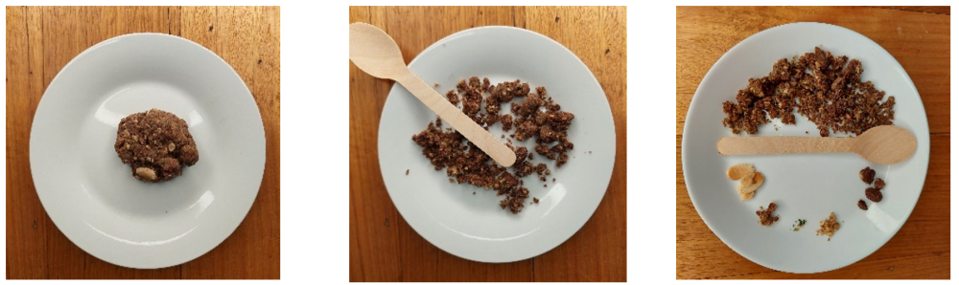 Explain that the components the students have identified in their model rock represent the minerals inside a real rock, and that some of the ways geologists classify minerals is according to their:
- colour.
- lustre—how light reflects off the surface of a mineral.
  - Does it look glassy like light reflecting off a window, metallic like light reflecting off a mirror, or dull and not shiny at all?
  - If you are using food ingredients to represent minerals in rocks, it is likely that the food ingredients won't have lustre properties like minerals, and will instead be dull.
- tenacity—a mineral’s reaction to pressure.
  - Does it shatter like a potato chip, bend like a banana peel or spring back like a marshmallow?
Use the Lustre and tenacity Resource sheet to help explain lustre and tenacity.
Using the demonstration copy of Model rock analysis Resource sheet, model for students how to examine their model minerals for colour, lustre and tenacity, and record their observations. Explain that for safety reasons they won't test for tenacity and instead should predict what they think would happen to the mineral under pressure.
Allow teams time to complete the Model rock analysis Resource sheet.

Integrate • Minerals
Share and discuss students’ findings.
Potential discussion prompts
- What colour was one of the ‘minerals’ you found inside your rock?
- How did you describe the lustre? Why?
- What do you think would happen if you applied lots of pressure to one of the ‘minerals’ found in your rock? What might you learn about its tenacity?
- How is a rock different to a mineral?
  - A rock is made up of one or more minerals, but minerals are not made up of rocks. Minerals are the ingredients of rocks.
Show the video Gems, Minerals, Crystals & Rocks–What's the Difference? (3:31) and discuss the difference between rocks, minerals, crystals and gems.
Show the video Inside of the Rock under the Microscope (1:04). Pause the video at 0:54 and discuss how the different minerals in the rock can be seen when observed through a microscope.
Potential discussion prompts
- Is this a rock, mineral or gem?
  - A rock made of several minerals.

- What colours can be seen?
  - Pink, gold, clear, brown.
- Are there any minerals in this rock with a metallic lustre (reflects light like a mirror)?
  - Yes, some of the yellows and also the pink have a metallic lustre.
- Can you identify a mineral with a glassy lustre?
  - The large clear pieces.
- Do we think this rock is made up of one mineral or many different minerals? Why?
  - Many, as each different colour is likely to be a different mineral and some of the minerals are metallic, some are glassy and some are dull
Optional: Watch the video Explore Amazing Rocks and Minerals! (stop by 3 minutes). This video explores minerals in a museum and might be useful for students looking for real mineral properties, like lustre.
Optional: If you have been building an Earth table during the course of the sequence, invite students to observe any minerals displayed and categorise them according to colour and lustre.
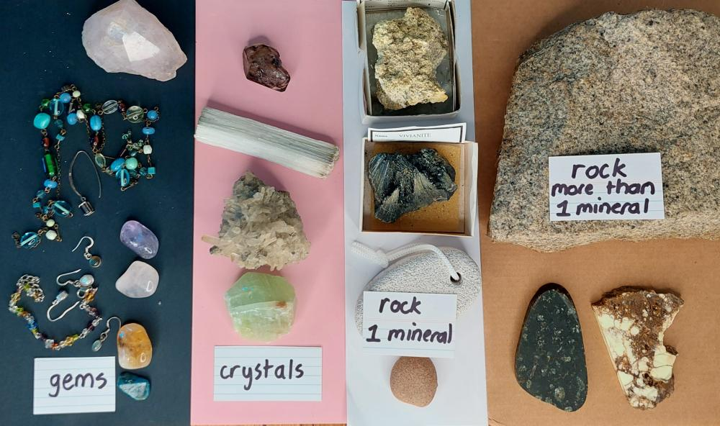
Pose the questions: How do humans use rocks and minerals? How would your life be different without rocks and minerals?

Investigate • Using rocks and minerals
Remind students that minerals can be small, valuable, or difficult to access for investigation. Sometimes, in cases like this, we have to rely on models—like we did with our model rocks—or information that geologists have found out before us in order to learn more. Explain that scientists also do this type of investigating all the time—they use other people's information or test results when they can't do the investigation themselves.
Show the video Using Rocks and Minerals (1:43).
Watch the video again, this time asking students to list 10 keywords or phrases from the video that help us answer our question How do humans use rocks and minerals?
Use the cumulative listing technique to share and rank students’ keywords by frequency:
- Ask one student to share a keyword.
- Other students who also had this keyword raise their hands.
- Record the keyword and note next to the keyword how many students in total identified it. Repeat for as long as appropriate.
Categorise the keywords based on whether they relate to using rocks or minerals.
Repeat the activity with the video In what ways do you interact with minerals in your daily life? (stop the video after the first two minutes). Students might also list actions they notice, such as items containing materials disappearing into the ‘mineral meter’.
Compare the information in the two videos, especially regarding how we use minerals. Also discuss the importance of using multiple sources to cross check key information when relying on other people’s research and data.
Potential discussion prompts
- Do the two videos identify some of the same uses of minerals?
- What different uses do they show?
- Do you think the information in the videos is accurate? Why do you think that?
- Why is it important to look at more than one source of information when you're relying on other people's research and data?
Discuss the different uses of rocks and minerals, and together brainstorm answers to the question How would your life be different without rocks and minerals? Jointly construct a series of sentences or a paragraph to answer the question and record it in the class science journal. Students might also do this in a collaborative team, before sharing their ideas and jointly constructed a shared class understanding.

Integrate • What have we learned?
Discuss why some rocks are harder than others, referring back to the pet rocks observed in Lesson 4, the scratch test conducted last lesson, and what students have discovered this lesson.
Potential discussion prompts
- Why are some rocks harder than others?
  - Different rocks are made of different minerals. Some minerals are harder than others and some rock minerals are changed because of heat and pressure.
- Are the rocks in our schoolgrounds hard or soft? How do we know?
- Can you describe the rocks you have seen in other places?
Optional: As a class, use the Who am I? Resource sheet to learn more about everyday minerals by matching mineral names to their description. You could also play this game using a selection of pet rocks from Lesson 4 and descriptions written by students.

Reflect on the lesson
You might:
- review the TWLH chart. Record what students have learned about minerals and answer any questions.
- add to the class word wall vocabulary related to minerals and the properties of colour, lustre (metallic, glassy, dull), and tenacity (shatter, bend, spring back).
- discuss how students were thinking and working like scientists during the lesson. Focus on classifying objects by their observable mineral properties of colour, lustre and tenacity.

Y3

Dig deep • Lesson 7 • Making soil
Lesson 7
INQUIRE
To read the most recent version of this lesson, download associated resources, and view embedded professional learning including classroom videos and work samples, visit: https://primaryconnections.org.au/teaching-sequences/year-3/dig-deep/lesson-7-making-soil

Lesson overview
Students consolidate their knowledge by investigating soil layers (from organic material down to bedrock) and making their own soil.

Key learning goals
Students will:
- investigate and model soil layers.
Students will represent their understanding as they:
- design and create a labelled model of soil layers.
- undertake a gallery walk.

Assessment advice
In this lesson, assessment is summative.
Students working at the achievement standard should have:
- demonstrated an understanding that rocks, and therefore minerals are components of soil, and that soil, rocks and minerals have observable properties that affect their use.
- constructed a physical model that shows simple relationships.
- applied their learning when creating their labelled model of soil layers.
Evidence should be found in student models and during the gallery walk.
Refer to the Australian Curriculum content links on the Our design decisions tab for further information.

List of materials
Whole class
- The video Organic Matter on the Soil (0:58)
- The video Soil Health, Humus (0:27)
- The video The 5 Layers of Soil (3:39)
- Optional: Shovel and access to a location on the schoolgrounds where you can dig a hole and observe soil layers. Alternatively, a pre-dug sod of soil with grasses, weeds intact.
- Demonstration copy of the Soil layers and labels Resource sheet (digital or hard-copy)
- Food safe preparation area if the models are edible
Each group
- Glass or clear plastic jar
- Materials for soil layers, for example:
- natural materials such as stones, sand and leaves.
- edible items such as cookies, choc chips, marshmallows and sour worms.
- other suitable items such as coloured paper, paper clips, cotton wool, string/wool, etc.
- Soil layers and labels Resource sheet
- Scissors
- Glue, sticky tape or blutac
Each student
- Individual science journal (digital or hard-copy)

Lesson routine | Estimated time | Task type
Re-orient | 5 minutes | Whole class
Question | 5 minutes | Whole class
Investigate | 15 minutes | Whole class
Integrate | 20 minutes | Small group

Inquire

Re-orient
Review the previous lessons, focusing on what is in soil and in particular:
- the analysis of a cup of soil in Lesson 2—stones/rocks, leaves, insects, sand.
- the soil profiles made in Lesson 3—the layers of different matter that settled in the jars.
- rock—soils contain pieces of rock and rocks are made of minerals.

Question • What’s underneath the soil?
Revisit the terms:
- organic matter—living or dead plants and animals and their wastes. Show the video Organic Matter on the Soil (0:58).
- humus—dark crumbly material of decomposed organic matter. Show the video Soil Health, Humus (0:27).
Potential discussion prompts
- What organic matter have we found in our soil samples and school yard?
  - Leaves, worms, bugs, ants, fungus, dead leaves.
- Why is it important to have organic matter in soil?
  - Organic matter breaks down and provides nutrients for plants—similar to how people need food, worms make holes for roots to grow into.
- Can we see a dark humus layer in our school garden?
- Can we create extra humus to add to the top of our soil?
  - Yes, through composting.
Pose the question: If we keep digging through the soil, what would we find underneath it?

Investigate • Building soil layers
Show the video The 5 Layers of Soil (3:39). Explain that the broken rock layer is called ‘weathered rock’ or ‘parent material’ (as in the video). We will use the term ‘weathered rock’ as it is more descriptive.
Using the demonstration copy of the Soil layers and labels Resource sheet, create a labelled diagram of soil layers.
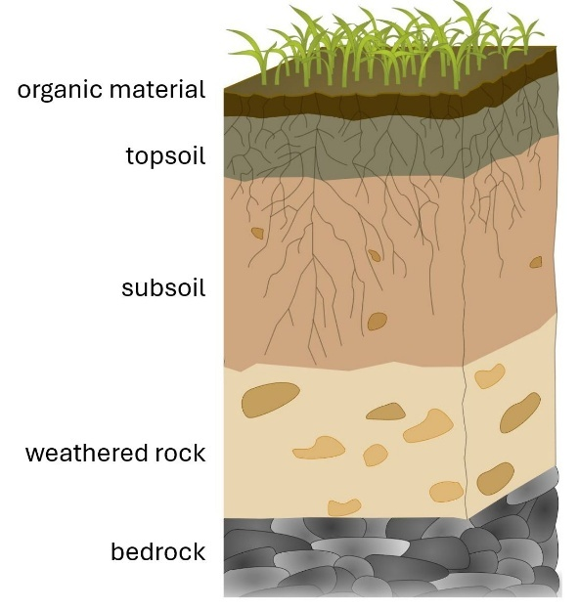
Optional: Investigate what soil layers are visible in the local area by digging a hole with the class or examining a pre-dug sod of soil. Discuss and compare the local soil to the soil in the video.
Potential discussion prompts
- What soil layers can we see?
- Is there an obvious layer of organic matter and humus on top?
- What do we predict we would see if we could dig down further?
- Are the layers easy to see?
Students then construct a model of soil layers in teams. They should label the layers using the Soil layers and labels Resource sheet. Discuss the materials they will be using and any required safety precautions.
Allow time for teams to plan and construct their model of soil layers.

Integrate • Modelling soil layers
Conduct a gallery walk for students to see how others have approached the task, provide opportunities for feedback and to make any alterations to their work. Use the huddle method to focus on teams’ work during the gallery walk, drawing attention to specific things as described in the discussion prompts below.
Potential discussion prompts
- What is the deepest/thickest layer in this model? Does that match what we have learned about soil layers?
- How has this team represented the bedrock/organic matter?
- What else could they have used?
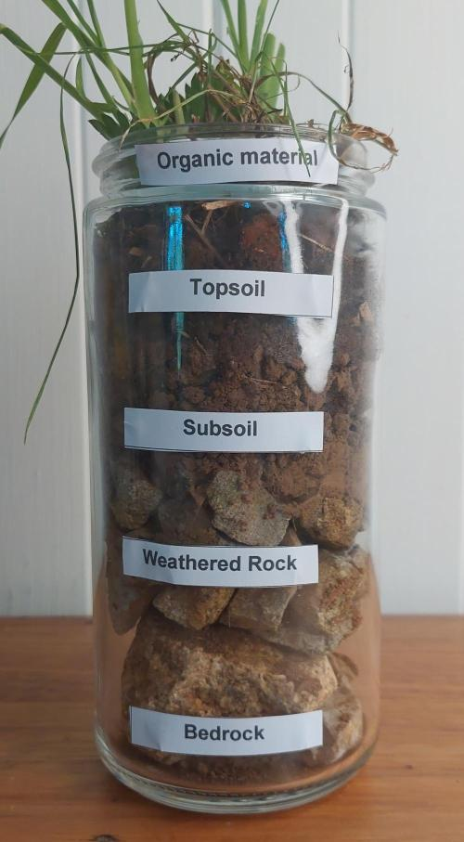
- If you were pushing a stick or pole into the ground, which layer do you think you would push down to? Why do you think that? Would be influenced by how heavy the stick or pole was, or if it was holding something up?

Reflect on the lesson
You might:
- review the TWLH chart. Record what students have learned about soil layers and add any new questions.
- add to the class word wall vocabulary related to soil layers.
- discuss how students were thinking and working like scientists during the lesson. Focus on creating a model to communicate science knowledge and understanding.

Y3

Dig deep • Lesson 8 • Sustainable design
Lesson 8
ACT
To read the most recent version of this lesson, download associated resources, and view embedded professional learning including classroom videos and work samples, visit: https://primaryconnections.org.au/teaching-sequences/year-3/dig-deep/lesson-8-sustainable-design

Lesson overview
Students consolidate their learning, using the design thinking process to use or reuse a material that exists because of soil, rocks or minerals.

Key learning goals
Students will:
- review and discuss what they have learned about soil, rocks and minerals.
- design and make a sustainable creation that uses or reuses a material that exists because of soil, rocks or minerals.
- share their sustainable creation with others.
Students will represent their understanding as they:
- discuss what conclusions they have drawn about soil, rocks and minerals.
- add extra information about soil, rocks and minerals to the class geology quest map.
- communicate their knowledge gained by sharing their sustainable creation in an appropriate way.

Assessment advice
Students working at the achievement standard (Science understanding) should:
- be able to recognise that soil, rocks and minerals are valuable and important Earth resources.
- applied their learning by creating and sharing their sustainable creation.
There is also potential for assessment of the achievement standard related to Science as a human endeavour, depending upon the focus of the Act task selected. Consider if this is possible and how and what you might assess.
Refer to the Australian Curriculum content links on the Our design decisions tab for further information.

List of materials
Whole class
- Item Class science journal (digital or hard-copy)
- Geology quest map from Lesson 1
Each student
- Individual science journals (digital or hard-copy)
- Materials to make a sustainable creation (see Selecting the prompt for the Act phase on the Preparing for this sequence tab in the Sequence overview for further details)

Lesson routine | Estimated time | Task type
Anchor | 10 minutes | Whole class
Connect | 10 minutes | Whole class
Design | Variable | Whole class/Individual
Communicate | Variable | Whole class

Act

Anchor • What have we learned?
Discuss what conclusions students have drawn about soil, rocks and minerals.
Potential discussion prompts
- What is in soil?
- Why is soil important?
- What is a rock made of?
- How might one rock be different to another rock?
- Why are rocks and minerals important?
Add any further questions that the students pose to the class science journal, to honour their interest and curiosity.
Anchor to the core science concept and key ideas by discussing with students how all the investigations in this teaching sequence have been about:
- observing, comparing, sorting and classifying soil, rocks and minerals according to similarities and differences.
- soil, rocks and minerals as an important part of Earth that change over time.

Connect • Geology quest
Refer to the geology quest map of the school from Lesson 1 and discuss:
- any changes students would like to make to the map.
- any extra information they can add to the map, for example, where they would find minerals.
- any changes they could make to the playground that involve soil, rocks or minerals, for example building a veggie garden, a worm farm, or creating an area for mud pie making.

Design • Sustainable creation
Using the steps of the design thinking process, students apply their knowledge gained throughout the sequence to contribute to the sustainability of Earth’s resources by using/reusing a material that was dependent on soil, rocks, or minerals.
You might present students with a design brief to outline their goals. Examples include making seed bombs/balls or clay pots (soil focus), microhabitats with rocks and tiles (rock focus), or planning a new recycling system for aluminium cans and glass (mineral focus). See Selecting the prompt for the Act phase in Preparing for this sequence for further advice.
If you have determined that you will add some parameters around the design, for example relating to materials available, design and construction time limits, introduce those here. Consider if the creation should adhere to a specific theme related to your school or community context (such as recycling, biodiversity, resident native animal etc.).

Define
Outline the problem in a simple manner such as:
How can we…(contribute to the sustainability of Earth’s resources)…by…(using/reusing a material)…for…(our school/community/backyard/home)?

Ideate
Brainstorm ideas related to the sustainable creation.
At this stage, to support creative thinking, every idea offered by students should be recorded in the class science journal. No idea is discounted, as the practicality/possibility of each idea will be considered later.
As students offer ideas, ask probing questions (Why do you think… or How do you know that…) to draw out the reasoning and evidence behind the idea.
Potential discussion prompts
- What materials could we use/reuse?
- How is/was that material reliant on soil, rocks or minerals?
- How does this improve sustainability of the Earth’s resources?
  - Reusing materials reduces waste, natural materials can be composted later, growing more trees helps the environment etc.
Once all ideas are listed, discuss which ones might be easy to include in a design and which ones might not be.
Introduce the criteria for which the designs will be assessed. Invite students to add to these criteria if appropriate.
Potential discussion prompts
- Does it matter how tall or wide the...is?
- Who will use your design? What do they need?
- How will we know if the design is a success?
- How could we test the design?

Prototype
Students draw a design of their sustainable creation. Their design should include clear labels stating the materials used.
If appropriate, assign pairs or collaborative teams for construction.
Optional: Students are provided with an opportunity to share their designs with their team and receive feedback. Teams then discuss, decide upon and draw one final prototype.
Allow sufficient time for the sustainable creation to be completed.
Optional: Students test their creation and make changes to improve it.

Communicate • Sharing our creations
Students share their creation(s) with an appropriate audience, describing:
- the materials used/reused.
- how the sustainable creation is dependent on soil, rocks or minerals, and/or is made from materials dependent on rocks, soils and minerals.
- the purpose of their creation.
- how the creation contributes to the sustainability of the Earth’s resources.
The type of creation will guide how students share their creations. For example, you might:
- invite another class or local community members to view the creation(s).
- take photographs of each creation for students to annotate then publish in a class booklet, school newsletter, local newspaper etc.
- record a short video to share with others.
- send home the creation with an explanation of the sustainable creation.

Reflect on the sequence
You might:
- refer back to the list of student questions asked in the Launch phase. Determine which questions have been answered over the course of the learning sequence, what the answers to the questions are, and the evidence that supports these claims. Address questions that have not been answered during the learning sequence, and discuss why they might not have been addressed and potential investigations that might support students to answer them.
- consider what students have learnt about the properties of soil, rocks and minerals, and their importance in our everyday lives. Ask students to represent this learning in words, symbols and pictures.
- discuss why it’s important to have a good understanding of soil, rocks, minerals and sustainability. What kinds of jobs would require you to understand this? What about in your everyday life?

