Code for caring and hygiene
Year 4
Code for caring
- As much as possible, look but don’t touch.
- Search carefully, disturbing the surroundings as little as possible.
- Replace stones and logs after searching under them.
- Leave all plants and gardens undisturbed- don’t remove any.
- Leave all dangerous small animals alone.
- Wear gloves to avoid bites and stings.
- Use spoons and damp brushes to avoid crushing small animals.
- When observing animals, keep them in a labelled container that has air holes and after a short time return the animal to where it was found.

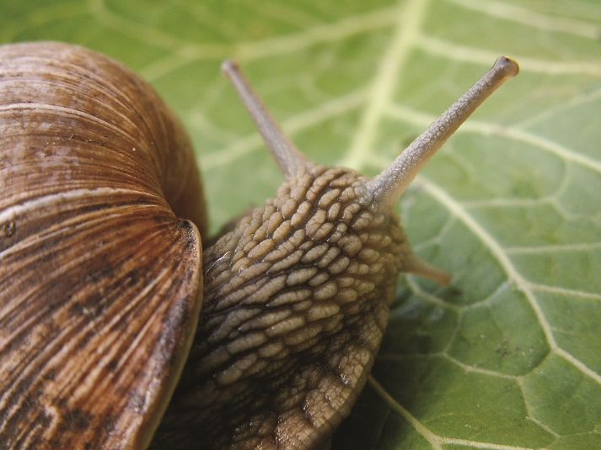
Code for hygiene
- Always wash your hands with soap and water after you’ve been touching leaves, rocks, soil and animals.

- Take extra care if you have touch snails, slugs or their slime. Don’t touch mouth afterwards and wash your hands with soap and water.

