Decaying fruit

**Year 4**

# Mandarins

Cut out the images and arrange them to show the process of decomposition.

# Lemons

Cut out the images and arrange them to show the process of decomposition.

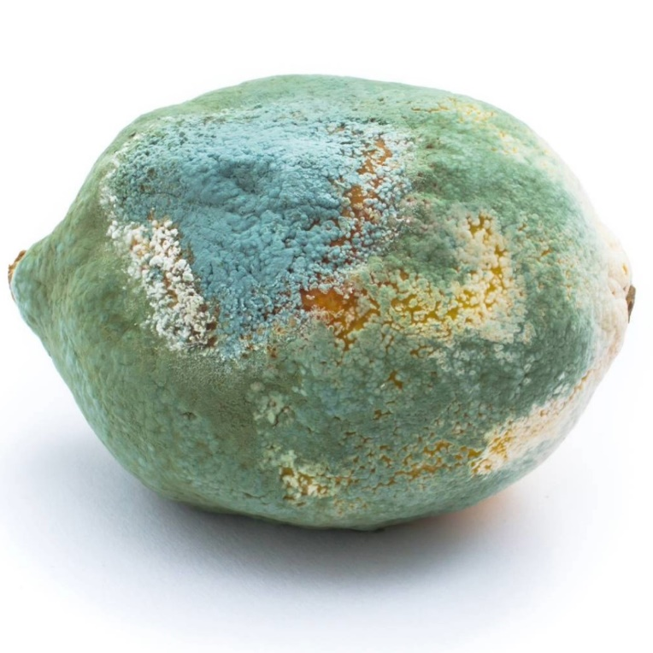

# Apples

Cut out the images and arrange them to show the process of decomposition.

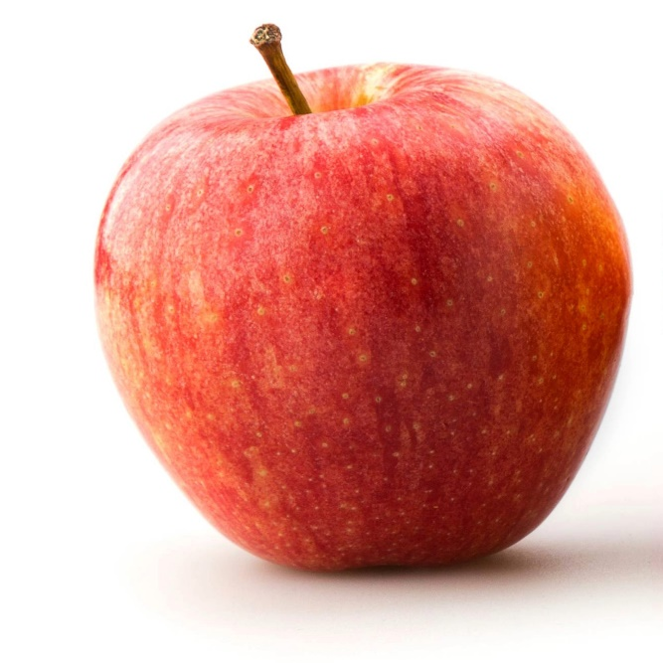

# Bananas

Cut out the images and arrange them to show the process of decomposition.

