Changing habitats

**Year 4**

# Spinner

Cut out the circle and arrow. Laminate them to enable future use.

Use a split pin to connect the spinner arrow on the top of the circle so that it spins freely.

# Producer and consumer cards

Grass cards (60%- approximately 20 cards)

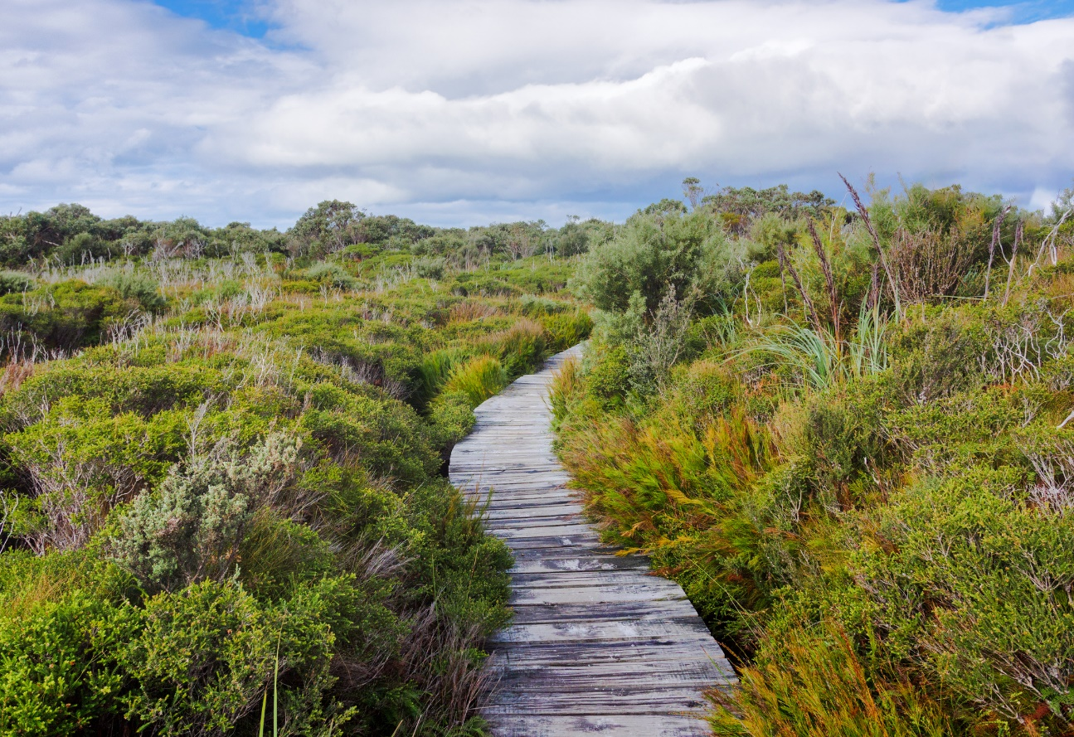

Insect cards (25%- approximately 8 cards)

Rosella cards (10%- approximately 3 cards)

Falcon card (5%- approximately 1 card)

