Creatively light

**Year 5**

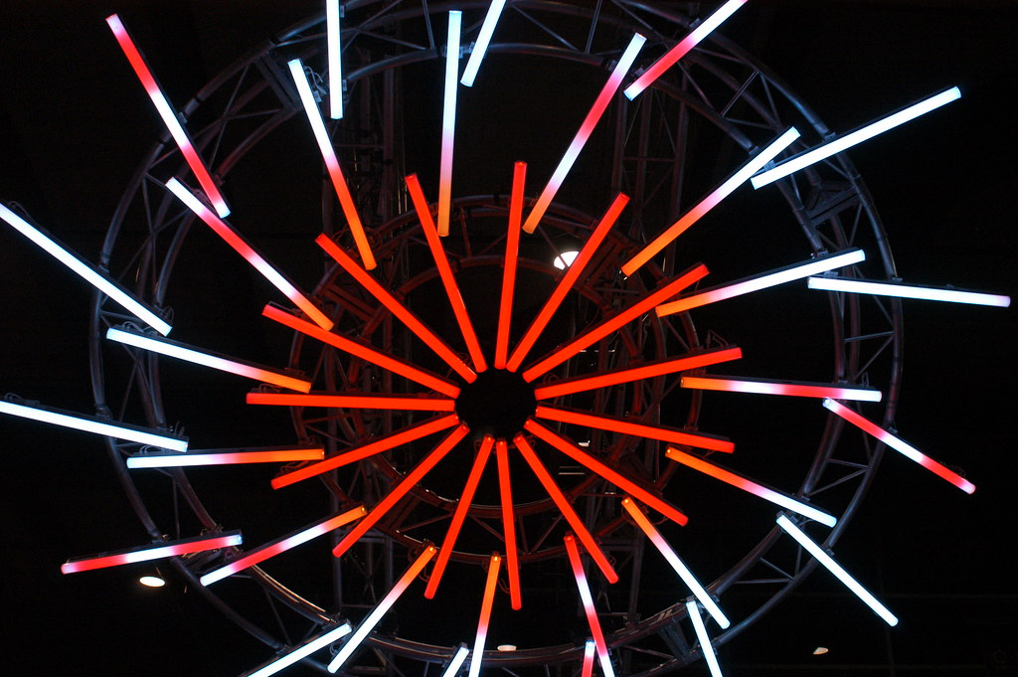

"[The Light Wheel](https://www.flickr.com/photos/37103729@N02/5769872211)" by [Doug Beckers](https://www.flickr.com/photos/37103729@N02) is licensed under [CC BY-SA 2.0](https://creativecommons.org/licenses/by-sa/2.0/?ref=openverse).

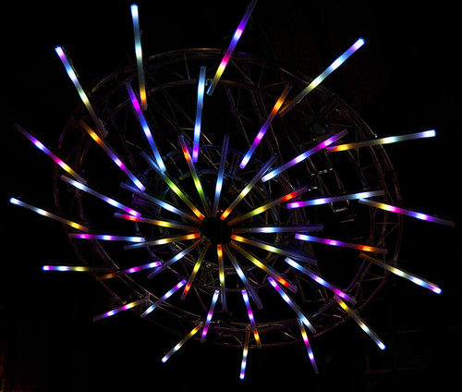

"[Light Wheel](https://www.flickr.com/photos/40939157@N03/5790193693)" by [nigelhowe](https://www.flickr.com/photos/40939157@N03) is licensed under [CC BY 2.0](https://creativecommons.org/licenses/by/2.0/?ref=openverse).

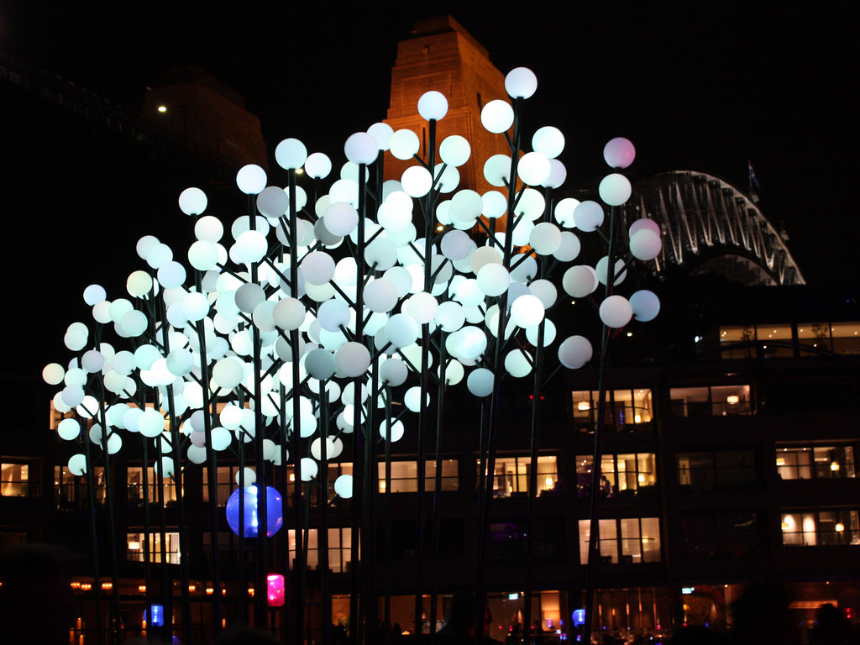

"[Vivid Sydney 2012](https://www.flickr.com/photos/65749227@N00/7356105050)" by [robynejay](https://www.flickr.com/photos/65749227@N00) is licensed under [CC BY-SA 2.0](https://creativecommons.org/licenses/by-sa/2.0/?ref=openverse).

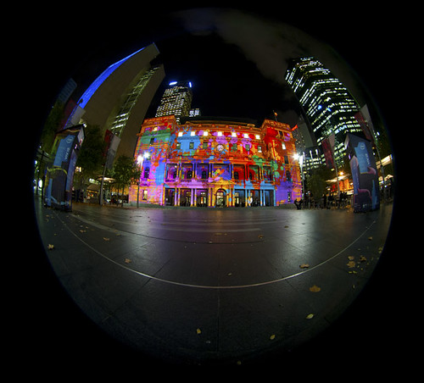

"[Vivid Sydney Fisheye](https://www.flickr.com/photos/40939157@N03/5788972656)" by [nigelhowe](https://www.flickr.com/photos/40939157@N03) is licensed under [CC BY 2.0](https://creativecommons.org/licenses/by/2.0/?ref=openverse). 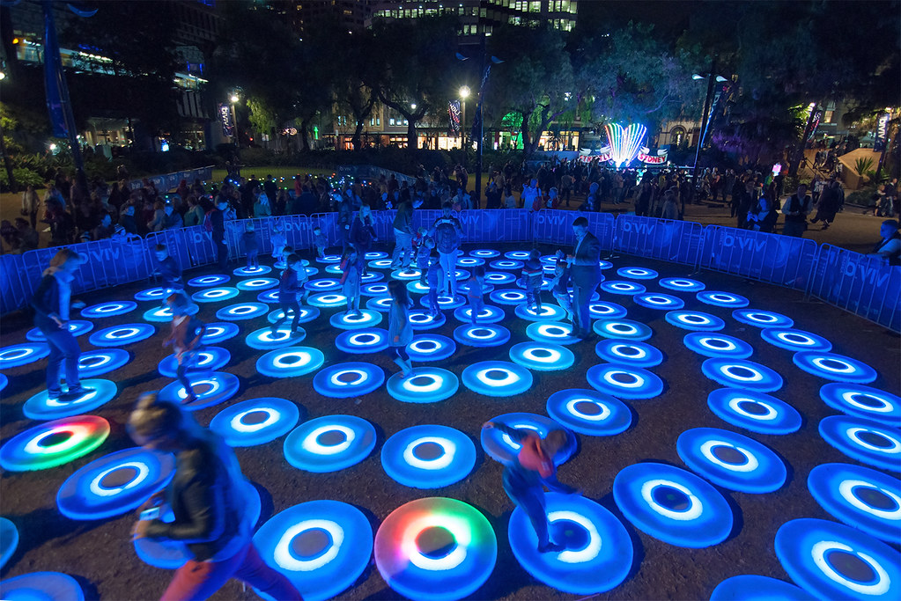  
"[Interactive Light Display Vivid sydney 2014](https://www.flickr.com/photos/115252884@N04/14299891461)" by [Paxtons Camera Video Digital](https://www.flickr.com/photos/115252884@N04) is licensed under [CC BY 2.0](https://creativecommons.org/licenses/by/2.0/?ref=openverse).

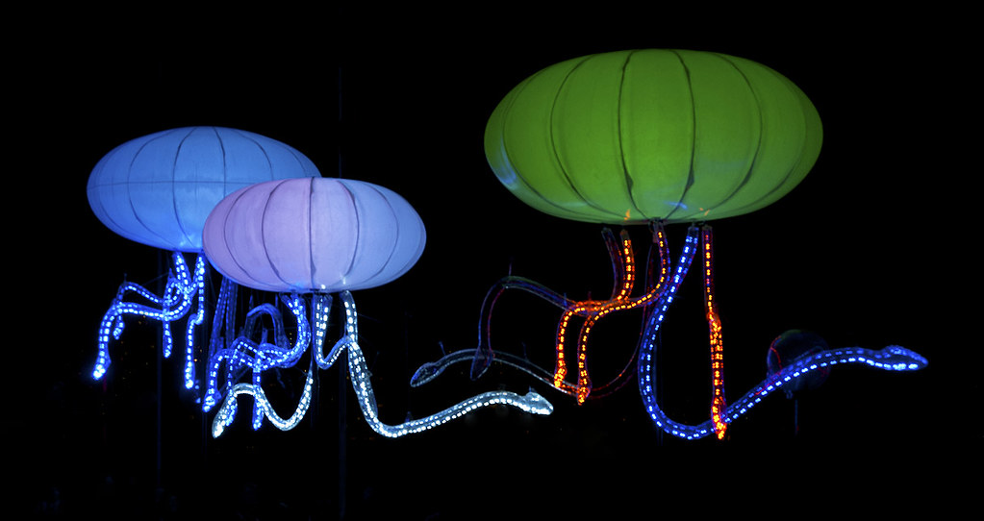

"[Vivid Sydney](https://www.flickr.com/photos/40939157@N03/5772171570)" by [nigelhowe](https://www.flickr.com/photos/40939157@N03) is licensed under [CC BY 2.0](https://creativecommons.org/licenses/by/2.0/?ref=openverse).

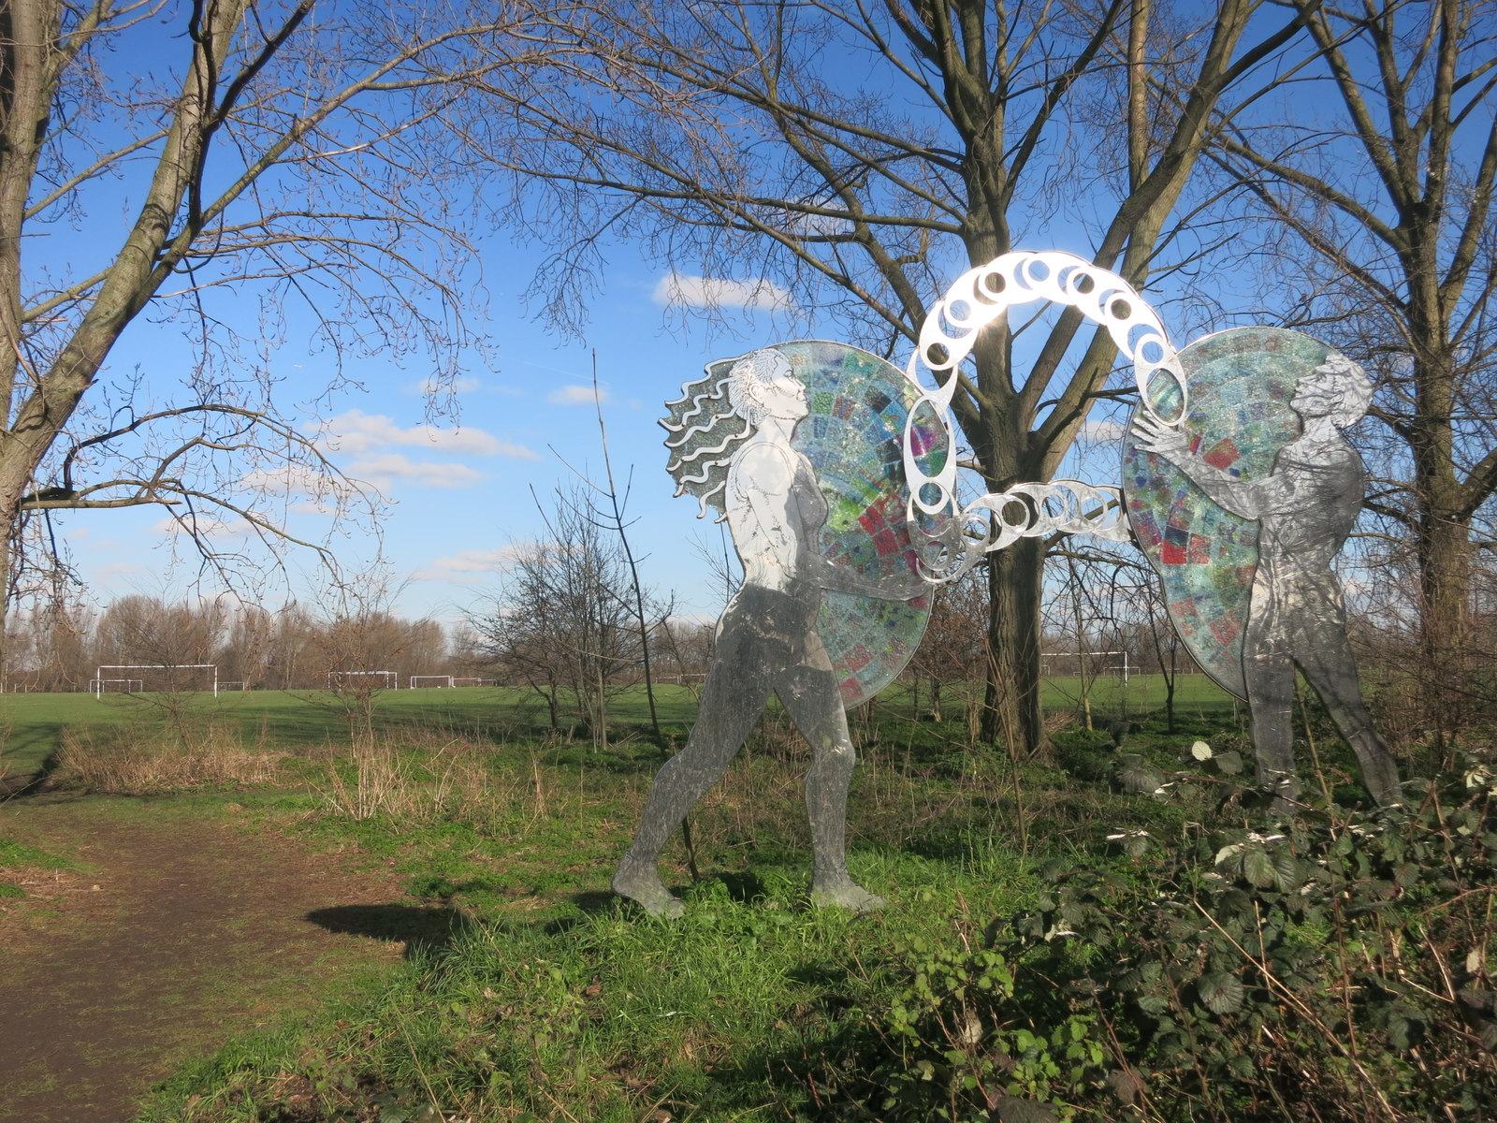

"[Mirror Sculpture, Hackney Marsh - geograph.org.uk - 4831917](https://commons.wikimedia.org/w/index.php?curid=132360692)" by [Des Blenkinsopp](https://www.geograph.org.uk/profile/43370) is licensed under [CC BY-SA 2.0](https://creativecommons.org/licenses/by-sa/2.0/?ref=openverse).

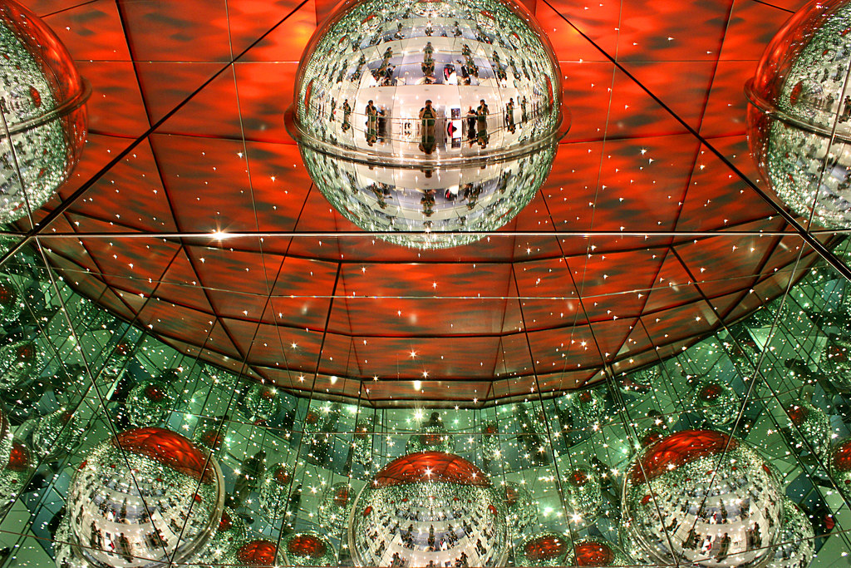

"[Mirrors and Stars](https://www.flickr.com/photos/29523289@N06/4954687416)" by [JarleR](https://www.flickr.com/photos/29523289@N06) is licensed under [CC BY 2.0](https://creativecommons.org/licenses/by/2.0/?ref=openverse).

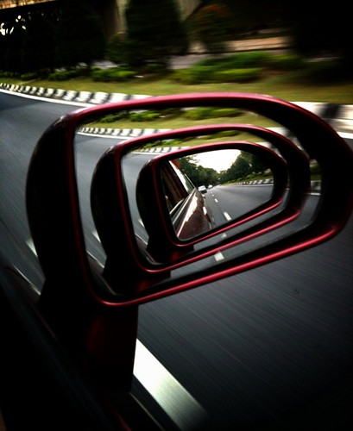

"[It's just an illusion..♫](https://www.flickr.com/photos/16899432@N05/4744303019)" by [thechannelc](https://www.flickr.com/photos/16899432@N05) is licensed under [CC BY 2.0](https://creativecommons.org/licenses/by/2.0/?ref=openverse).

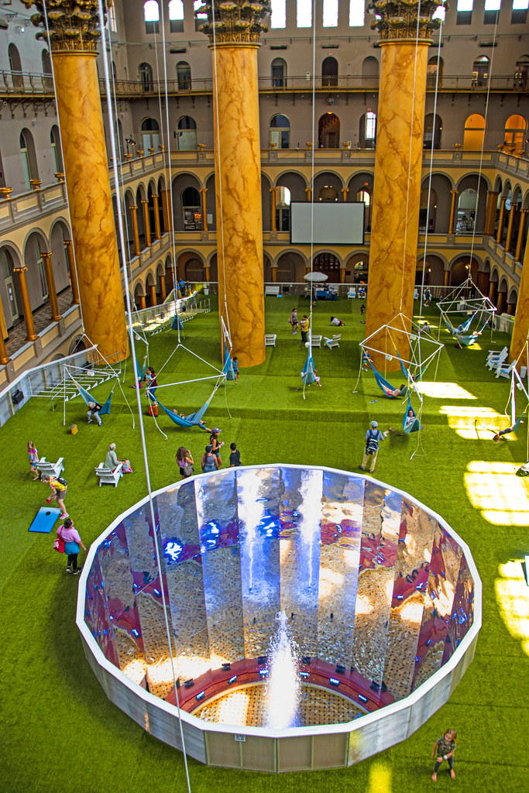

"[The 'LAWN' Exhibit at the National Building Museum (DC) August 2019](https://www.flickr.com/photos/22711505@N05/48586793627)" by [Ron Cogswell](https://www.flickr.com/photos/22711505@N05) is licensed under [CC BY 2.0](https://creativecommons.org/licenses/by/2.0/?ref=openverse).

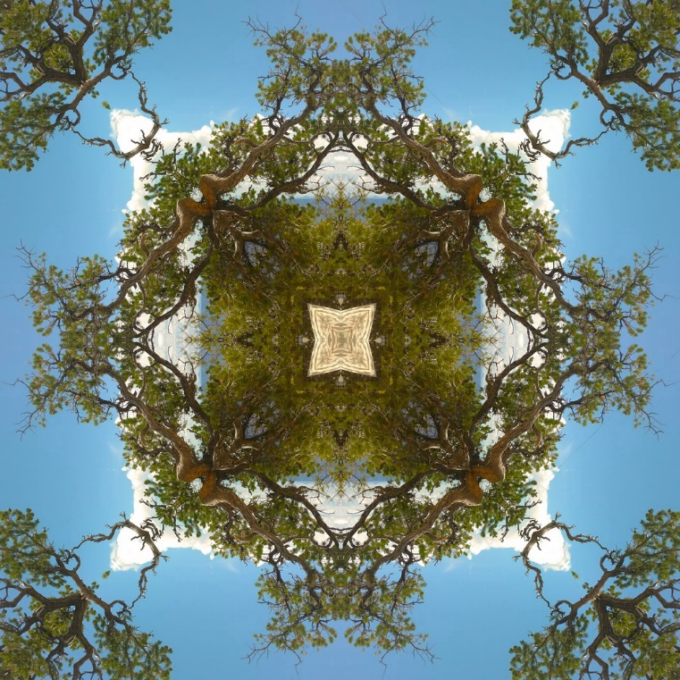

"[kaleidescope (4)](https://www.flickr.com/photos/138158825@N07/38095581312)" by [a.agnum](https://www.flickr.com/photos/138158825@N07) is licensed under [CC BY 2.0](https://creativecommons.org/licenses/by/2.0/?ref=openverse).

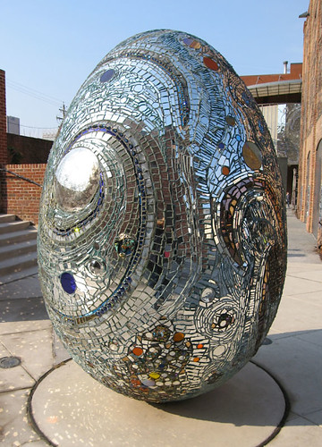

"[Mirror Egg](https://www.flickr.com/photos/96466040@N00/417658909)" by [LollyKnit](https://www.flickr.com/photos/96466040@N00) is licensed under [CC BY 2.0](https://creativecommons.org/licenses/by/2.0/?ref=openverse).

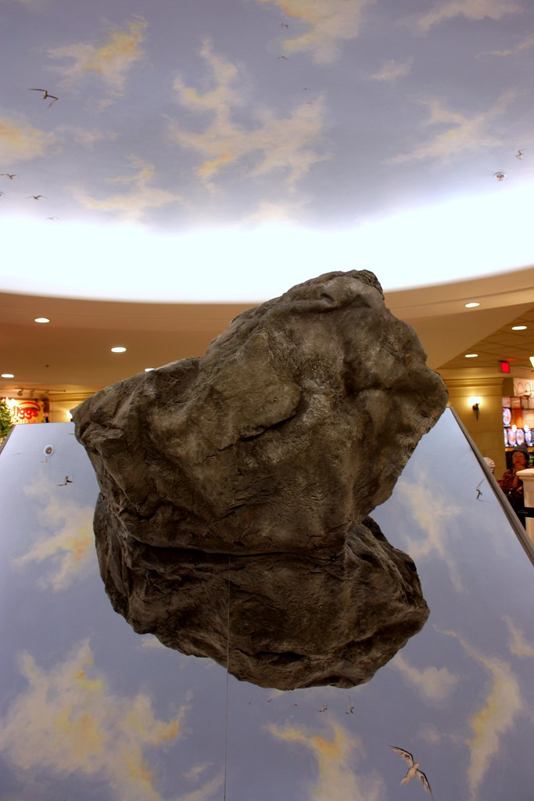

"[Marc Dulude, 2012, Se perdre dans le décor](https://www.flickr.com/photos/57286185@N04/6823724946)" by [art_inthecity](https://www.flickr.com/photos/57286185@N04) is licensed under [CC BY 2.0](https://creativecommons.org/licenses/by/2.0/?ref=openverse).

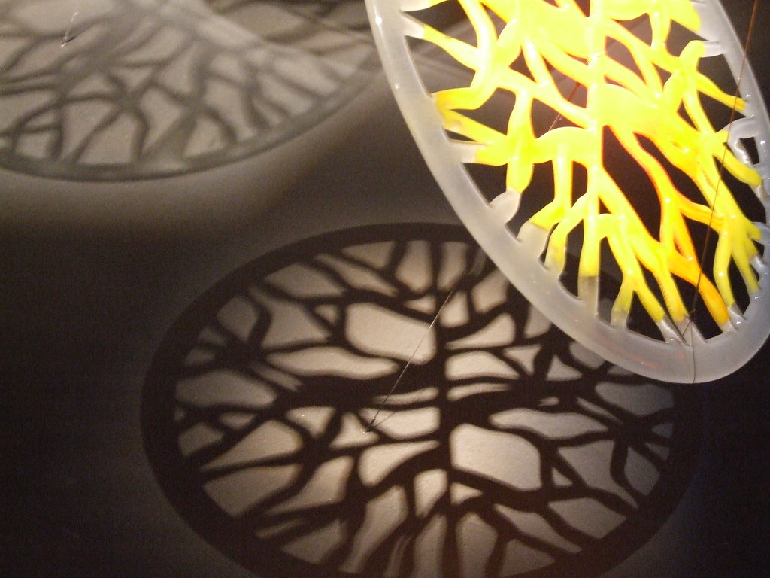

"[Modus Vivendi glass ring and shadows - Art exhibition in Milan](https://www.flickr.com/photos/28618423@N00/469717331)" by [stepaganini](https://www.flickr.com/photos/28618423@N00) is licensed under [CC BY-SA 2.0](https://creativecommons.org/licenses/by-sa/2.0/?ref=openverse).

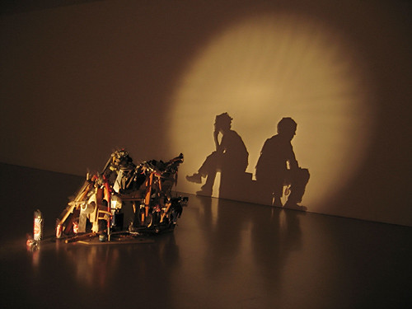

"[shadow-art-4](https://www.flickr.com/photos/126011099@N05/15017481565)" by [tati01691](https://www.flickr.com/photos/126011099@N05) is licensed under [CC BY 2.0](https://creativecommons.org/licenses/by/2.0/?ref=openverse).

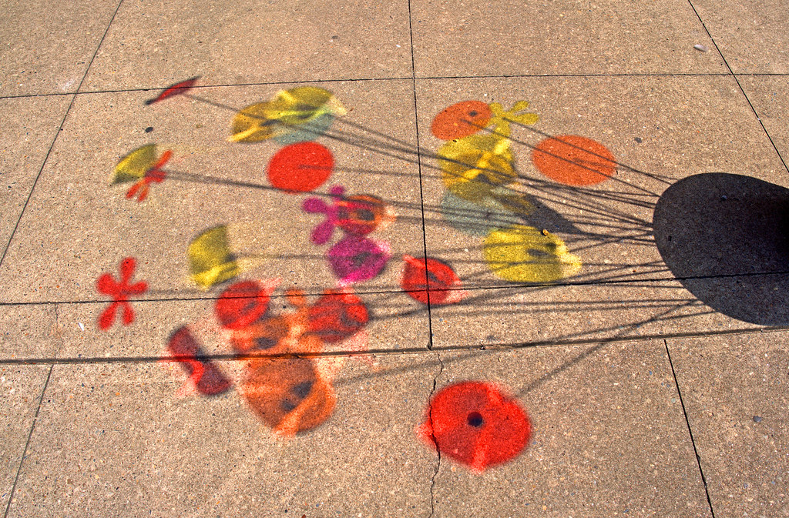

"[Shadow Art](https://www.flickr.com/photos/188479097@N07/52381046766)" by [Alan Kyker](https://www.flickr.com/photos/188479097@N07) is marked with [Public Domain Mark 1.0](https://creativecommons.org/publicdomain/mark/1.0/?ref=openverse).