Shining light
Year 5

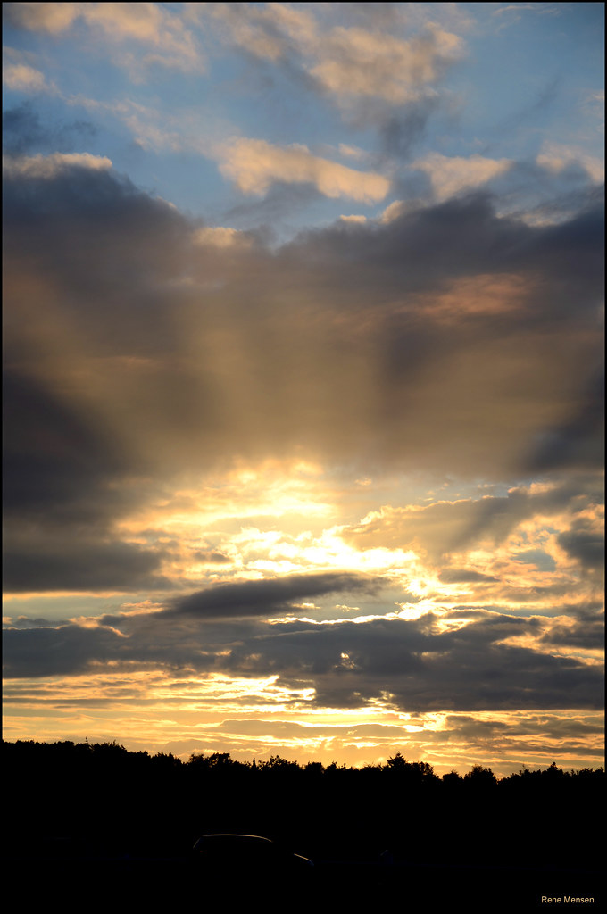
"Ray of light" by Rene Mensen is licensed under CC BY 2.0.

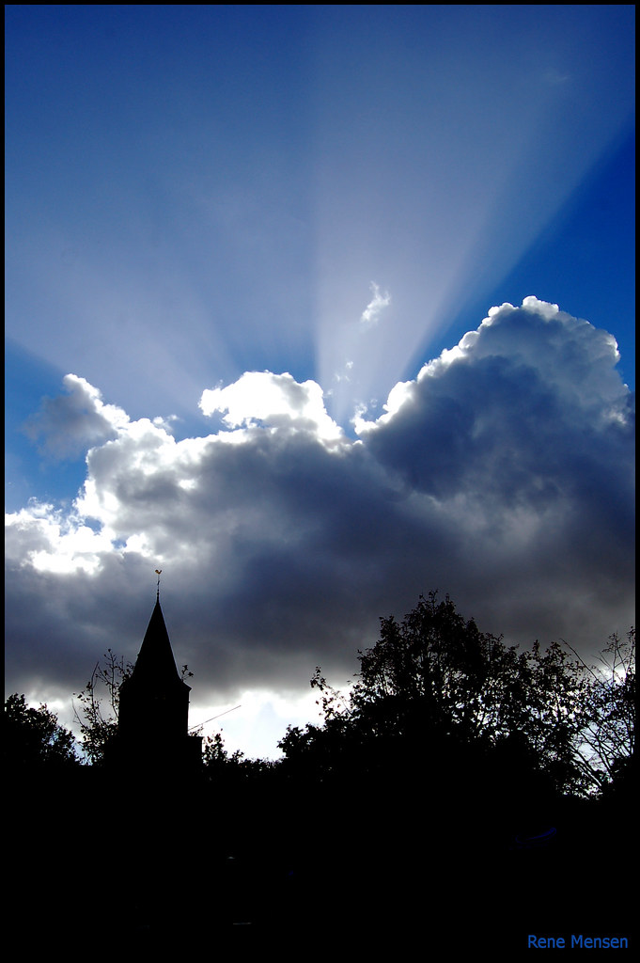
"Ray of light" by Rene Mensen is licensed under CC BY 2.0.
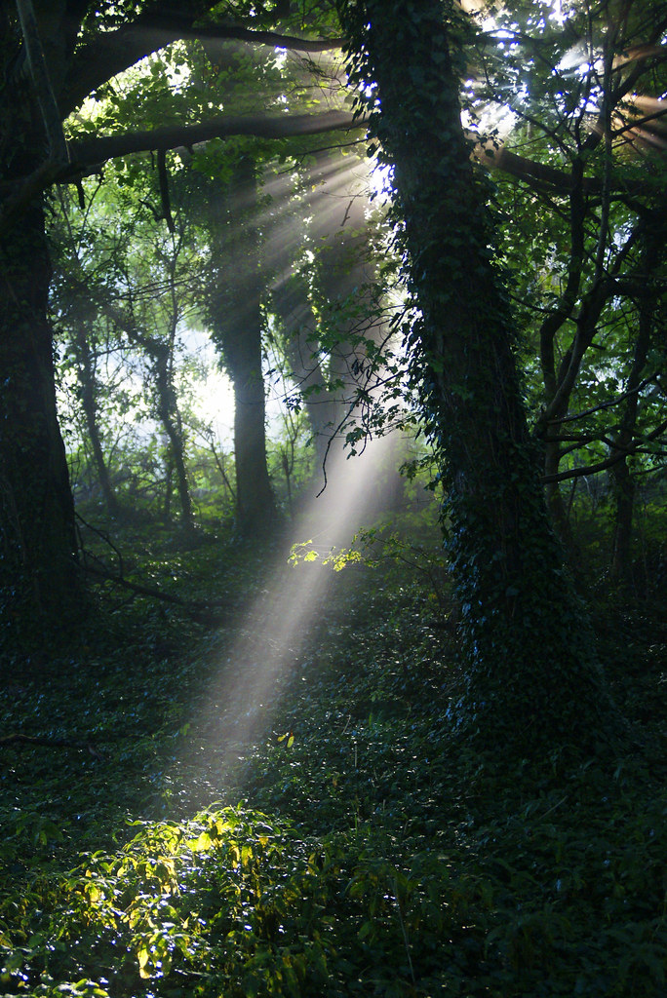
"Ray of Light, Cotswolds, Gloucestershire" by Kumweni is licensed under CC BY 2.0.

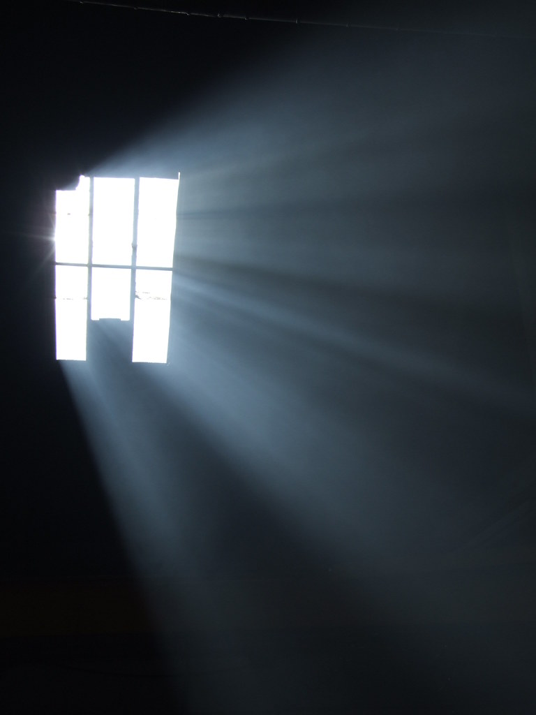
"Ray of Light" by Russ Cribb is licensed under CC BY 2.0.
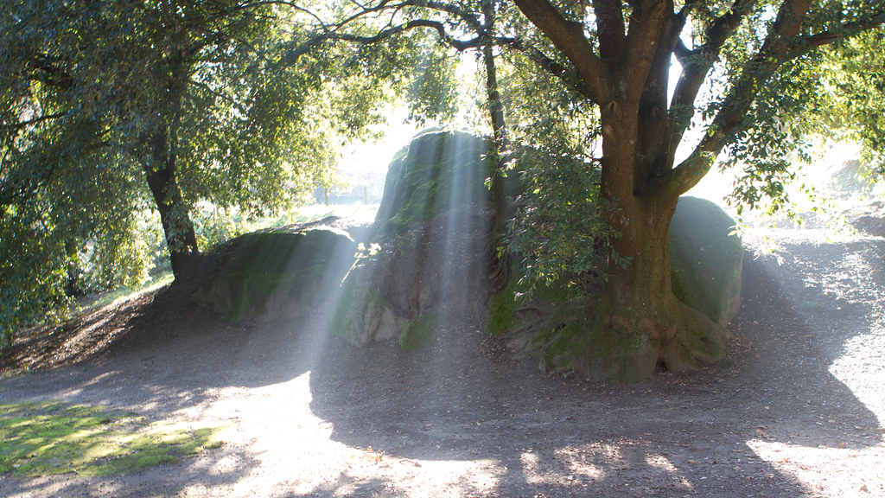
"Ray of Light - IMG_0121" by Nicola since 1972 is licensed under CC BY 2.0.

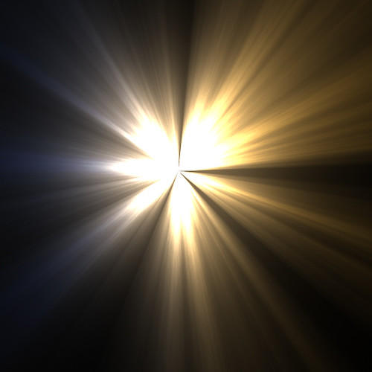
"Light Beams FX" by Filter Forge is licensed under CC BY 2.0.
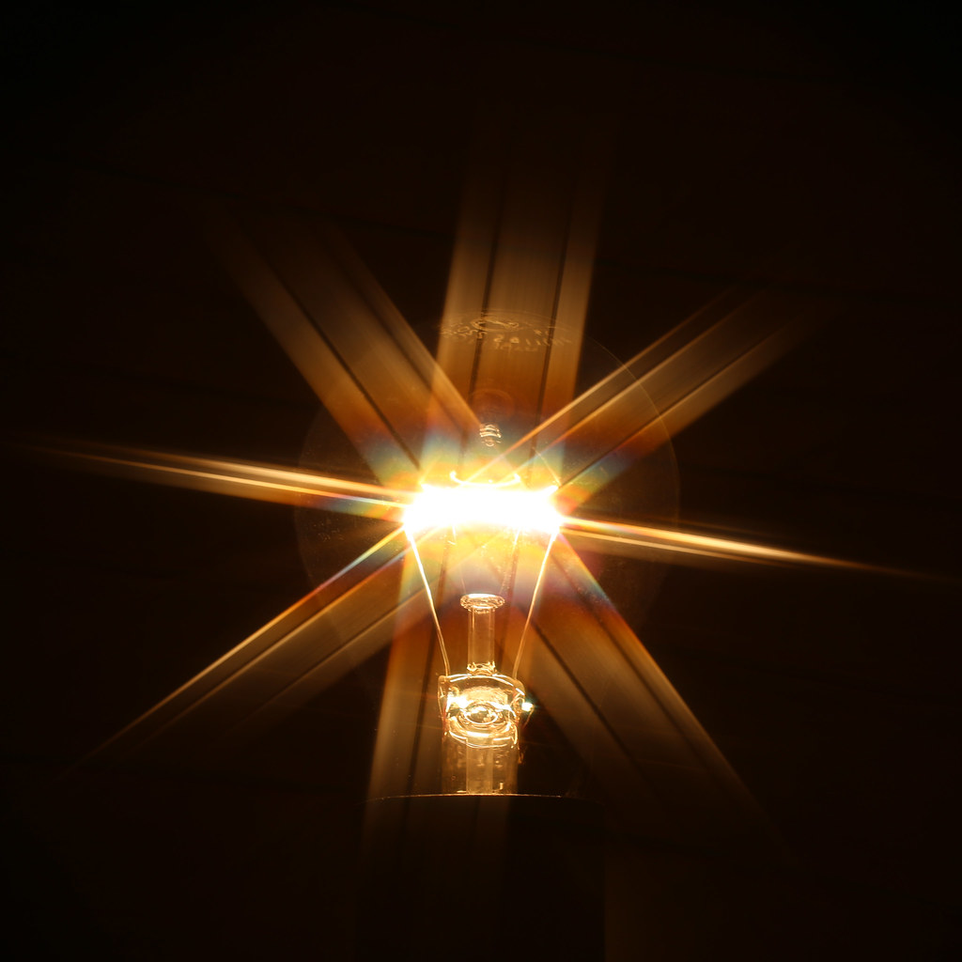
"Glowing light bulb with rays of light" by Markus Grossalber is licensed under CC BY 2.0.

