What’s in milk? What’s in vinegar?
Year 6

Milk
The following shows an approximate chemical breakdown of cow’s milk. Milk from other animals have the same basic structure, but the amounts may differ. For example, both goat and sheep’s milk contain higher percentages of fat and protein.
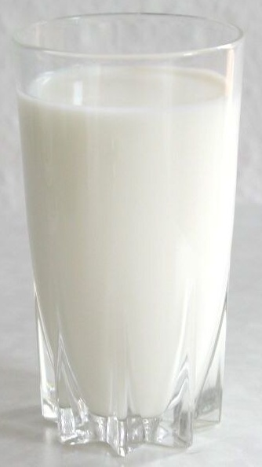
87.5% water

3.4% protein
Mostly casein
(pronounced kay-seen)

5.2% lactose

and minerals
3.9% fat

Triglycerides (try-gli-cer-ides), phospholipids (fos-fo-lip-ids), cholesterol (kol-est-er-ol), etc.
A sugar-based carbohydrate (car-bo-hi-drate)

Calcium (kal-cee-um), phosphate (fos-fate), magnesium (mag-nee-see-um), sodium (so-dee-um), potassium (po-ta-see-um) etc.

Milk glass, Stefan Kühn, via Wikimedia

Vinegar
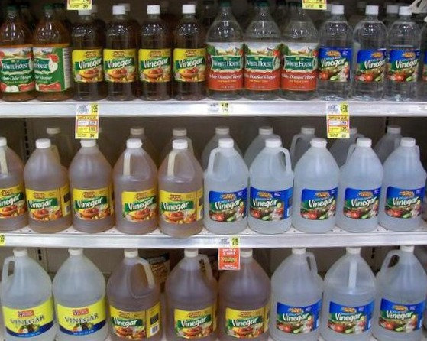
Vinegar is a liquid that is made mainly of water and between 4-18% acetic acid.
Vinegar with an acid content higher than about 10% can be highly corrosive and is usually only used for commercial purposes, not consumed.
Vinegar is made by double-fermenting a source ingredient, typically fruits.
As the fruit breaks down, yeast converts the sugars into alcohol, and bacteria then converts this alcohol into acid. This traditional process can take weeks or sometimes months.
Modern commercial vinegar-making uses a faster process that can take between
Bottles of vinegar at a supermarket,
Ms angie gray, via Wikimedia

1-3 days.

Different types of vinegar
- Appe cider vinegar
- Red wine, white wine or balsamic vinegar (made from grapes)
- Rice wine vinegar
- Malt vinegar (made from barley)
- Black vinegar (made from glutinous, or sticky rice as well as grains, and often used in Chinese cooking)
- Cane vinegar (made from sugar cane and often used in Filipino cooking)

What does vinegar do to milk?
The acid in vinegar lowers the pH level of the milk, neutralising the charge between the liquid particles and causing the proteins in the milk to clump together into solids. The liquid left behind is now referred to as whey.
The solids/curds can then be used to make different types of fresh cheese, such as ricotta, mozzarella, cottage cheese and paneer.
The whey can also be used as an alternative to milk or water when making soups or smoothies, when baking, or soaking or boiling things. This can help make food more easily digestible.
When making an acid-set cheese, milk is typically heated to between 80°-90°C. Heating the milk encourages the proteins to clump and can create a better taste and texture than using cold milk.
Whilst cheese can be made using vinegar, most cheeses are made using rennet, which comes from the stomach of ruminant, or hooved, animals such as cattle, sheep or goats.
Rennet contains enzymes and it is these enzymes that allow the curds to form. It’s a different chemical reaction that achieves the same result.

