Focus on fizz
Year 6

Materials
6 teaspoons of sodium bicarbonate  6 teaspoons or tartaric (or citric) acid  3 cups of non-acidic water  1 cup measure  1 teaspoon  4 pieces of paper towel | 4 transparent bottles the same size (350-400ml approximately)  4 balloons  1 labelling pen  1 funnel  Masking/adhesive tape
Instructions
1. Label the 4 bottles with the following information:  - Bottle 1: bicarb + acid  - Bottle 2: bicarb + water  - Bottle 3: acid + water  - Bottle 4: bicarb + acid + water  2. Label the balloons 1, 2, 3, 4.  3. Add 2 teaspoons of sodium bicarbonate to balloons 1, 2 and 4 by placing the funnel into the opening of each balloon then spooning the sodium bicarbonate in.  4. Wipe funnel clean carefully with a piece of paper towel. Discard the paper towel.  5. Add 2 teaspoons of tartaric (or citric) acid to balloons 1, 3 and 4 by placing the funnel into the opening of each balloon then spooning the tartaric/citric acid in.  6. Wipe funnel clean carefully with the second piece of paper towel. Discard the paper towel.  7. Carefully add 1 cup of water to bottles 2, 3 and 4 by placing the funnel into the opening of each bottle then pouring the water in.  8. Have one team member carefully fit the opening of each balloon over the mouth of the corresponding bottle while another team member holds the balloon so that no powder falls in. Pull the stem part of the balloon down so that it will not come off easily. Secure it with a piece of masking tape to make it airtight.  9. Carefully upend balloon 1 so that its contents falls into bottle 1. Mix the contents gently. Observe the bottle carefully and record your observations in the table below.  10. Repeat step 9 for each of the bottles. | 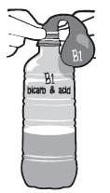  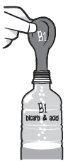  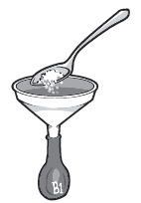

Predictions & Observations
Bottle 1: bicarb + acid
Prediction | Observation
Bottle 2: bicarb + water
Prediction | Observation
Bottle 3: acid + water
Prediction | Observation
Bottle 4: bicarb + acid + water
Prediction | Observation

Explaining results
Write a statement or draw a labelled diagram to summarise your findings.

