Fire triangle
Year 6

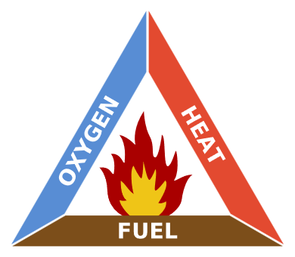
Fire triangle, Gustavb, via Wikimedia

This simple model shows the three elements essential for a fire to burn.
Think of a gas or charcoal BBQ that you might use at home.
Can you identify the three elements?
If one of these elements is removed the fire cannot continue to burn.

Think of ways that people can put out a fire. How do these ways remove one or more of the elements?

