Melt or burn
Year 6

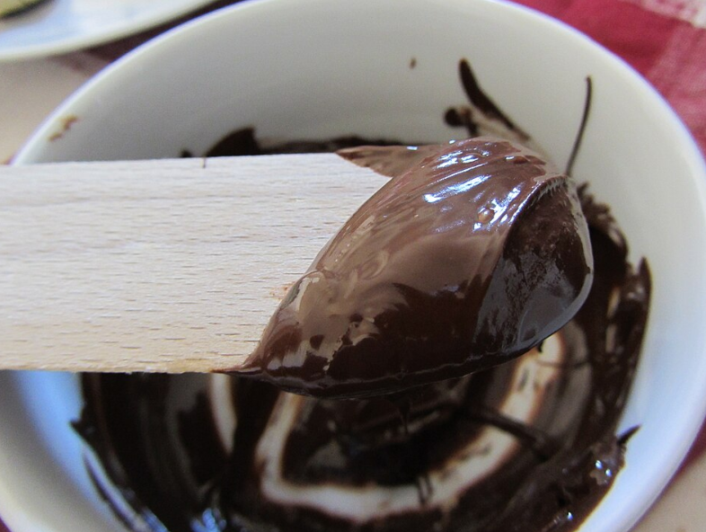 | 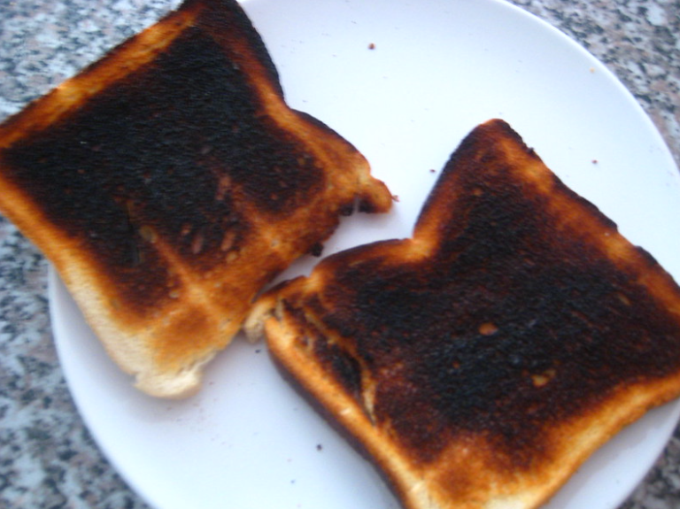
13 Italy Chocolate melted - italian premium chocolate top quality,  Andrea Pavanello, CC BY-SA 3.0 IT, via Wikimedia Commons | Toast, Sheep purple, CC BY 2.0, via Flickr

