Which plant parts can I eat?
Year F
Name:
Only some parts of plants are edible. We can eat the leaves on some plants, but they are poisonous on others. We must check with an adult when we are not sure.

These plant parts are edible:

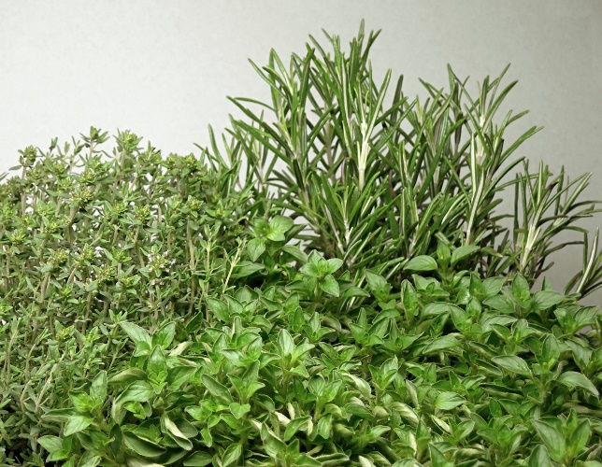  Leaves | spinach leaves, parsley, celery leaves, lettuce
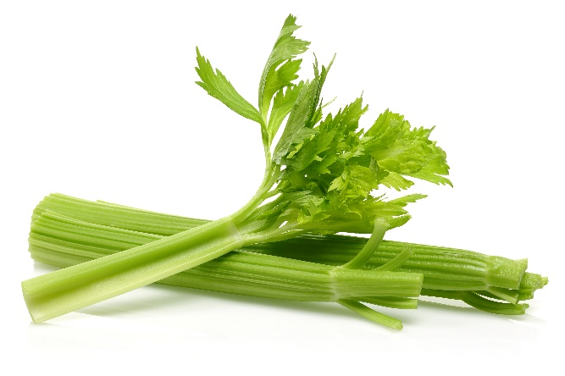  Stalks/stems | celery, spring onion, chives
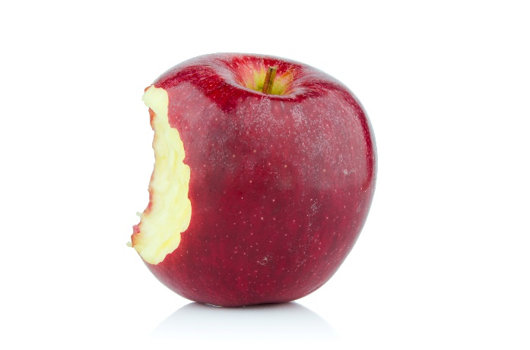  Fruit | capsicum, cucumber, tomato, avocado, beans, apple, orange and many more
Roots  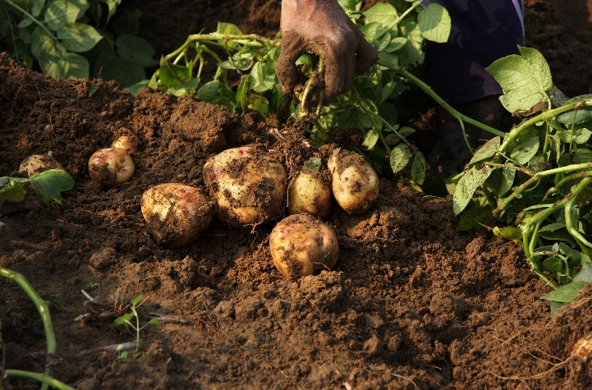 | Carrot, sweet potato  Note: Potatoes are not technically a root, they are a ‘tuber’ which grows from an underground stem.

