Code for caring and hygiene
Year F
Code for caring
- Look, film, photograph, but don’t touch the animals.
- If you move something while looking, like leaves, rocks or dirt, put them back.
- If you see an animal that might bite or sting you, stay calm, move away immediately and tell the teacher.

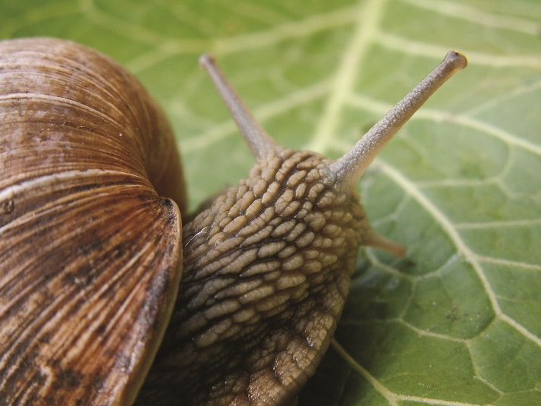
Code for hygiene
- Wash your hands with soap and water after touching leaves, rocks, and dirt.

- Take extra care if you have touch snails, slugs or their slime. Don’t touch mouth afterwards and wash your hands with soap and water.

