Fantastic fungi
Year 6
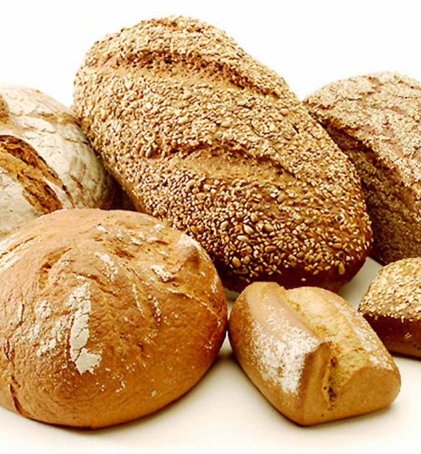
Assorted bread, Klaus Höpfner, CC BY-SA 3.0, via Wikimedia Commons

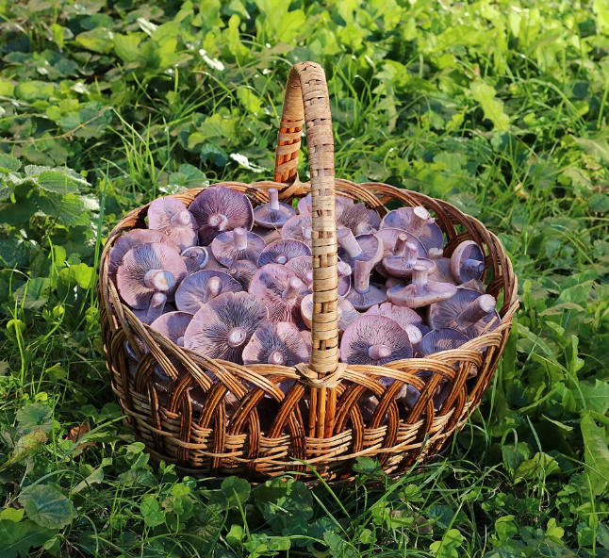
Edible fungi in basket 2022 G5, George Chernilevsky, CC BY 4.0, via Wikimedia Commons

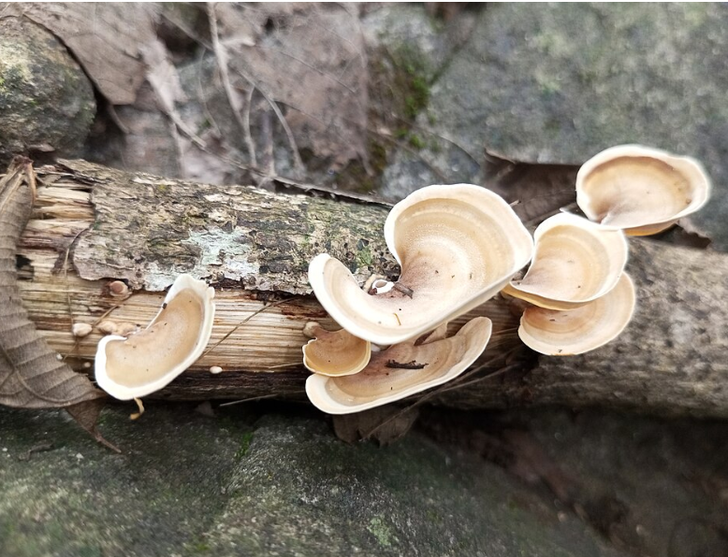
Fungi 42, Nativeplants garden, CC BY-SA 4.0, via Wikimedia Commons

