Forgotten lunch
Year 6

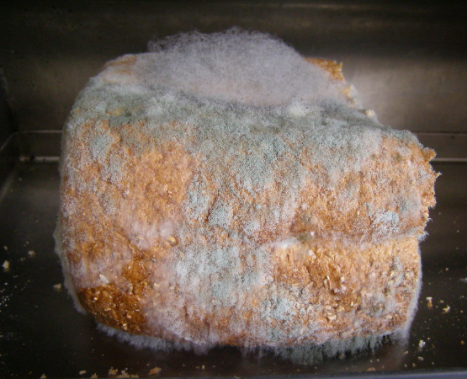
Mouldy bread, Matt Wharton, CC BY-SA 2.0, via Flickr
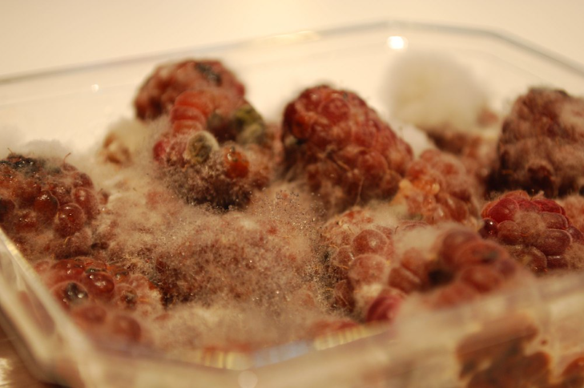
Spore heads - Mouldy Raspberries still in the fridge, Alpha, CC BY-SA 2.0, via Flickr

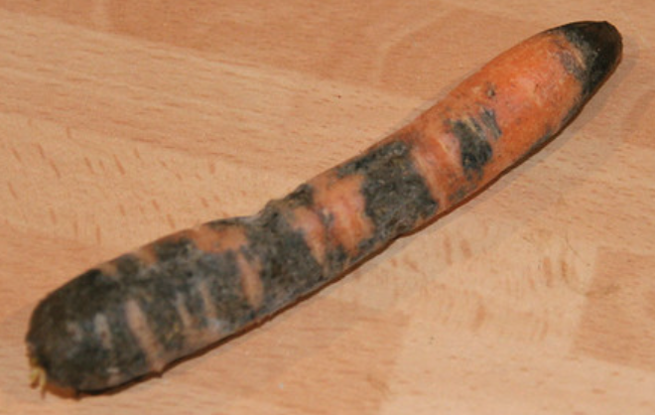
Vegetable left to rot, I See Modern Britain, CC BY-SA 2.0, via Flickr

